**Jubilee Year of HOPE, 2025**

**INTRODUCTION:** In May 2024, Pope Francis issued a Bull of Induction of the Ordinary Jubilee of the Year 2025, entitled “Hope

Does Not Disappoint” *(Spes Non Confundit).* The Holy Father invited “everyone to an intense experience of the love of God” and “calls on

all Christians to become Pilgrims of Hope.” (adapted from 12/24 letter,

Most Reverend Mitchell T, Rozanski, Archbishop of St. Louis)

**CALL to PRAYER:** “*May the God of hope fill you with all joy and peace in believing, so that by the power of the Holy Spirit you may abound in hope*.” (Romans 5, 13)

**JUBILEE PRAYER ALL**: *Father in heaven, may the faith you have given us in your son, Jesus Christ, our brother, and the flame of charity enkindled in our hearts by the Holy Spirit, reawaken in us the blessed hope for the coming of your Kingdom. May your grace transform us into tireless cultivators of the seeds of the Gospel. May those seeds transform from within both humanity and the whole cosmos in the sure expectation of a new heaven and a new earth, when, with the powers of evil vanquished, your glory will shine eternally. May the grace of the Jubilee reawaken in us, Pilgrims of Hope, a yearning for the treasures of heaven. May that same grace spread the joy and peace of our Redeemer throughout the earth. To you our God, eternally blessed, be glory and praise for ever. Amen.* (https://www.usccb.org/resources/Jubilee%20Information%20Sheet_0.pdf)

**ANTIPHON**: **”My Soul in Stillness Waits”** Marty Haugen ref(rain (Sing or recite, please.)

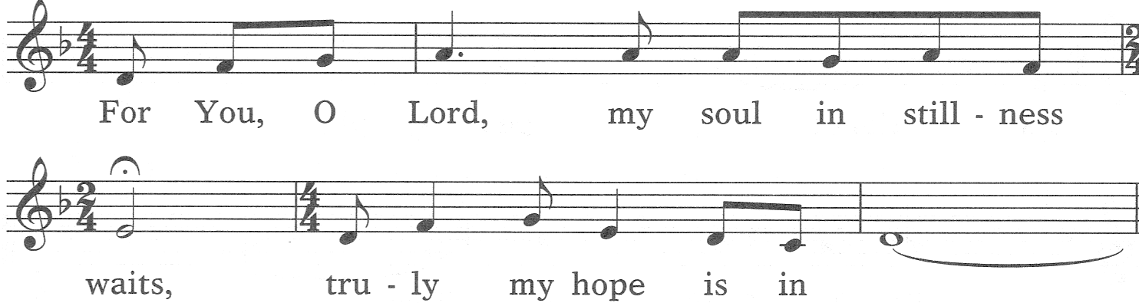

you.

Text: Psalm 95 and “O” Antiphons; Marty Haugen, b. 1950 Send Us Your Spirit DH c1982, GIA Publications, Inc. Used with permission, license #5393

**PSALM 71** verses 14-19, 23 (Alternate sides, please.) New International Version

As for me, I will always have hope; I will praise you more and more.

My mouth will tell of your righteous deeds, of your saving acts all day long,  
     though I know not how to relate them all.  
I will come and proclaim your mighty acts, Sovereign Lord;  
    I will proclaim your righteous deeds, yours alone.  
Since my youth, God, you have taught me; to this day I declare your marvelous deeds.  
Even when I am old and gray, do not forsake me, my God,  
I declare your power to the next generation, your mighty acts to all who are to come.

Your righteousness, God, reaches to the heavens, you who have done great things.

Who is like you, God?   
My lips will shout for joy when I sing praise to you.

**ALL**: Glory be …

**ANTIPHON**: **”My Soul in Stillness Waits”** refrain (Sing or recite, please.)

**Jubilee Year of Hope, 2025** (con’t) 2

**READINGS**: **Romans 5: 2-5** *Through [Christ] we have obtained access by faith into this grace in which we stand and we rejoice in hope of the glory of God. More than that, we rejoice in our sufferings, knowing that suffering produces endurance and endurance produces character and character produces hope and hope does not put us to shame, because God’s love has been poured into our hearts through the Holy Spirit who has been given to us.*

**Romans 8: 24-25** *For in this hope we were saved. Now hope that is seen is not hope. For who hopes for what he sees? But if we hope for what we do not see, we wait for it with patience.*

**RESPONSE**:



**Leader:** God is my all; God is my Creator and all my hope.

**ALL**: **God is my all; God is my Creator and all my hope.**

**Leader:** God is my all.

**ALL**: **God is my Creator and all my hope.**

**Leader:** Glory be to the Father and to the Son and to the Holy Spirit,

**ALL**: **God is my all; God is my Creator and all my hope.**

Coste, Vincent de Paul Conferences, X: 73. INDIFFERENCEJune 6, 1656 page 141

**REFLECTION and SHARING**: (Pause to process, reflect. Then share in pairs, please.)

**In my life now, how is God inviting me to hope?**

**How do I share my hope with those I serve, at home, as a Lady of Charity?**

**RESPONSE** **ALL**: **“Hope is a golden cord connecting you to heaven.”**

Jesus Calling, Sarah Young, 7/27

**INTERCESSIONS**:

**Leader:** For all the hurting people in our world who need hope,

**ALL**: O **God, hear our prayer.**

**Leader:** For our political, civic and church leaders that they may encourage hope, **ALL**: O **God, hear our prayer.**

**Leader:** For each of us, our loved ones and all called to be Pilgrims of Hope,

**ALL**: O **God, hear our prayer.**

(Please, add your own prayers. ALL respond: O **God, hear our prayer.**)



**PRAYER** **ALL**: **Blessed be you, God and Father of**

**our Lord Jesus Christ! According to your great**

**mercy, you have caused us to be born again to**

**a living hope through the resurrection of Jesus**

**from the dead. Now, God of hope, fill us with**

**all joy and peace, so that by the power of the**

**Holy Spirit, we may abound in hope. Amen.**

(based on 1 Peter 1, 3 Romans 15, 13 English Standard Version)

++++++++++++++++++++++++++++++++++++++++++++++++++++++++++++++++++

**PRAYER TEXTS** Psalm 147, 11 “… put … hope in [God’s] unfailing love.” New International Version

Jeremiah 29, 11 “… give … a future full of hope.” New American Bible

prepared for the Ladies of Charity by Sr. Carol Schumer, D.C., January 2025