God’s Power in the Powerlessness of Love
Call to Prayer: Let’s gaze at the manger in Bethlehem. See a tiny arm reaching out. God’s power is revealed in the powerlessness of love. This is what became flesh on Christmas day. adapted from Bishop Barron, Daily Gospel Reflection, 12/31/21
Hymn: “Away in a Manger” Traditional American Carol

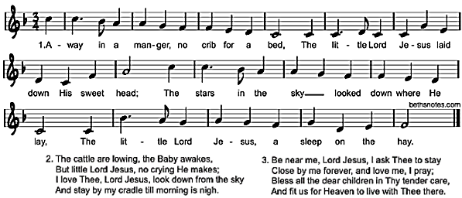

Reading: Mary is wide awake. The pain has been eclipsed by wonder. She looks into the face of the baby, her son, her Lord. She can’t take her eyes off of him. Somehow she knows she is holding God. She remembers the words of the angel, “His kingdom will never end.” (Luke 1:33 NIV) He looks like anything, but a king. His face is prunish and red. His cry, though strong and healthy, is still the helpless and piercing cry of a baby. He is absolutely dependent upon Mary for his well-being. Majesty in the midst of the mundane. Holiness in the filth of sheep manure and sweat. Divinity entering the world on the floor of a stable, through the womb of a teenager and in the presence of a carpenter. A more lowly birth could not exist.
adapted from Max Lucado, Christmas Stories: Heartwarming Classics …
Pause and Reflect on Jesus as a Baby in Mary’s Arms
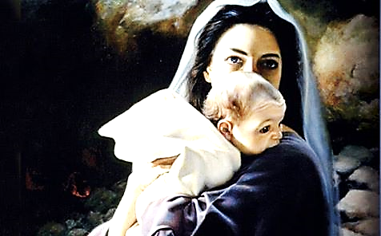
Closing: Leader: St. Louise had a great devotion to the humanity of Jesus. Let us make her sentiments our own.
ALL: Divine Love, teach me and permit me to attach myself to the greatest means You have given me for reaching my end, the most holy humanity of Your Son. With the help of His grace, this sacred humanity shall be the only example for my life. adapted from Spiritual Writings
A.I9, On The Love Which God Has Shown …, page 770
Let me honor Jesus Christ by practicing the virtues which He, in His holy humanity, taught. Amen.
adapted from Spiritual Writings L.447 August 19, 1655, page 478
prepared for the Ladies of Charity, by Sr. Carol Schumer, D.C., December 2023

