Become and Pray with St. Louise January

Call to Prayer Leader: “I ask Our Lord that this new year may be a happy one for you … and be followed by many other similar ones that will lead you to God, our last end.”
(St. Vincent, Coste, VII, page 58 Paris, January 11, 1658)
ALL: In the name of the Father and of the Son and of the Holy Spirit. Amen.

Antiphon ALL: “I adore You, O my God, and recognize that You are the author of my
existence.” Spiritual Writings, A.1 “Rule of Life in the World,” page 691
Psalm 8 (Alternate sides, please.)
How great is Your name above the heavens on the lips of children and of babes.
You have found praise to foil the enemy to silence the foe and the rebel.
When I see the heavens, the work of Your hands,
the moon and the stars which You arranged.
Who are we that You should keep us in mind, mortals that You care for us?
Yet You made us little less than a god. With glory and honor you crowned us;
gave us power over the works of Your hand; put all things under our feet,
All of them, sheep and cattle, yes, even the savage beasts,
Birds of the air and fish that make their way through the waters.
ALL: How great is Your name, O Lord our God, through all the earth.
Glory be ... As it was ...
Antiphon ALL: “I adore You, O my God, and recognize that You are the author of my
existence.” Spiritual Writings, A.1 “Rule of Life in the World,” page 691
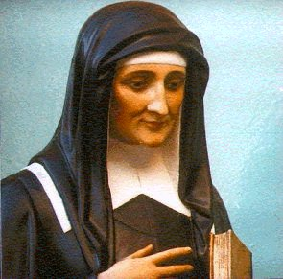

Reading Reader 1: Louise’s Charism Louise offers two extraordinarily important lessons. The first is obvious. It is the recognition of how important women and this woman in particular, are to the Vincentian story. The second is more subtle. It is the lesson that Louise’s importance stems from the fact that she was the recipient of a powerful charism of her own, a gift bestowed by the Spirit of the God and given to her in a fullness and forcefulness that was hers alone. That charism, matched with the equally full and forceful charism of Vincent, created something akin to nuclear fission. It unleashed a mighty power of example and of hope for people who wanted to live the authentic Christian message.
Reader 2: Too often we suppose that our study and imitation of these great saints is a sure path to our own holiness. Her story shows us that what matters is not the effort to “draw down” from the spiritual wealth of another whom we admire, as though only a sharing of another’s gift can make us good.
ALL: What Louise shows us is that we need only have the courage to unlock what is within us, to spend our days powered by the graced anointing that we already possess.
adapted from Light of Assisi: The Story of Saint Clare, Margaret Carney, OSF
Reflection and Sharing
In this new year, how does St. Louise invite me into deeper holiness?
What grace do I already possess, that I need to unlock, to become my best self?
Become and Pray with St. Louise (con’t) 2
Response Hymn: “The Summons” verses 4-5
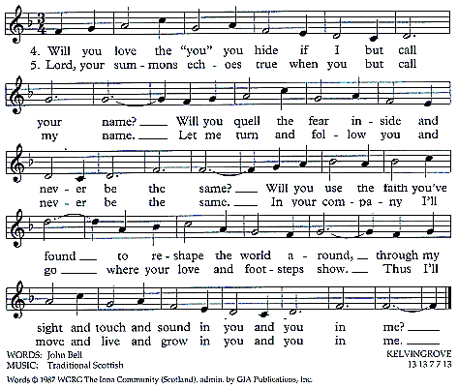
Closing Intercessions and Prayer to St. Louise
ALL: Loving and compassionate God, we celebrate with great joy the faith and works of St. Louise de Marillac. Instill in us the fire of her love, the tenacity of her belief and the tenderness of her care for those most abandoned.
Leader: O God, through Louise, you taught us a deeper love and respect for those whom the world oppresses and so we pray:
(Leader reads each petition. All pray the prayers italics.)
+Help us serve them with respect and dignity.
Christ Jesus, you inspired the co-workers of Louise to be women of compassion and empathy in their service to those living in poverty.
+Help us follow her example in our service to the Church and the world.
May we follow Louise in transforming adversity into positive energy for the service of poor people.
+Help us see with the eyes of faith and the mind of Jesus.
Loving God, through the intercession of Louise, inspire more laborers to come into the vineyard to model the gospel values of service, justice and love which Louise lived.
+May our lives and our service give you glory and praise, O God.
May the God of Louise de Marillac be with us more and more each day, quickening our hearts’ desire for love and sharpening our awareness of all that the world suffers. As the charity of Christ impelled her, may we be moved with urgency to be women of her charism, her witness and vision. May our response to the challenges, which God and our world place before us, reflect Louise’s vision of loving service.
+May the blessing of Louise be upon us! ALL: Amen.
adapted from the Federation Feast Day Prayer, written by Sister Esther Plefka, SC-Halifax
prepared for the Ladies of Charity by Sr. Carol Schumer, D.C.

