Preparing for the Birth of Jesus

Call to Prayer: “God does not rise up in grandeur but lowers himself into littleness. Littleness is the path that God chose to draw near to us, to touch our hearts, to save us and to bring us back to what really matters. Let us be amazed by this scandalous truth. The One who embraces the universe needs to be held in another’s arms. The One who created the sun needs to be warmed. Tenderness incarnate needs to be coddled. Infinite love has a miniscule heart that beats softly. The eternal Word is an infant, a speechless child. The Creator of the world has no home. [On Christmas,] all is turned upside down. God comes into the world in littleness. Let us ask ourselves, Can we accept
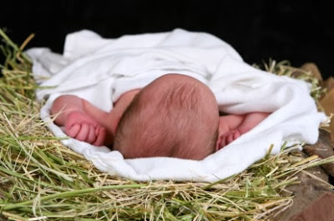
God’s way of doing things?” Pope Francis, Midnight Mass homily, 12/25/21

Hymn: “Silent Night” verse 1
Silent night, holy night, all is calm, all is bright round yon virgin mother and child.
Holy Infant, so tender and mild, sleep in heavenly peace. Sleep in heavenly peace.

Reading: Christmas is the favorite time of year when joy fills us with cheer, unless we get too distracted by the festivities and forget that there's a bigger reason for celebration. With making lists and shopping for perfect gifts; buying ribbon, paper or bags for gift giving; stringing lights; decorating the house and the tree; baking and cleaning; writing and mailing cards, often there's no time to rest because we want this Christmas to be our very best! However, "busy-ness" can soon take over our lives, filling too many hours with stress. It’s sad when we forget to talk about and with Jesus, whose birthday it is, so as we prepare for our celebrations, let's hold in our hearts a true anticipation, for the coming of Jesus, knowing he brings true peace, joy and love. He knows we have challenges, that the economy is bad and our days are difficult, yet he holds each one of us in his embrace. Let’s believe in the message of that first Christmas, when the angels proclaimed the child is born. May Jesus be born in our hearts. Then we can overflow with love as we spread kindness and joy in everything we do and the blessings of Christmas will return to us. Let’s remember to keep Jesus as our honored guest, then Christmas will truly be a joyous celebration.

Pause for Silent Reflection and Sharing
Can I accept God’s way of doing things?
How am I preparing my heart for the birth of Jesus?

Response: “Silent Night” verse 3
Silent night, holy night, Son of God, love’s pure light radiant beams from thy holy face,
with the dawn of redeeming grace, Jesus, Lord at thy birth, Jesus, Lord at thy birth.
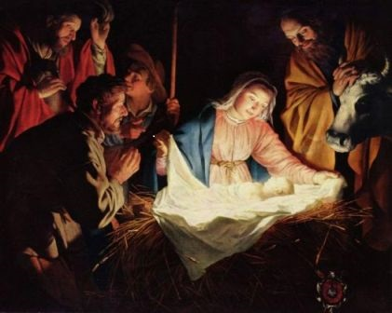
Prayer: (all) “Let your goodness, O God, appear to us, that we, made in your image, may conform ourselves to it. In our own strength, we cannot imagine your majesty, power and wonder, nor is it fitting for us to even try. Yet your mercy reaches from the heavens, through the clouds, to the earth below. You have come to us as a small child, but you have brought us the greatest gift, the gift of your eternal love. Caress us with your tiny hands, embrace us with your tiny arms and pierce our hearts with your soft, sweet cries. Amen.”

adapted from Christmas Prayer of St. Bernard of Clairvaux, The Essential Advent and Christmas Handbook
prepared for the Ladies of Charity by Sr. Carol Schumer, D.C., December

