The Rosary – Mary’s Memories
Call to Prayer: Let’s ponder scrapbooks. These aren’t about holding onto scraps rather they keep memories alive. Often on the death of a mother, children are surprised and deeply moved by what she kept of their childhood. Items like baby shoes, artwork, report cards, mother’s day cards, maybe even a first lock of hair became souvenirs of milestones in life. All were precious to her. Later in life, she would take out these mementos and be transported back to those special moments in the life of the child who was the center of her life. Mary has a scrapbook, too, for Jesus, we call it the “rosary.”
Hymn: “Hail Mary, Gentle Woman” refrain only
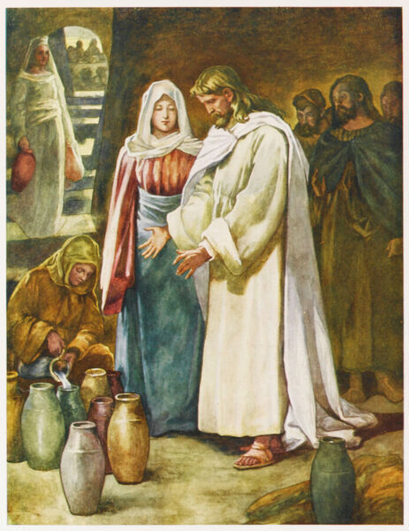
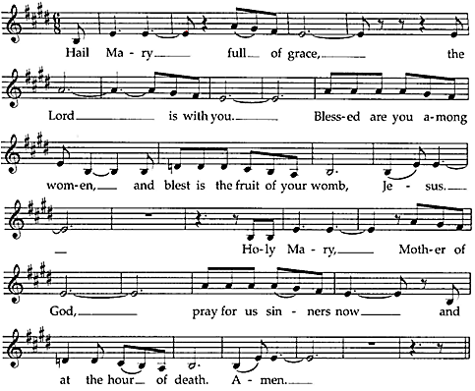
Reading: St. John Paul II reminds us Mary lived with her eyes fixed on Jesus as she treasured his every deed. According to Luke, Mary “… kept all these things, pondering them in her heart.” (Luke 2:19) The memories of Jesus, impressed upon her heart, were always with her, leading her to reflect on the various moments of her life at her Son’s side. In a way those memories were the “rosary” which she recited uninterruptedly throughout her earthly life. In truth, Mary probably never saw anything like our scrapbooks, but if she had, undoubtedly she would have had memories that were joyful, sorrowful, luminous and glorious saved.

Mary’s Luminous, “light-filled” memories (Recite the “Hail Mary” after each mystery.)
Introduction: Let’s join Mary in praying her memories of Jesus bringing light into the world.
- Jesus’ Baptism in the Jordan when God told us that Jesus was his beloved Son, listen to him.

- Jesus’ self-manifestation through his first sign at the wedding feast of Cana, a sign performed at the request of his mother. (What a memory to treasure!)

- Jesus’ first proclamation of the kingdom of God. “The time has come. The kingdom of God is near; repent, change you way of thinking and believe in the good news.”

- Jesus’ transfiguration when the Spirit of God descended upon him like dove and God’s voice is heard, saying, “This is my beloved Son with whom I am well pleased.”

- Jesus’ last supper when he showed his followers what he wanted them to do in memory of him, “wash one another’s feet” and gave the gift of the Eucharist.

The Rosary – Mary’s Memories (con’t) 2
Pause for Reflection and Sharing
Introduction: All of the mysteries are first and foremost Mary’s memories of Jesus. To pray the Rosary is to contemplate with Mary the face of Jesus.
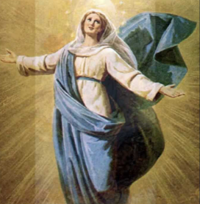
How does Mary reveal the face of Jesus to you?
What mystery of the rosary speaks to your heart?
Response: Mary’s Magnificat (Pray, alternating sides, please.)
My soul magnifies the Lord and my spirit rejoices in God, my Savior.
Because He has regarded the lowliness of His handmaid,
for behold, henceforth all generations will call me blessed.
He who is mighty has done great things for me and holy is His name.
His mercy is from generation to generation on those who fear Him.
He has shown might with His arm and
has scattered those who are proud in the conceit of their heart.
He has put down those who are mighty from their thrones and has exalted the lowly ones.
He has filled those hungry with good things and those rich He has sent away empty.
He has given help to Israel, his servant, mindful of His mercy
even as he spoke to our ancestors, to Abraham, Sarah and their posterity forever.
Glory be … As it was … adopted from https://www.ourcatholicprayers.com/magnificat.html

Intercessions
Introduction: Dear God, with Mary, we rejoice in your faithful, extravagant love, as we pray;
Response: God of life, hear our prayer.
+that we may follow Mary’s example of pondering the mysteries of God’s action in our lives …
+that we may be strengthened by Mary’s memories as she followed Jesus throughout life …
+that we may look to Mary as a model of one who hears the Word of God and acts on it …
(Spontaneous prayers are welcome.)
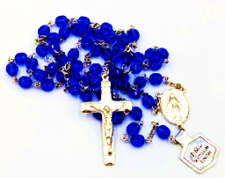
Conclusion: The Rosary mystically transports us to Mary’s side as she busily watches over and guides the human growth of Jesus. Our uniting ourselves with Mary enables her to help mold us, with the same care, until Jesus is “fully formed” in us. (Galatians 4:19) Thus Mary, totally grounded in Jesus, always leads us to her Son. The rosary allows us to ponder with Mary her memories of Jesus, memories which she held in her heart. The rosary then invites us to look, through her mother’s eyes at Jesus, the center of her life!
gleaned from John Freund, CM, Vincentian Mindwalk, 10/4/21
https://johnfreund.net/2021/10/04/marys-memories-the-rosary-as-her-scrapbook/
Prayer: (together) Pour forth, we beseech you, O God, your grace into our hearts, that we, to whom the Incarnation of Jesus, your Son, was made known by the message of the angel Gabriel, may, through the intercession of the Blessed Virgin Mary, by his Passion and Cross, be brought to the glory of his Resurrection, who lives and reigns with you in the unity of the Holy Spirit, God, forever and ever. Amen.
adapted from the Collect on the feast of Our Lady of the Rosary, October 7
* * * * * * * * * * * * * * * * * * * * * * * * * * * * * * * * * *
Prayer Texts
Luke 2: 19 “Mary treasured all … in her heart.”
John 2: 5 “Do whatever he tells you.”
prepared for the Ladies of Charity by Sister Carol Schumer, D.C., October

