Give Thanks to God for EVERYTHING
Call to Prayer: “My only desire is that God may give us the spirit of profound gratitude for so many benefits bestowed on us...” Vincent de Paul, Coste, Volume 5, #1705, page 81
“Be very grateful to God, thank Him often…” Vincent de Paul, Coste, Volume 8, #3147, page 375
Leader: O God, come to our assistance
ALL: O Lord, make haste to help us.
Leader: Glory be to the Father and to the Son and to the Holy Spirit,
ALL: As it was in the beginning, is now and ever shall be world without end.
Amen.
Hymn: “Now Thank We All Our God” by Martin Rinkart,1586-1649
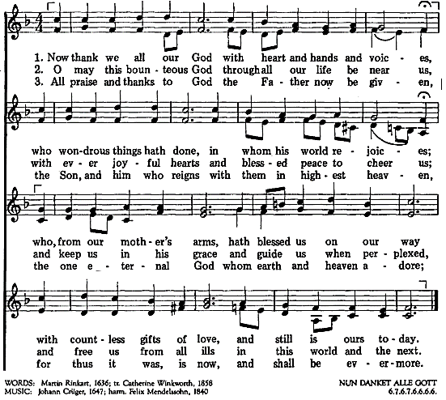

used with permission OCP LicenSing Online #612305

Antiphon: “Get excited about your mistakes and thank God for his strength. Fulfillment happens when we fall forward, not backward.” Justin Fatica, You’re Amazing
Psalm 34, 1-6 (Pray alternating sides, please.)
I will extol God at all times; praise will always be on my lips.
I will glory in God; let those who are afflicted hear and rejoice.
Glorify God with me; let us exalt God’s name together.
I sought God who answered me and delivered me from all my fears.
Those who look to God are radiant; their faces are never covered with shame.
Those who are poor call and God hears them; God saves them from all their troubles.
Glory be … As it was …

Give Thanks to God for EVERYTHING (con’t) 2
Reading: What is gratitude? Gratitude is the quality of being thankful, readiness to show
appreciation for and to return kindness. When we intentionally practice gratitude, it allows
us to recognize the good in our lives. Practicing gratitude, on a regular basis, has many benefits. Gratitude can improve your physical health, improve sleep, improve psychological health, increase empathy, reduce aggression, offers deeper social connections, enhances self-esteem and improves mental strength.
For a few moments, let’s focus on those things that cause pain in our lives, recalling all that leads to ingratitude. What have we missed out on? What have we been cheated out of? What happened that just made us gasp, made our hearts ache? (pause)
Now, imagine that with every exhale, you are casting your cares on God (1 Peter 5:7) and exchanging the spirit of heaviness and despair for a garment of praise. (Isaiah 61:3) (pause)
Let’s consciously choose gratitude that feels authentic, by starting with an ingratitude list, naming our pain and giving it to God. Then, rather than ignore what we are really feeling inside, we will be able to truly be grateful.
adapted from writing by Arsenia Tate, St. Margaret of Scotland bulletin, 1-17-21
Sharing: For what in my life am I profoundly grateful?
Prayers of Gratitude (Please, rotate readers for each prayer, please.)
Response: (All reply after each prayer.) We are grateful, O God.
+We are grateful for eyes that can see and ponder, for taste buds that know the sensuous pleasures of eating and drinking, for hands that hold and touch and feel, for ears that can delight in music and the voice of a friend, for a nose that can smell the aroma of freshly-baked cookies and another’s cologne and can also breathe the air which gives us life …
+We are grateful for the treasure of loved ones whose hearts of openness and acceptance have encouraged us to be who we are. We are grateful for their faithfulness, for standing by us when our weaknesses stood out glaringly, for being there when we were most in need and for delighting with us in our good days and joyful seasons …
+We are grateful for the eyes of faith, for believing in the presence of God, giving us hope in our darkest days, encouraging us to listen to our spirit’s hunger and reminding us to trust the blessings of God’s presence in our most empty days …
+We are grateful for the ongoing process of becoming who we are, for the seasons within, for the great adventure of life that challenges and comforts us at the same time …
+We are grateful for the messengers of God -- people, events, written or spoken words – that came to us at just the right time and helped us to grow …
+We are grateful for God’s calling to minister as Ladies of Charity, grateful that we can be of service and use our talents, that we have the means and the ability to hear the cries of those living in poverty and to respond out of our abundance …
+We are grateful for the miracle of life, for our green earth, our amazing history. We are grateful that we still have time to decide the fate of our world by our choices and our actions, grateful that we have it within our power to bring a divided world to peace …
ALL: Faithful God, you lavish us with love. Help us remember that you are comfort on our difficult, pain-filled days. On our joyful days, fill us with a deep sense of thanksgiving. Allow us to share your graciousness with all those who need a touch of generous love. We pray this in Jesus and through your Spirit, Amen. adapted from Joyce Rupp, May I Have This Dance?, pages 151-52
prepared for Ladies of Charity by Sr. Carol Schumer, D.C.

