Vincent’s Questions: Prayer Service

Call to Prayer Sometimes we wish we were among those who walked with Jesus 2000 years ago. Pope Francis boldly attests, “even today we do walk with them.” When believers want to see Jesus in person and touch him with their hands, they know where to turn. “The poor are a sacrament of Christ; they represent his person and point to him.”

adapted from https://johnfreund.net/2021/11/15/pope-francis-challenged-me-to-think-more-deeply/
Leader: O God, open our lips
ALL: and our mouths will proclaim your praise.
Leader: Glory be to the Father and to the Son and to the Holy Spirit,
ALL: as it was in the beginning so now and ever shall be, world without end. Amen.
Hymn “The Cry of the Poor” verses 1, 3
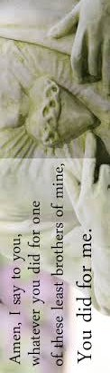
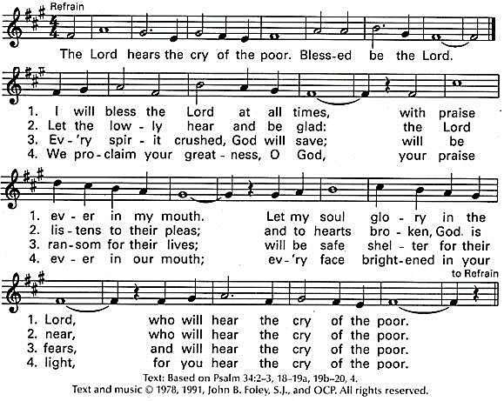
Antiphon (ALL) “How beautiful it is to see poor people if we consider them in God and with the esteem in which Jesus Christ held them.” (St. Vincent, Coste volume 11, #19, page 26)
Psalm 41: 1-2, 4, 10-13 (Alternate sides, please.)
Blessed is the one who considers the poor. In the day of trouble, God will deliver you.
God protects you and keeps you alive. You are called blessed.
As for me, I said, “O God, be gracious to me and raise me up. By this, I know that you delight in me.
You have upheld me because of my integrity and set me in your presence forever.
Blessed be our God from everlasting to everlasting!
Amen and Amen.
Glory be to the Father and to the Son and to the Holy Spirit,
As it was in the beginning so now and ever shall be, world without end. Amen.
adapted from the English Standard Version
Vincent’s Questions: Prayer Service (con’t) 2
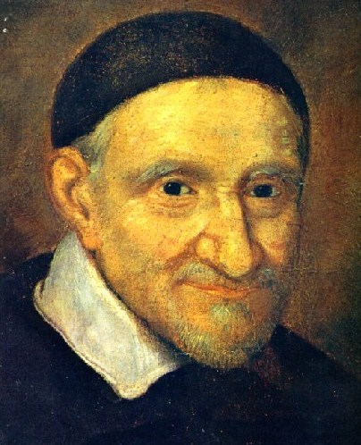
Reading St. Vincent implicitly always asked two questions:
- What is wrong with this picture I see?
- What is the next thing that needs to be done?
Vincent saw there was a family in need of food. After requesting his parishioners
to help he discovered they had too much for one day and not enough for the week.
Why must this family have too much one day and not enough the next?
Vincent asked himself, “Why can’t we organize this better? What can be done?”
And so was born the Ladies of Charity, the oldest functioning organization of laywomen in the church.
Looking at the questions Vincent asked himself offers us some inspiration for changing our ways of thinking. If we look closely at all the heroes and heroines in the Vincentian Family, we recognize a pattern. They all asked same two questions: Why? What can be done?
adapted from https://johnfreund.net/2021/10/13/what-questions-get-you-thinking/

Reflection and Sharing
When could I ask, “What is wrong with this picture?”
and “What might I/we do?”

Response (ALL) The mystery of those living in poverty is that they are Jesus and what we do for them we do for Him. adapted from Dorothy Day, On Pilgrimage: The Sixties, ed. R Ellsberg (Orbis Books: 2021), 113

Intercessions (Leader) “Don’t think that it’s a small thing to be devoted to the relief of those in distress.” St. Vincent, Coste volume 11, #13, page 17
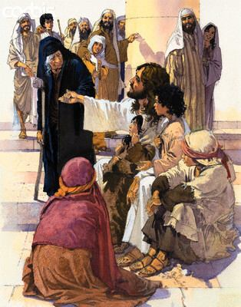

Response (ALL) Jesus, let us serve others for love of You.

+ that our prayers may be beneficial for our service of others,

especially persons living in poverty …

+ that we may be alert to other people and anticipate their needs

with our support and assistance …

+ that we may accept and respect all who come to us for help …

+ that we may see Jesus in the people with whom we work and

those we serve …

(Additional intercessions are welcome.)
Our Father
Prayer (ALL) In these uncertain and confusing times, I place my confidence in you, O God. Guide the work of my hands so it may be values-driven and benefit those I serve. According to St. Vincent, “To serve the poor is to serve Jesus Christ … how true this is! You serve Jesus Christ in the person of the poor. This is as true as that we are here present.” O God, may I see your image in every person I encounter today and in this coming year. We ask this in the name of Jesus through your Spirit. Amen. Vincentian calendar Daily Reflections, 10-29-21, 11/9/21

++++++++++++++++++++++++++++++++++++
Prayer Texts
Matthew 25: 34 – 40 “As often as you did it for one of my least, you did it for me.”
I Corinthians 1: 27 – 29 “God chose … the weak … so no boasting before God.”

prepared for the Ladies of Charity by Sr. Carol Schumer, D.C.

