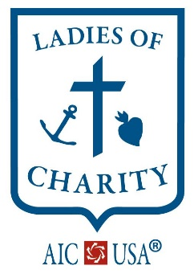
LADIES OF CHARITY
OF THE UNITED STATES OF AMERICA ®
Providing Vincentian Leadership to Women Acting Together Against All Forms of Poverty

Association Due’s Roster 2023
When completing Association Dues forms, please send a copy of your current roster to National Office with your completed dues paperwork.
If you have your roster on any type of file that can be emailed, sending a copy of your roster electronically to the National Office email will be accepted and greatly appreciated for quickly updating the database file.
For large Associations having an electronic file emailed to National is very helpful and will ensure the database is updated more efficiently in a timely manner.
This file does not have to be in any specific format as we are able to copy/paste information for the database, so please do not worry about navigating an Excel file unless you have one already or have access to Excel and can easily manage it.
If you would like to receive a current copy of your Associations roster the database has for your Association, that can be requested via email to National. Requesting a current roster for you to use as reference to make changes could help with changes and additions.
Please specify Leadership roles within your Association so we can update the website directory for Leadership within each Association.
If there are any questions, please contact National Office.
TO EMAIL YOUR ASSOCIATION ROSTER, PLEASE ATTACH FILE TO YOUR EMAIL AND SENDTO NATIONAL OFFICE.
Office@ladiesofcharity.us

