Mary, Our Mother and Role Model
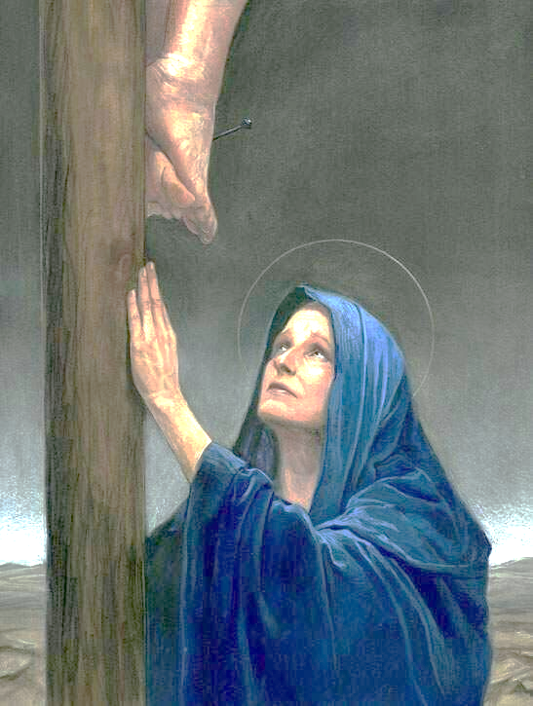

Call to Prayer: Mary was the silent witness to the events of Jesus’s Passion and Resurrection. She stood beside the Cross. She did not fold in the face of pain; her faith made her strong. In the broken heart of the Mother, the flame of hope was kept ever burning. Let us ask her to help us, too, to fully accept the Easter proclamation of the Resurrection, so as to embody it in the reality of our daily lives. adapted from Pope Francis

ALL: In the name of the Father and of the Son and of the Holy Spirit. Amen.

Reading: What does a mother do? A mother is the emotional backbone of the family, of the community. She teaches her “children” how to be functioning, mature adults, Christians. She is the one who supports dreams when no one else will. Her smile can make the day a whole lot better no matter how bad it is.
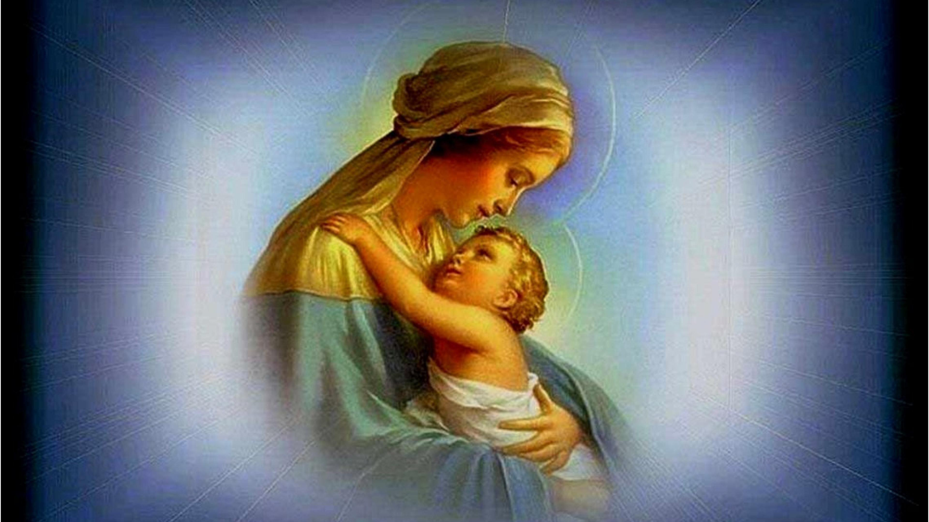

Pause and Reflection: Who has “mothered” me?

Who am I called to “mother”?

Reading: How did Mary learn to be the Mother of God? In her day there was no internet or Alexa. The angel did not leave a user’s manual. In addition, she was tasked not only with being the mother of God. At the foot of her son’s cross, the most trying of times, she was told that her child-rearing days would never end. She is our mother, too.

How did Mary make sense of all this? The Gospel tells us, Mary “kept all these things, pondering them in her heart.” (Luke 2:19) Let us learn from the Mother of God how to have that same attitude, to keep and to ponder. Often, our expectations clash painfully with reality. That can also happen in the life of faith when the joy of the Gospel is put to the test in troubling situations. How do we surmount this clash between the ideal and the real? By doing exactly what Mary did; by keeping and pondering.
Mary goes beyond the pain and the problems and sees a bigger picture, one of care and love that gives birth to new hope.
Pause for Reflection: Do I “ponder and keep” the good and the bad in my life?
Can I see the bigger picture in times of conflict and division?
Reading: "My soul proclaims the greatness of the Lord." In the Magnificat, Mary announces that her whole being is ordered to the glorification of God. Her ego wants nothing for itself; it wants only to be an occasion for giving honor to God. Yet since God needs nothing, whatever glory Mary gives, returns to her benefit, so that she is magnified in the very act of magnifying God. In giving herself away fully to God, Mary becomes a superabundant source of life; indeed, she becomes pregnant with God.
This odd and wonderful rhythm of magnifying and being magnified is the key to understanding everything about Mary, from her divine motherhood to her Assumption and Immaculate Conception, to her mission in the life of the Church.
Reflection and Sharing: How is Mary our model of discipleship?
adapted from Vincentian Mindwalk, John Freund, CM, 2/14/22
https://johnfreund.net/2022/02/14/lessons-mary-learned-and-teaches/

Mary, Our Mother and Role Model (con’t) 2
Reading: When Elizabeth blessed Mary at the Visitation, Mary’s spontaneous response was her “Magnificat.” Surely, Mary sang this song of praise regularly and often heard it refraining in her head. Let us join her in this hymn of glory to God.
Hymn Response: “Magnificat” Bernadette Farrell all verses
(Optional Crowning of Mary, between verse 1 and 2.)
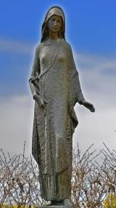
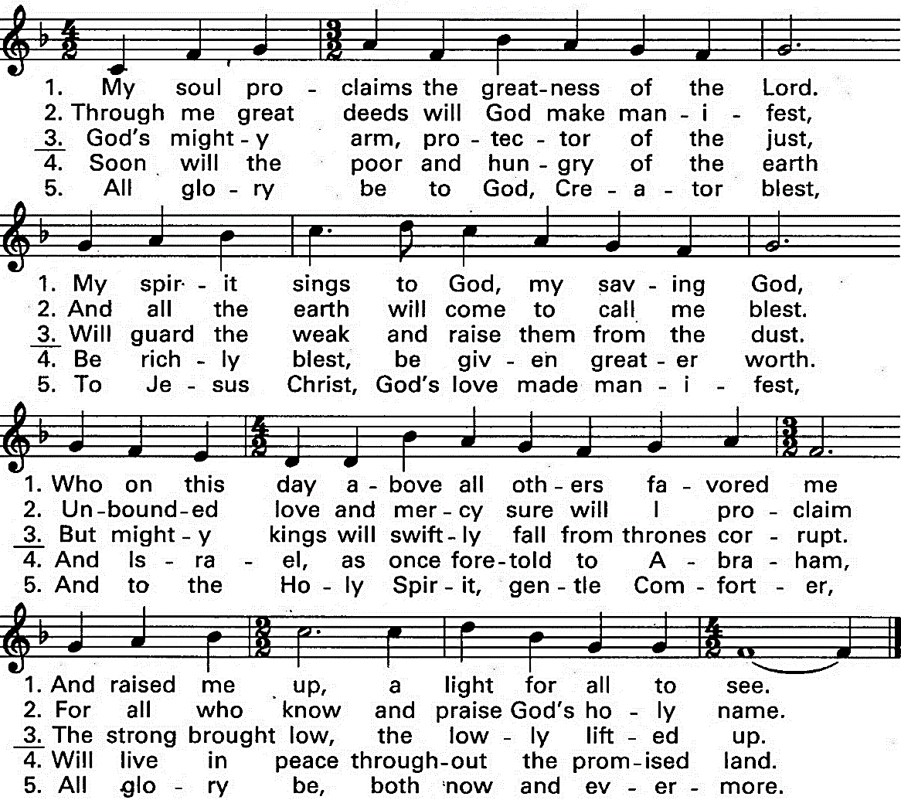
Intercessions
Leader: Let us pray to God who invited Mary to accompany Jesus in saving all of us.
Response ALL: O God, bless us through Mary.
+that we may follow the example of Mary by accepting our current situations, keeping and
pondering them in our hearts, we pray …
+that we may be strengthened to adopt the attitude of Mary who walked with Jesus untiringly
on his earthly journey, we pray …
+that we may share in the joy that filled Mary in God’s choice of her and us, we pray…
+that we may look to Mary as our mother, our model and our queen, we pray …
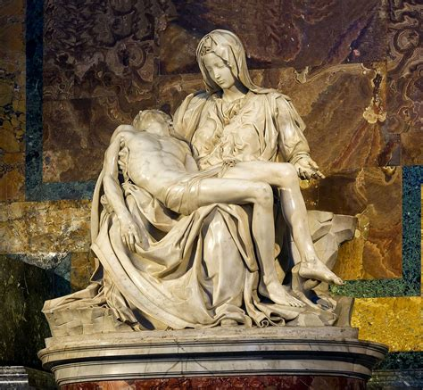
Closing Prayer ALL: Hail Mary …

++++++++++++++++++++++++++++++++++++++++
Prayer Texts
Luke 2: 19 “Mary treasured … pondering …” (English Standard Version)
John 19: 25-27 “Woman, behold your son!” (English Standard Version)
prepared for the Ladies of Charity by Sr. Carol Schumer, D.C.

