At the Cross with Mary and St. Louise – Holy Week, 2023

Call to Prayer Leader: “Let us take the first step in following [Jesus] which is to exclaim, ‘l desire … to follow You to the foot of Your Cross… There, I shall … be open to Your great love.’”
Response ALL: “My Lord, we are at the foot of the Cross where we see You hanging so that we may be drawn to You as You promised.” St. Louise Spiritual Writings, A.27 p. 828, 829

Hymn “At the Cross” verses 1-3

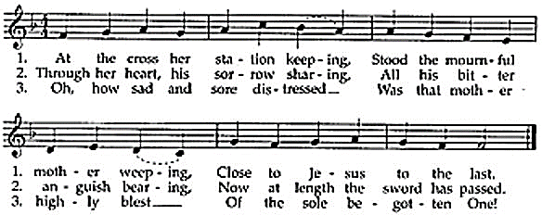
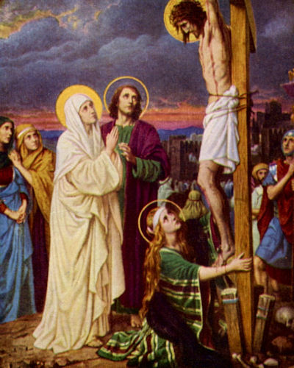

Reading 1 Every Mass is the Last Supper. Every celebration of the Eucharist is a doorway. By entering this portal, we believe that we are standing at the foot of the cross on that first Good Friday, that we are standing at that empty tomb on that first Easter Sunday, that we are face-to-face, heart-to-heart, immediately and directly in contact with the God who loved us so much that he died for us while we were still sinners. (Romans 5, 8 NIV).
Reading 2 “I reflected on the greatness of the Blessed Virgin as Mother of the Son of God … [and] congratulated Mary on her excellent dignity which unites her to her Son in the perpetual sacrifice of the Cross, reenacted and offered on our altars.” St. Louise Spiritual Writings, M.5B p. 831
Hymn “At the Cross” verses 4-6
4. Christ above in torment hangs; She beneath beholds the pangs Of her dying, glorious Son.
5. Is there one who would not weep, ‘Whelmed in miseries so deep, Christ’s dear Mother to behold?
6. Can the human heart refrain From partaking in her pain, In that Mother’s pain untold?

Reading 3 Tears represent the heart, the spirit and the soul of a person. To put a lock and key on our emotions is to bury part of our Christlikeness especially when we come to Calvary. We can’t go to the cross with just our head and not our heart. It doesn’t work that way. Calvary is not a mental trip. It’s not an intellectual exercise. It’s not a divine calculation or a cold theological principle. It’s a heart-splitting hour of emotion. Don’t walk away dry-eyed and unstirred. Don’t just straighten your clothing and clear your throat. Don’t descend Calvary cool and collected. Please, pause. Look again. Those are nails in those hands. That’s God on that cross. It’s us who put him there. No wonder we call him the Savior. adapted from Max Lucado, Help Is Here

Hymn “At the Cross” verses 9-10
9. O sweet Mother! Fount of love, Touch my spirit from above, Make my heart with yours accord.
10. Make me feel as you have felt; Make my soul to glow and melt With the love of Christ, my Lord.

At the Cross with Mary and St. Louise (con’t) 2
Reading 4 “If … you are standing on Calvary, rest assured that Jesus Crucified is pleased to see you … and to know that you have enough courage to want to remain there as He did for love of you. You may be certain that you will emerge from there gloriously.” St. Louise Spiritual Writings, L.545B p. 570
Reflection and Sharing
How do I deal with suffering in my life?
When has suffering lead me to deeper compassion for others?
Reading 5 We “… implore you, Mary, to offer to God the way by which He is calling [us], that is, by honoring the Cross and by imitating the Son of God who, in … His Passion, united the human race to God.” paraphrase St. Louise Spiritual Writings, A.39 p.697
Hymn “At the Cross” verses 13-14
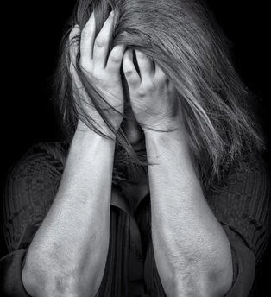
13. Let me mingle tears with thee, Mourning him who mourned for me,
All the days that I might live:
14. By the cross with you to stay, There with you to weep and pray,
This I ask of you to give.
Response Leader: We adore you, O Christ, and we bless you,
ALL: Because by your holy cross, you have redeemed the world.

Intercessions Leader: Mary, mother of Jesus, you stood before the
Cross of your dying son; now we pray to you,
ALL: Be with us, Mary.
Leader: Jesus hung naked on the cross, at the mercy of those
who reviled him, as you watched, Mary;
ALL: Strengthen those who are rejected, abandoned, hated and tortured today.
Leader: Jesus entrusted you into the care of John,
ALL: May God enfold everyone who grieves in the care of family and friends.
Leader: Jesus gave you to John and to us as Mother, Mary,
ALL: Let us look to you for guidance, help and assistance in our times of trial.
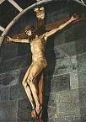
(Spontaneous prayers of intercession are welcome.)
Prayer ALL: Dear Jesus, we honor your Holy Cross in our suffering, after your example. You showed us how to do so by your death and by all the other pains and sufferings which you endured during your life on earth. (paraphrase St. Louise Spiritual Writings, A.20, p. 775) We beg you, dear Jesus Crucified, attach us firmly to your Cross so that we may be closely united to you by your love and that our little sufferings and the little we accomplish may be in, through your love. (paraphrase St. Louise Spiritual Writings, L.46, p. 54)
We pray this through Mary and St. Louise, in your Spirit. Amen.
Leader: God, please, bless us, protect us and bring us to everlasting life.
ALL: Amen. (Sign of the Cross)
In the name of the Father and of the Son and of the Holy Spirit. Amen.

++++++++++++++++++++++++++++++++++++++++++
Prayer Texts
John 19: 25-27 “… ‘Woman, there is your son’ … ‘There is your mother’…”
Philippians 2: 6-11 “ … accepting even death, death on a cross…’
prepared for the Ladies of Charity by Sr. Carol Schumer, D.C., April, 2023

