Becoming Jesus – Lent, 2023
Call to Prayer Leader: “Souls that surrender themselves to Our Lord to do and to suffer all things will be justified by Him and will have the honor and merit of resembling Him.” St. Vincent de Paul, Coste, volume 8, page 233
ALL: In the name of the Father and of the Son and of the Holy Spirit. Amen.
Hymn “I Want to Walk as a Child of the Light” verses 1-2
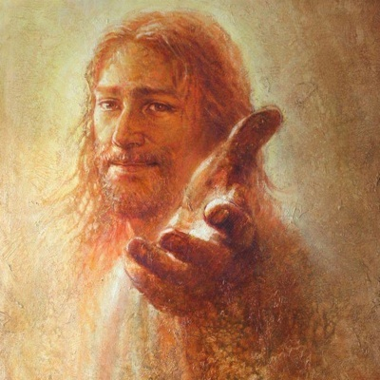
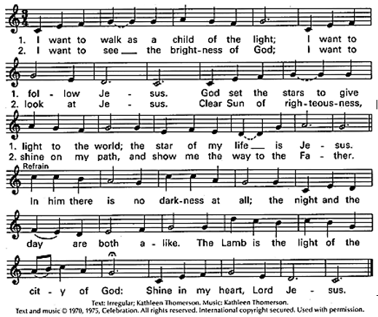
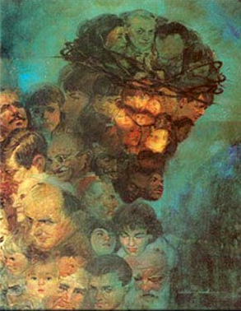
Used with permission LicenSing Online #612305
Conversation with Jesus
Reader (Jesus): “If you were going away for 6 weeks, would you wait until the last minute to plan and prepare?”
ALL (us): “Well, no …”
Reader (Jesus): “If you needed to turn something around in your life, would you decide on the run what you needed to change?”
ALL (us): “There’s got to be a better way …”
Reader (Jesus): “If I offered you a special time to get things right between us and improve our friendship and your outlook on the future, would you take it?”
ALL (us): “You bet I would!”
Reader (Jesus): “Then you need to strategize, commit to meet me daily. Lent is here. It’s my special season of opportunity and growth, for your becoming more like me!”
ALL (us): “Will you help me, Jesus?”
Reader (Jesus): “Sure, we’re in this together!”
ALL (us): “Amen! Let’s do it!”
adopted from Concord Pastor

Becoming Jesus (con’t) 2
Reading All of us are born with the image of God stamped indelibly into the fibers of our being. Despite our personal flaws and brokenness, we all have divine goodness inscribed on our hearts. We don’t acquire it from without as much as we uncover it from within. Unfortunately, our personal experiences and cultural messages tend to have us believe that our worthiness
resides in something external. This is an illusion which obscures the divine goodness that is the birthright of each one of us. We see through a glass dimly. An important part of spiritual practice is “cleaning the lens” to rediscover the deepest truths of who we are, who we are created to be.
adapted Making Room: Soul-Deep Satisfaction through Simple Living, Kyle Kramer

Reflection and Sharing Let us pause to reflect. Then share.

What could I do to remind myself that I am created to incarnate Jesus?

Who needs me to be Jesus in their lives?

Response ALL: We are the light of the world. Let’s let our light shine before others that they may see our good deeds and give glorify to God. (paraphrase of Matthew 5: 14-16)

Intercessions Let us pray to God who sent Jesus as a living example for us.

Response ALL: Jesus, let us strive to become more like You.

+ Send Your Spirit to free us to become Your presence in our

world, we pray …

+ Enlighten our minds to know and strengthen our wills to

follow Your example, we pray …

+ Inflame our hearts with Your love as we share Your goodness

with all those we touch, we pray …

+ Let us see You in the people with whom we live and work,

in those we serve, we pray …

(Additional intercessions are welcome.)

Our Father

Closing Prayer ALL: All gracious God, science says human beings need four basic elements to survive, i.e., water, air, food and light. The Bible tells us that Jesus is the Living Water, the Breath of Life, the Bread of Life and the Light of the World. Science is correct; we need Jesus to live and our world needs us to incarnate Jesus, to be His Body on earth. Continue to transform us into His image so all that comes forth from us is Jesus. We pray this in His name, in union with the Holy Spirit, one God for ever and ever. Amen.
Leader: Jesus, be us; let us be you! ALL: Amen.
++++++++++++++++++++++++++++++++++++++++++++
Prayer Texts:
1Thessalonians 3: 12 “… make your love overflow …”
1 John 3:2 “… we are God’s children … we shall be like him…”
prepared for the Ladies of Charity by Sr. Carol Schumer, D.C., March, 2023

