New Year Manifestation
Call to Prayer: “I ask Our Lord that this new year may be a happy one for you … and be followed by many other similar ones that will lead you to God….” (Coste, Vincent, volume 7, # 2507. 1/11/1658, page 58)
Hymn: Songs of Thankfulness and Praise verses 1, 4
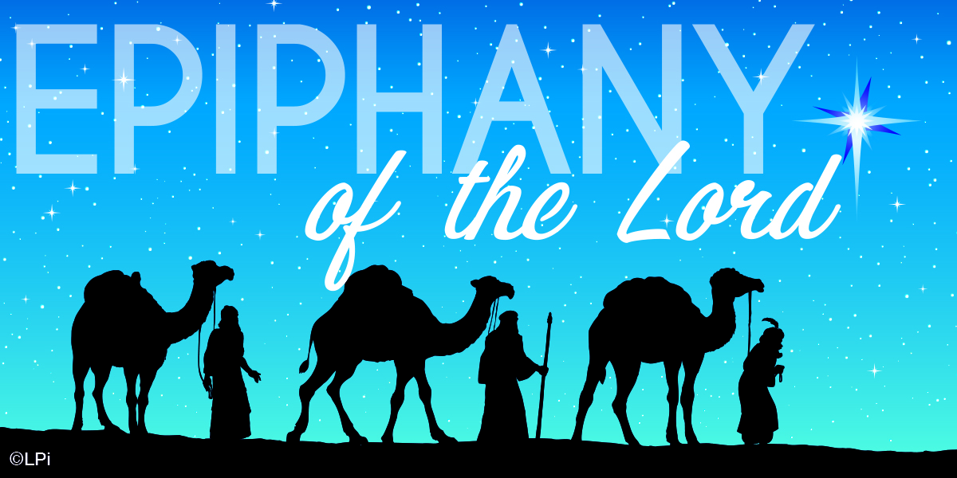
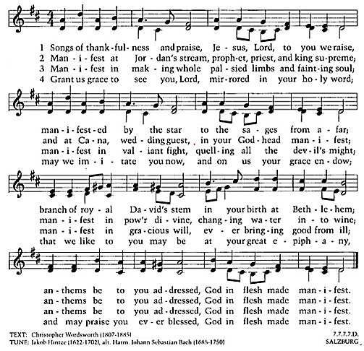
Reading: We don't know much about the Magi in Matthew's gospel, but we do know that following them is a long line of wise women and men who seek the One who saves us. A painting by Janet McKenzie (see link at right) portrays women from around the world gathered with Mary, the mother of Jesus. Its powerful, protective and tender manifestation of a mother and child, embraced and nurtured by a loving community shows a global inclusiveness proclaiming anew: Christ for all people. God's favor extends to all! That, of course, is the message of Epiphany. (Concord Pastor, posted January 2021)
Response: Leader: The Son of God has appeared
among us.
All: The Son of God has appeared among us.
Come, let us adore Him.

Link to the painting
Epiphany
by Janet McKenzie
janetmckenzie.com/lgepiphany.gif

New Year Manifestation (con’t) 2

Reading: The Queens Came Late
The Queens came late, but the Queens were there
with gifts in their hands and crowns in their hair.
They'd come, these three, like the Kings, from far,
following, yes, that guiding star.
They'd left their ladles, linens, looms,
their children playing in nursery rooms,
And told their sitters, "Take charge, for this
is a marvelous sight, we must not miss!"
The Queens came late, but not too late to see the animals small and great,
Feathered and furred, domestic and wild, gathered to gaze at a mother and child.
And rather than frankincense and myrrh, and gold for the babe, they brought for her
Who held him, a homespun gown of blue and chicken soup, with noodles, too,
And a lingering, lasting, cradle-song. The Queens came late and stayed not long,
For their thoughts already were straining far, past manger and mother and guiding star
And a child aglow as a morning sun, toward home and children and chores undone.
Norma Farber in When It Snowed That Night
Response ALL: The Kings and Queens worshipped the Author of life in the crib.
Lead by a star, they saw the glory of God manifested in a baby.

Reflection and Sharing
When and where have I seen God manifested?
Do I ever see God manifested in myself, in my family, in persons who are poor?
Response ALL: Glory be to the Father and to the Son and to the Holy Spirit.
As it was in the beginning, is now and ever shall be, world without end. Amen.
Intercessions:
Leader: O God, You guided the travelers from the East to Jesus. We, too, come before You, praying,
ALL: Manifest Jesus to us, O God.
Leader: May we, like the royal visitors from the East, offer You our worship and praise
ALL: as we commit our daily activities and experiences to Your glory.
Leader: You manifested Your deep love for us through Jesus;
ALL: may we be open to the many ways you show Yourself to us each day.
Leader: May we discover Jesus
ALL: in the presence of our families, friends and people we accompany.
(Add your own petitions, please.)
Prayer ALL: By the light of a star, O God, you guided the nations to Jesus, the light of the world. May we seek the face of Jesus in those around us. Let us open ourselves to Your gift of love and then share it with all who yearn for Your presence. We ask this through Jesus, Your Son, our brother, in Your Holy Spirit. Amen.

+++++++++++++++++++++++++++++++++++++++
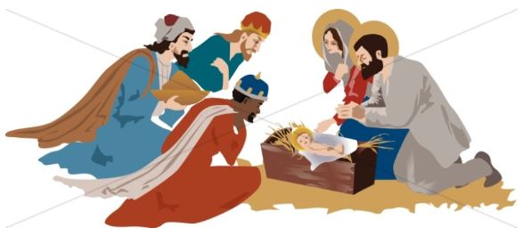

Prayer Texts
1 John 6:19 “… we love God because he first loved us.”
Matthew 2: 10-12 ”… they saw the child with Mary his mother.”
prepared for the Ladies of Charity by Sr. Carol Schumer, D.C.

