Charity
Call to Prayer “May your loving heart belong only to Jesus Christ, fully and always, in time and in eternity.” St. Vincent, Coste, volume 6, #2176, page 161, 1656

Leader: May the God who created out of love, the God who lived love and the God who inflames our hearts to love, bless us.
ALL: Entering this time of prayer, we rest in God’s love so that we may love well.
Leader: May we believe God helps us to break through and love others especially persons who are living in poverty.
ALL: The love of Jesus urges us to be open, to break through and to love.
Hymn “Where Charity and Love Prevail” (Benoit) verses 1-2, 5
1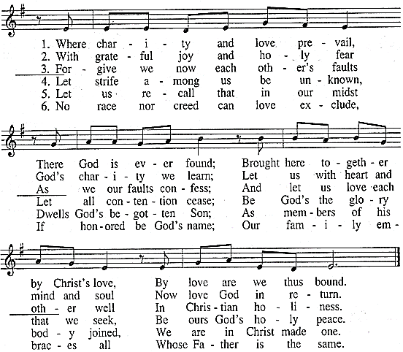
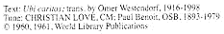
Thoughts to Ponder (Rotate the reading of the following, pausing briefly between each.)
+“What can shut us out from the love of [God] who will ever dwell within us through love?” St. Elizabeth Ann Seton (Daily Vincentian Calendar, July 16)
+“Love is as strong as death and God alone deserves to be loved and served.”
St. Vincent de Paul, Coste, volume 6, #2174, page 157, December,1656
Charity (con’t) 2
+“I ask the Holy Spirit, who is nothing if not love, who is the sacred bond of the Father and the Son, to be the soul … and the gentleness of your words and actions.” St. Vincent de Paul, Coste, volume 8, #3105, page 318, March,1660
+“All you have is the name of Charity… strive always to have the robe of Charity of which the signs are love of God, love of our neighbor and among [ourselves.]”
Coste, volume 10, #93, page 379, March, 1658
+“Give yourselves to God, …treat every individual with gentleness and respect, always using kind words and requests .”
St. Vincent de Paul, Coste, volume 8, #3027, page 202, November,1659
+“Do whatever God asks you and remain at peace; above all, love and support one another in Our Lord.” Coste, volume 7, #2646, page 256, August, 1658
+“Love one another… esteem and respect one another as daughters of Our Lord made in the image of God; bear with one another’s little weaknesses as you would wish to be borne with; lastly, comply graciously with one another’s wishes and never argue.” Coste, volume 7, #2768, page 449, January, 1658
+“You have to love... It is the reason you are here on earth. You are here to risk your heart.” Louise Erdrich, The Painted Drum
+“If there is any immortality to be had among us human beings, it is certainly only in the love we leave behind.” Leo Buscaglia, the thing about Fathers, October 3
Reflection and Sharing
Which quote speaks to my current experience?
How is God inviting me to become more loving?
Response “Where Charity and Love Prevail” (Benoit) verse 5
Leader: “Charity is like a flame which soars aloft. When present in a soul, charity raises it aloft to God and draws God to it in such a way that if you could see the beauty of it, you would fall in love with it and be transported with astonishment.” St. Vincent de Paul
ALL: Lord, cause charity to so inflame our hearts that everything we do will be an act of love of you. Amen. (adapted Daily Vincentian Calendar, June 2)
Leader: God, bless us, protect us and fill us with love of you and others.
ALL: Amen.
++++++++++++++++++++++
Prayer Texts
1 John 4: 8-13 “God is love … the same love for one another.”
John 13: 34-35 “I give you a new commandment ... my diciples … love ...”

prepared for the Ladies of Charity by Sr. Carol Schumer, D.C., February

