Advent Prayer – December
Call to Prayer Leader: May we be filled with the wonder of Mary, the obedience of Joseph, the joy of the angels, the eagerness of the shepherds, the determination of the magi and the peace of the Christ child. (Pause briefly in silence.)
ALL: Almighty God, Father, Son and Holy Spirit, bless us now and forever. Amen.
Hymn “Come, Thou Long Expected Jesus” (all verses)
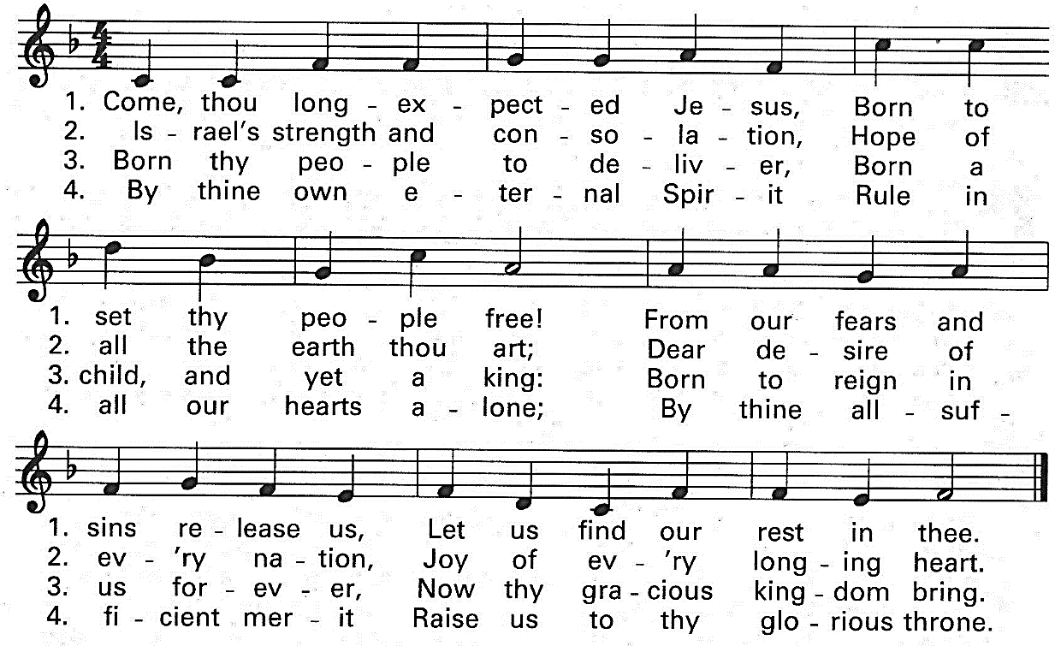
Used with permission
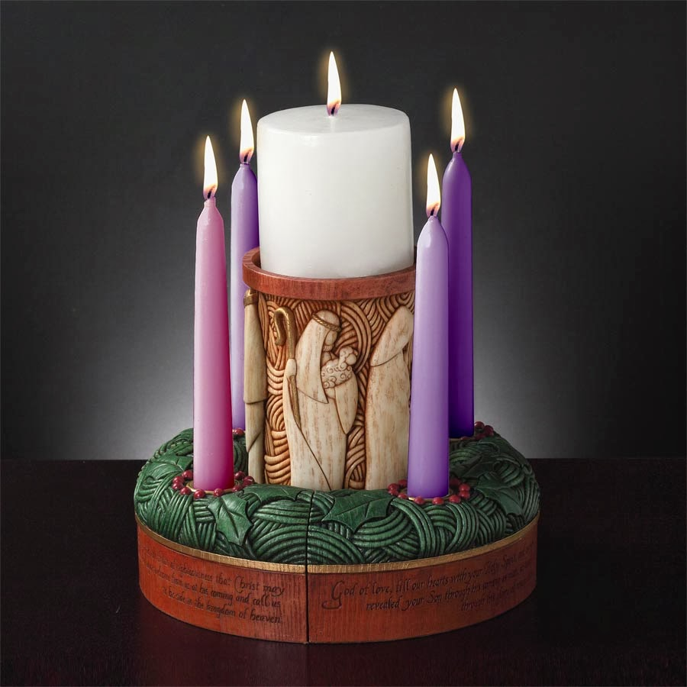
An Advent Prayer (Alternate sides, please.)
I. Come, long-expected Jesus. Excite in us a wonder at the wisdom and power of Your Father and ours. Receive our prayer as part of our service to You as You enlists us in God's work for justice.
2. Come, long-expected Jesus. Excite in us a hunger for peace, peace in the world, peace in our country, in our homes, peace within.
1. Come, long-expected Jesus. Excite in us a joy responsive to our Father's joy. We seek God’s will so we can serve persons who are poor with gladness and love.
2. Come, long-expected Jesus. Excite in us the joy, love and peace it is right to bring to Your manger. Fill us with reverence for You, the Word made Flesh, with a heart-felt gratitude for the life You began there and determined resolution to serve You in those who are disadvantaged and needy.
ALL: We pray this in Your name, Jesus, whose advent we greet. Amen.
Reading (John 1:14) “The Word became flesh and made his dwelling among us and we saw his glory, the glory as of the Father's only Son, full of grace and truth.”
Reflection We are gifted with glimpses of God's glory, grace and truth. In our experiences of love, we see the "Word made flesh" with our own eyes. Often these experiences go deeper than words can convey, but we strive to use words anyway to capture the essence of who God is and what it means for us to know him. Share a recent glimpse of God’s glory.
Prayer ALL: Jesus, Word made flesh, thank You for revealing God's glory to us. Grant us the grace to freely share our experience of you with others especially during Advent. Amen.
prepared for the Ladies of Charity by Sr. Carol Schumer, D.C., December

