Communion of Saints
Call to Prayer Leader: November is the month when we remember and pray for our loved ones who have died As we do so, experience tells us there’s a thin veil between heaven and earth. The spirits of these passed loved ones are still very much with us. Most of us, who’ve lost someone significant, have stories of undeniable “SIGNS” following their deaths.

ALL: In the name of the Father and of the Son and of the Holy Spirit. Amen.

Reading A reading from the letter to the Hebrews, chapter 12, verses 22-24, “… you have drawn near to … the city of the living God, the heavenly Jerusalem, to myriads of angels …, to the assembly of the firstborn who are enrolled in heaven, to God, the Judge of all, to the spirits of righteous people, made perfect, and to Jesus …” The Word of the Lord.
ALL: Thanks be to God.

Hymn “By All Your Saints Still Striving” verses 1, 3
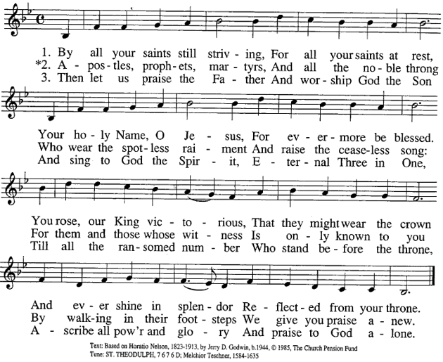

Communion of Saints (con’t) 2
Reading 1 “When I was 23 years old, in the space of just three months, both my parents died. Their leaving left a gaping hole. After a time that void began to fill and my sadness began to dissipate. It didn’t happen quickly. It took a couple of years, but eventually things changed. What was once a cold absence now became a warm presence. My mother and father came back to me in a new way. I began to feel their presence as a warm nurturing spirit, as a permanent sustaining love. They were now present in a deeper way. Their love and their presence began to flow into my life.
Jesus prepares us for this reality with these words, “It is better for you that I go away. If not
nIo2005
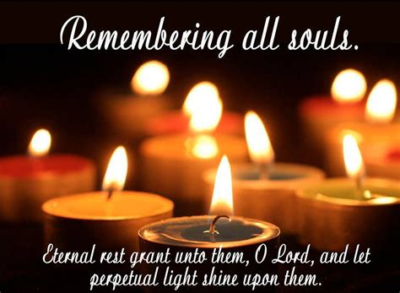
go away, I cannot send you the spirit. You will grieve now, but later you will rejoice.” (John 16:7)
Ron Rolheiser, 5/8/05
Reading 2 “[All Souls Day] reminds us that those we pray for are in a state of purgation (not punishment.) They are waiting, as the Catechism puts it, ‘to achieve the holiness necessary to enter the joy of heaven.’ Some years ago, when pressed by a group of teenagers to explain purgatory, I simply said to a girl sitting in the first row, ‘I can see that you are really someone special.’ She blushed, just as I had anticipated. Then I said, ‘We all blush in such moments because deep within us have dark doubts that we are lovable and good. Purgatory is about God trying to convince us that he loves us, that we are lovable thus purifying us of the darkness and doubts so that we can look into (God’s) face and not blush.’ Let us pray in a way that expresses what we believe and reminds us of who we are.”
Cardinal Blase Cupich, Give Us This Day, November 2014, page 33
Reflection and Sharing
Remember someone you love who has died
and a time after their death when you felt close to him/her.
What was the sign of his/her presence?

Response ALL: “The souls of the just are in the hands of God … They seemed, in the view of the foolish, to be dead … But they are in peace.” (Wisdom 3: 1-3)

Words of Vincent to Louise and us Leader: “I beg you to honor the interior state …in which the saints, indeed even the Saint of saints, found themselves … and the closer union they enjoyed with God.” Coste, volume 1, #106, between 1632 and 1636 page 157

Prayer ALL: Almighty ever-living God, by whose gift we venerate in one celebration the merits of all the Saints and saints, bestow on us, we pray, through their prayers, an abundance of grace for which we earnestly long, through Jesus, your Son and the Spirit, God, forever and ever. Amen.
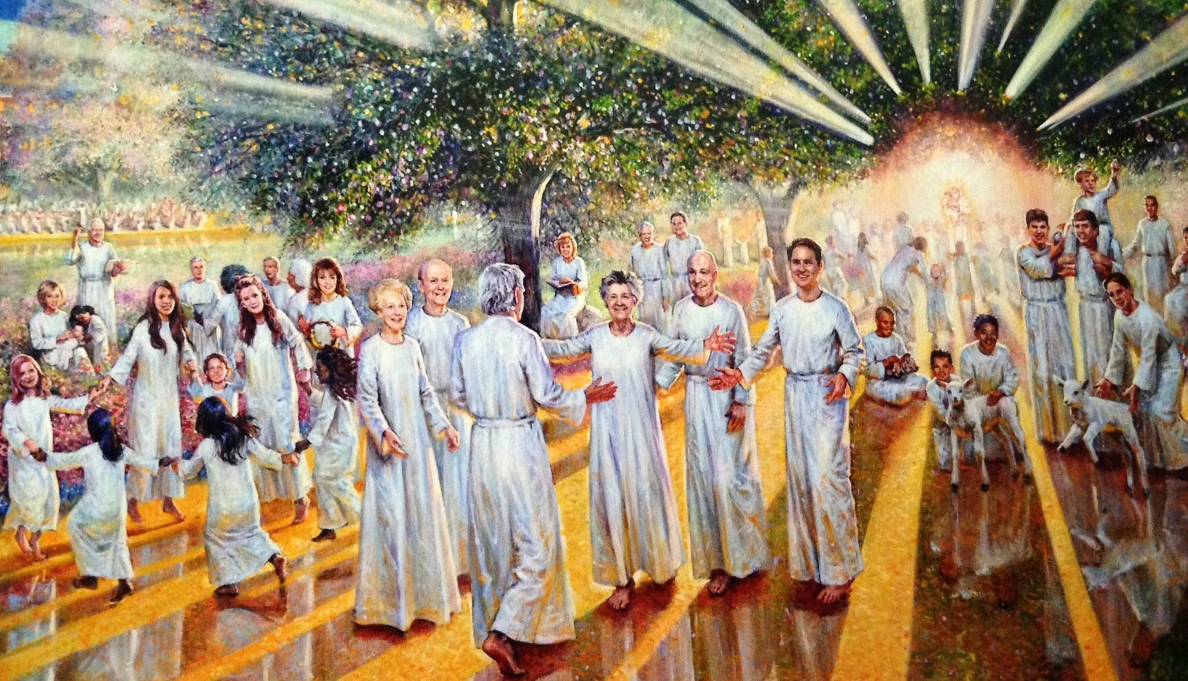

Prayer Texts
Wisdom 3: 5-7 “… they shall shine…”
Revelation 7: 9-10 “I saw a huge crowd …”

prepared for the Ladies of Charity by Sr. Carol Schumer, D.C.

