Peace is My Gift to You
Call to Prayer: “Peace I leave with you; my peace I give you. I do not give to you as the world gives. Do not let your hearts be troubled and do not be afraid.” John 14: 27 NIV
Leader: O God, come to our assistance
ALL: O Lord, make haste to help us.
Leader: Glory be to the Father and to the Son and to the Holy Spirit,
ALL: As it was in the beginning, is now and
ever shall be world without end. Amen.

Psalm 4 (Pray in alternating sides, please.) (adapted from New International Version)
1 Answer me when I call to you, my righteous God.
Give me relief from my distress;
have mercy on me and hear my prayer.
2 How long will you people turn my glory into shame?
How long will you love delusions and seek false gods?
1 Know that God has set apart faithful servants;
God hears when I call out.
2 Tremble and do not sin; search your hearts and be silent.
1 Offer the sacrifices of those who are righteous and
trust in the God.
2 O God, many are asking, “Who will bring us prosperity?”
Let the light of your face shine on us.
1 Fill our hearts with joy when grain and new wine abound.
2 In peace, we will lie down and sleep, for you alone,
O God, let us dwell in safety.
- Glory be …

- As it was …

Quotes from St. Vincent (Rotate these readings with a slight pause between each.)
According to the world, peace and health are the treasures of life; according to the state in which you are, they are also two sources of good, since they give you the means of serving God and the people better. (Coste Volume 6, page:188)
Let us strive to conform our wills to God’s will and peace of mind will be one of the many great benefits that will result from it. (Coste Volume 6, page 493)
Peace is worth more than all worldly possessions. (Coste Volume 3, page:612)
We must act moderately and tranquilly and always preserve peace of mind and heart.
(Coste Volume 11, page 361)
Personal Reflection and Sharing
Our troubled world needs peace. How am I offering peace to others?
What might I do to make my world more peaceful?

Peace is My Gift to You (con’t) 2
Response “Make Me a Channel of Your Peace” all verses

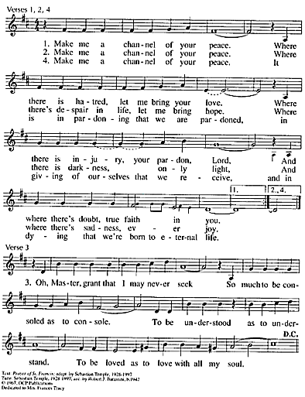

Vincent’s Blessing
Leader: You are God’s and God is yours. Oh! what happiness. (Coste volume 8, page163)
Live always in God and take care of yourself for service. (Coste volume 8, page 191)
ALL: Amen, Amen.
+++++++++++++++++++++++++++++++++++++++++++++++++++++
Prayer Texts
Colossians 3:15 “Let the peace of Christ rule in your hearts.” (NIV)
1 Peter 3:11 “… seek peace and pursue it.” (NIV)
Prepared for the Ladies of Charity by Sr. Carol Schumer, D.C. October

