ROLE of WOMEN in SERVICE
Call to Prayer: “You practice what widows of the primitive Church did, namely, to meet the material needs of the poor as they did, and even [their] spiritual needs …”
(Coste, St. Vincent, volume 13b, Documents Pertaining to the Ladies of Charity, page 381)
Leader: O God, come to our assistance.
ALL: O Lord, make haste to help us.
Leader: Glory be to the Father and to the Son
and to the Holy Spirit,
ALL: As it was in the beginning, is now and
ever shall be world without end. Amen.

Hymn: “The Servant Song,” Richard Gillard
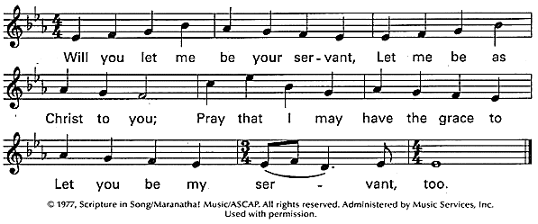

Psalm 67 (Pray, alternating sides.)
+The Beloved is gracious to us and blesses us; the Radiant One shines upon us
that Love’s Way may be followed on the earth, … among all the nations.
+May the people rejoice in You; may all people sing with gratitude to the Beloved.
+Let the nations be glad and give thanks, for You call the people to integrity and justice.
You guide the nations upon the earth.
+May the people rejoice in You; may all people sing with gratitude to the Beloved.
+The earth yields its harvest; the Beloved blesses us.
Yes, the Beloved blesses us; let us abandon ourselves into the Heart of Love.
+May the people rejoice in You; may all people sing with gratitude to the Beloved.
(Nan C. Merrill, Psalms for Praying, page 128)
ALL: Glory be to the Father and to the Son and to the Holy Spirit,
As it was in the beginning, is now and ever shall be world without end. Amen.

ROLE of WOMEN in SERVICE (con’t) 2
Reading from St. Vincent to the first Ladies of Charity: “For eight hundred years or so, women have had no public role in the Church, … however, Providence is turning today to some of you to supply what was lacking to the sick poor of the Hotel-Dieu. They corresponded to God’s plan, and soon after, when others joined the first ones, God established them as the mothers of abandoned children, made them the heads of their hospital and the distributors of alms from Paris for the provinces, principally for those in distress. Those good souls have responded to all that with zeal and firmness, by the grace of God.” (Coste, volume 13b, Documents Pertaining to the Ladies of Charity, page 432)
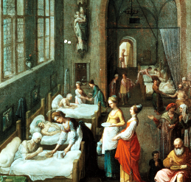

Reflection and Sharing:
How open am I, are we to God’s call to action in our lives?
How is God inviting me/us to serve during this year?

Response: St. Vincent continues (Read, alternating sides.)
+”The works of God have their moment; God’s providence brings them about at that time and neither sooner nor later.” (Coste, Volume 5, page 400)
+“People look upon you as servants of God and workers of the Gospel. I mean good servants and that is why you are esteemed and assisted.” (Coste, Volume 4, page 117)
+“Three can do more than ten when Our Lord puts His hand to things.” (Volume 4, page 122)
+”Put your trust in God’s great goodness and offer yourself frequently to God that He may accomplish His good pleasure in and through you.” (Coste, Volume 7, page 218)

Our Father

Closing Prayer: Leader: St. Vincent prays, “I ask Our Lord to redouble your strength, to sustain you with the essence of His Spirit, to gladden you with the hope of His glory and the success of your work; and to fill the family with peace and confidence in His divine guidance. I ask God to give you a twofold share of His Spirit: the first share to unite you to Him, to act in His holy presence and for love of Him; and the other, for the guidance of the souls entrusted to you. (Coste, Volume 4, page 214, 220)
ALL: Amen.
Blessing: Leader: The Lord bless and keep you. ALL: Amen.
Leader: The Lord make his face shine on you and be gracious to you. ALL: Amen.
Leader: The Lord turn his face toward you and give you peace. ALL: Amen.
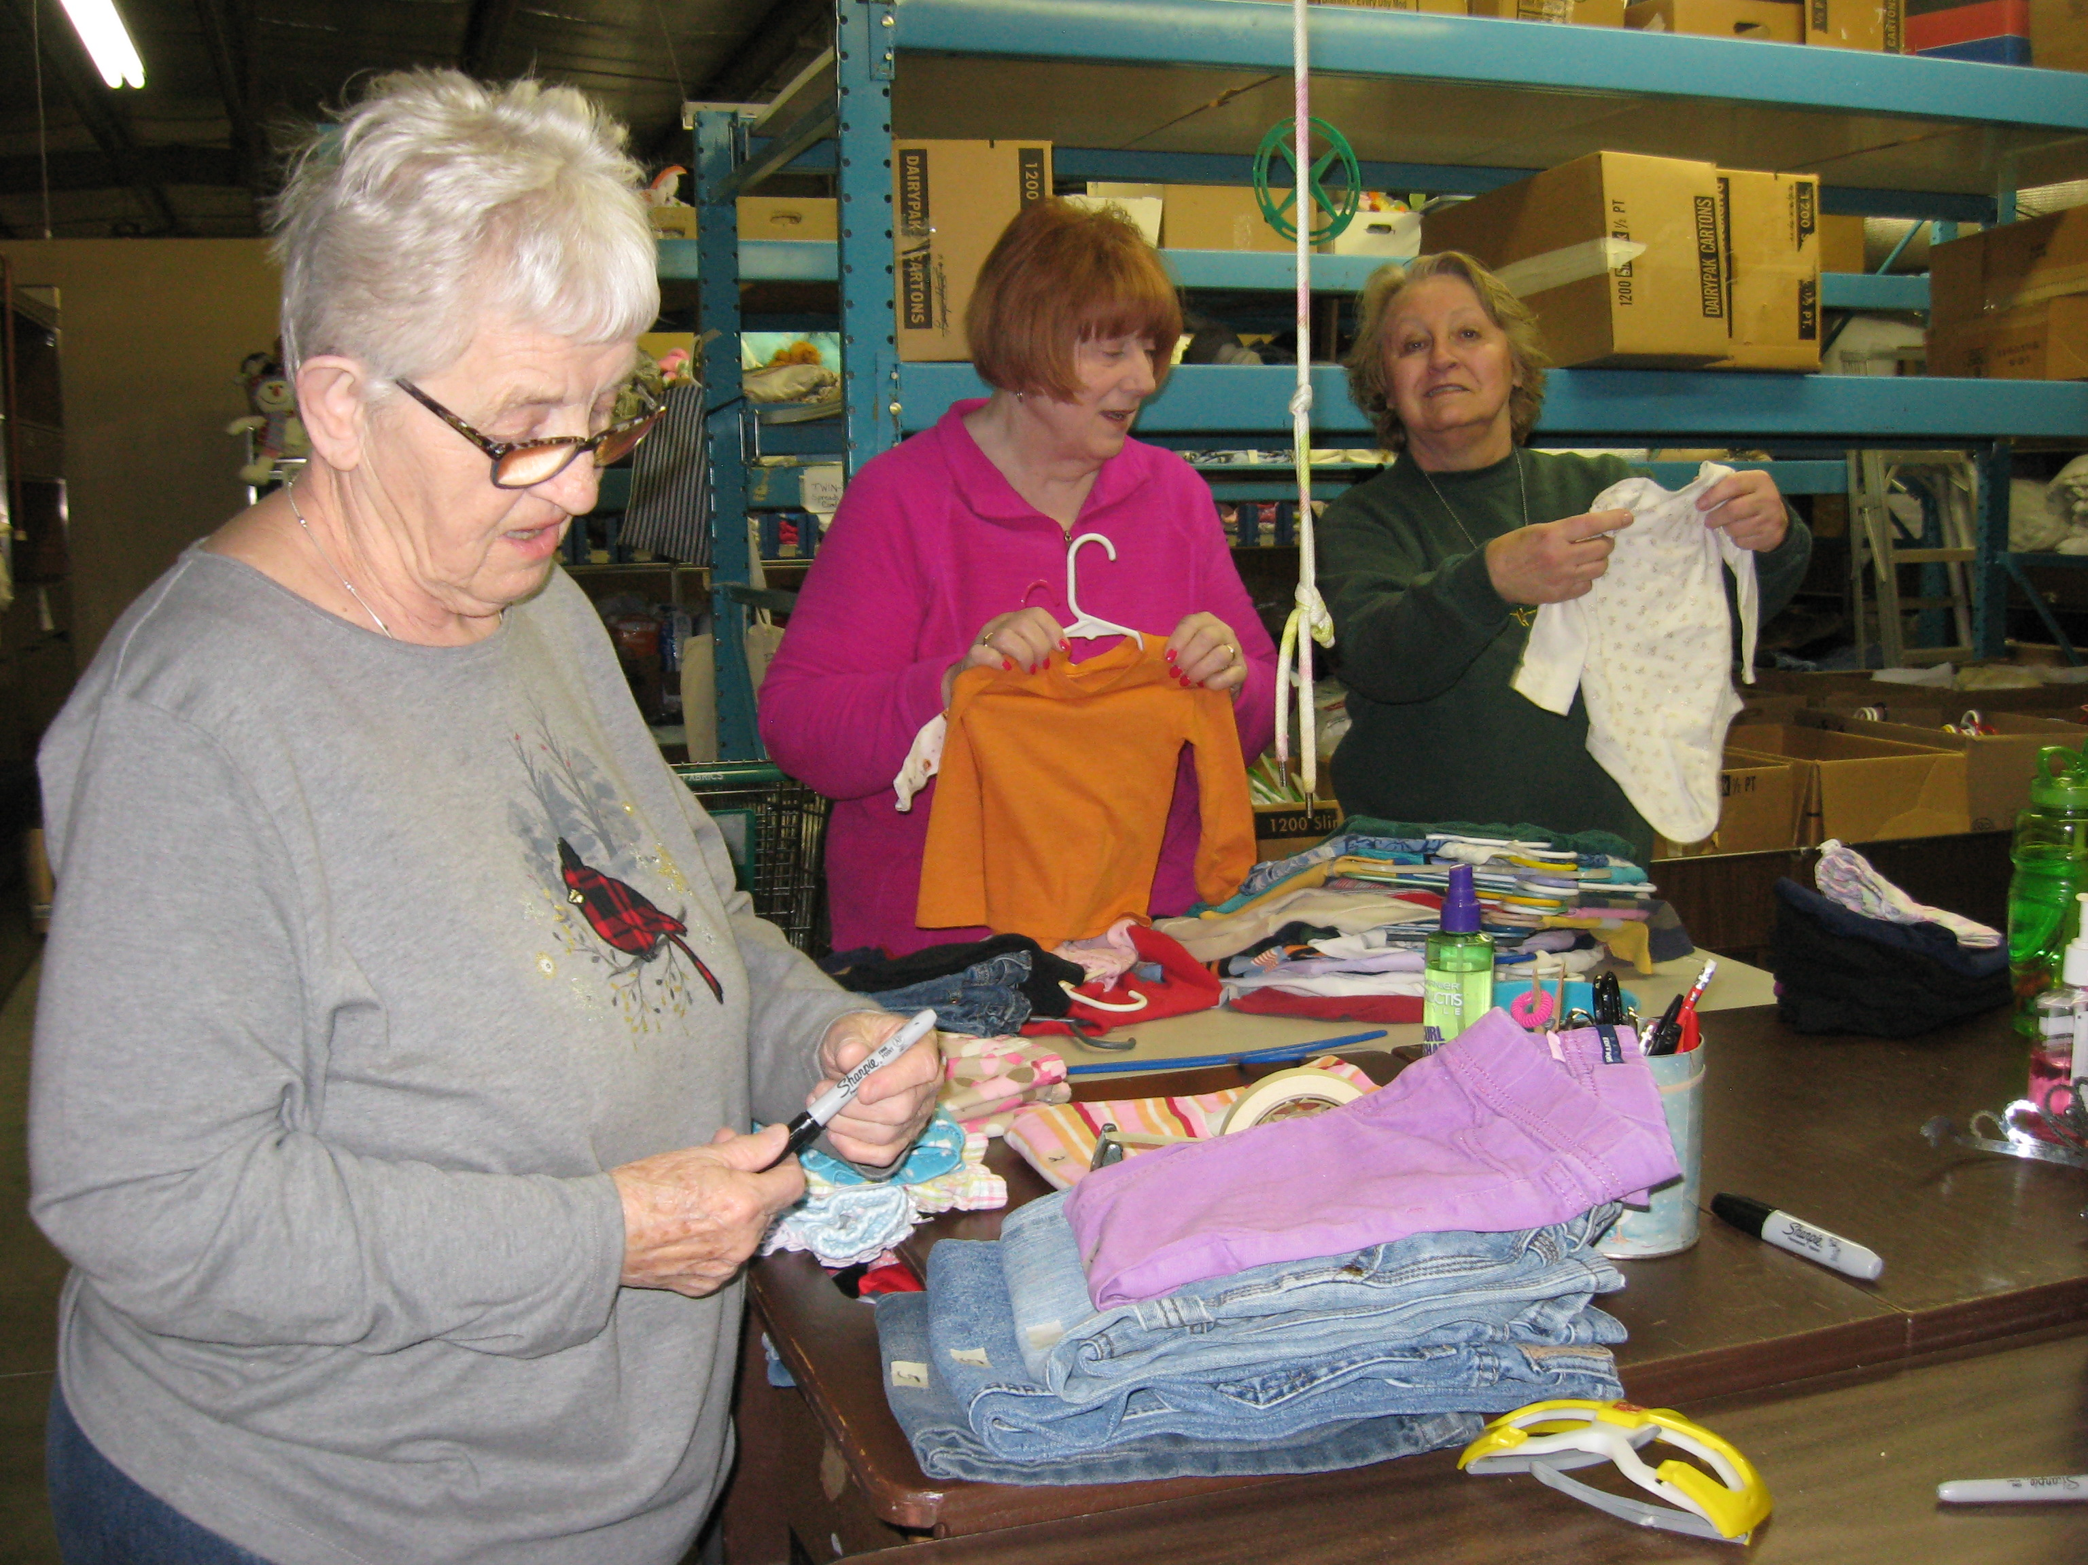
Numbers 6:24-26 (New International Version)
******************************************************
Prayer Texts

John 12:16 “ … where I am, my servant also will be…”

Romans 7: 6 “ … we serve in the new way…”

(New International Version)

prepared for the Ladies of Charity by Sr. Carol Schumer, D.C.

