The First Follower of Jesus -- Mary, her YES!
Call to Prayer Leader: On August 15, 2017, Pope Francis said, “Mary is the model of virtue and of faith. …[and] she precedes us in the pilgrimage of life and faith. She is the first disciple. And we ask her to keep us and support us; that we may have a strong, joyful and merciful faith; that she may help us to be saints, to meet with her, one day…” (Kathleen Appler, D.C., letter 8-15-18)
ALL: In the name of the Father and of the Son and of the Holy Spirit. Amen.
Hymn “Hail Mary, Gentle Woman” Landry Introduction, refrain
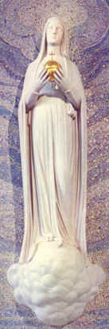
Virgo Potens, Paris France
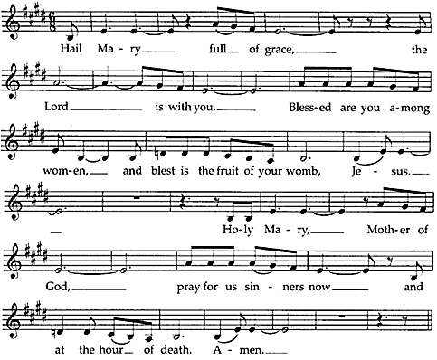
refrain
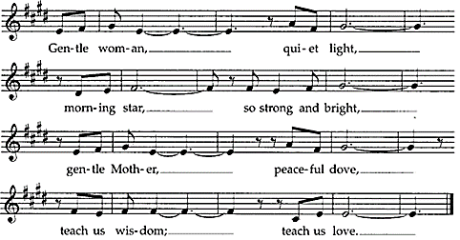

Scripture “In the sixth month, the angel Gabriel was sent from God to a town of Galilee called Nazareth, to a virgin betrothed to a man named Joseph, of the house of David, and the virgin’s name was Mary. And coming to her, he said, ‘Hail, favored one! The Lord is with you.’” Luke 1:26–28
The First Follower of Jesus -- Mary, her YES! (con’t) 2
Reflection The story is familiar. The angel Gabriel delivers God’s message to Mary. In that brief encounter, Mary’s life is changed forever and so is ours. She is invited into a unique relationship with God and after questioning the angel, accepts God’s invitation to give birth to his Son. Just when she thought she knew how her life would unfold, everything was turned upside down. While free to say no, her yes brought God closer to humanity than ever imagined. Mary became the first disciple. In her, we have a model of what entrusting our lives to God looks like and of how to follow God’s call.
adapted from Loyola Press, 3-minute retreat, The Lord is with You

Reflection and Sharing
What can I learn from Mary about being a Jesus’ disciple?
How do I give birth to Jesus in my ordinary daily life?

Response and Crowning (if desired) “Hail Mary, Gentle Woman” refrain only

Intercessions Leader: Mary, full of grace, you were called to be the mother of Jesus. We rejoice in your “yes” to be his first follower, as we say: ALL: Mary, you are a model for us.
+Mary is blessed among women with an unexpected invitation from the angel.
- O God, bless all women through her intercession.
+Mary chose freely to become the mother of our Savior.
- O God, offer all people the freedom to choose and follow their vocations in life.
+Mary pondered the mystery of her motherhood.
- O God, give your grace and guidance to all mothers and grandmothers.
+Mary changed her life plans and welcomed God’s shocking intervention.
- O God, fill our hearts with acceptance when circumstances change our plans.
(Your intercessions are welcome.)
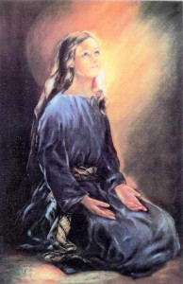

Hail Mary

Prayer Leader: Loving God, we honor Mary as the Mother of God and as our own mother. Help us to follow her example of complete trust and faith in you.
ALL: Blessed Mary, Mother of God, intercede for us with your Son. We long to say yes and are afraid of what that means. Guide us with your mother’s hand so that we may know that all will be well. We pray all this through your intercession with Jesus, your Son, and in the Spirit. Amen.
adapted from Loyola Press, 3-minute retreats, The Lord is with You and Assumption

Blessing ”Most Blessed Mother and Queen of Apostles, we humbly offer our tribute of love and gratitude to thee for the tender care and protection thou hast shown … [us.]” ALL: Amen.
Elizabeth Ann Seton, Collected Writings, Vol. 3b, page 57, 11.40
***********************************************************************
Prayer Texts (New American Bible)
Luke 1: 38 “… Let it be done to me as you say.”
Luke 1: 46-49 “… my spirit finds joy in God my Savior …”

prepared for the Ladies of Charity by Sister Carol Schumer, D.C.

