EASTER, SPRING
Call to Prayer Leader: May you be forever a beautiful tree of life bringing forth
fruits of love. (Coste, Volume 1, letter of St, Vincent to St, Louise, #27, page 46)
All: In the name of the Father and of the Son and of the Holy Spirit. Amen.
Hymn Now the Green Blade Rises” all verses
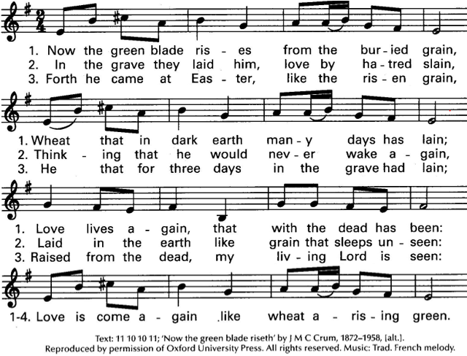

Antiphon: Leader: “For this is what the Lord says,
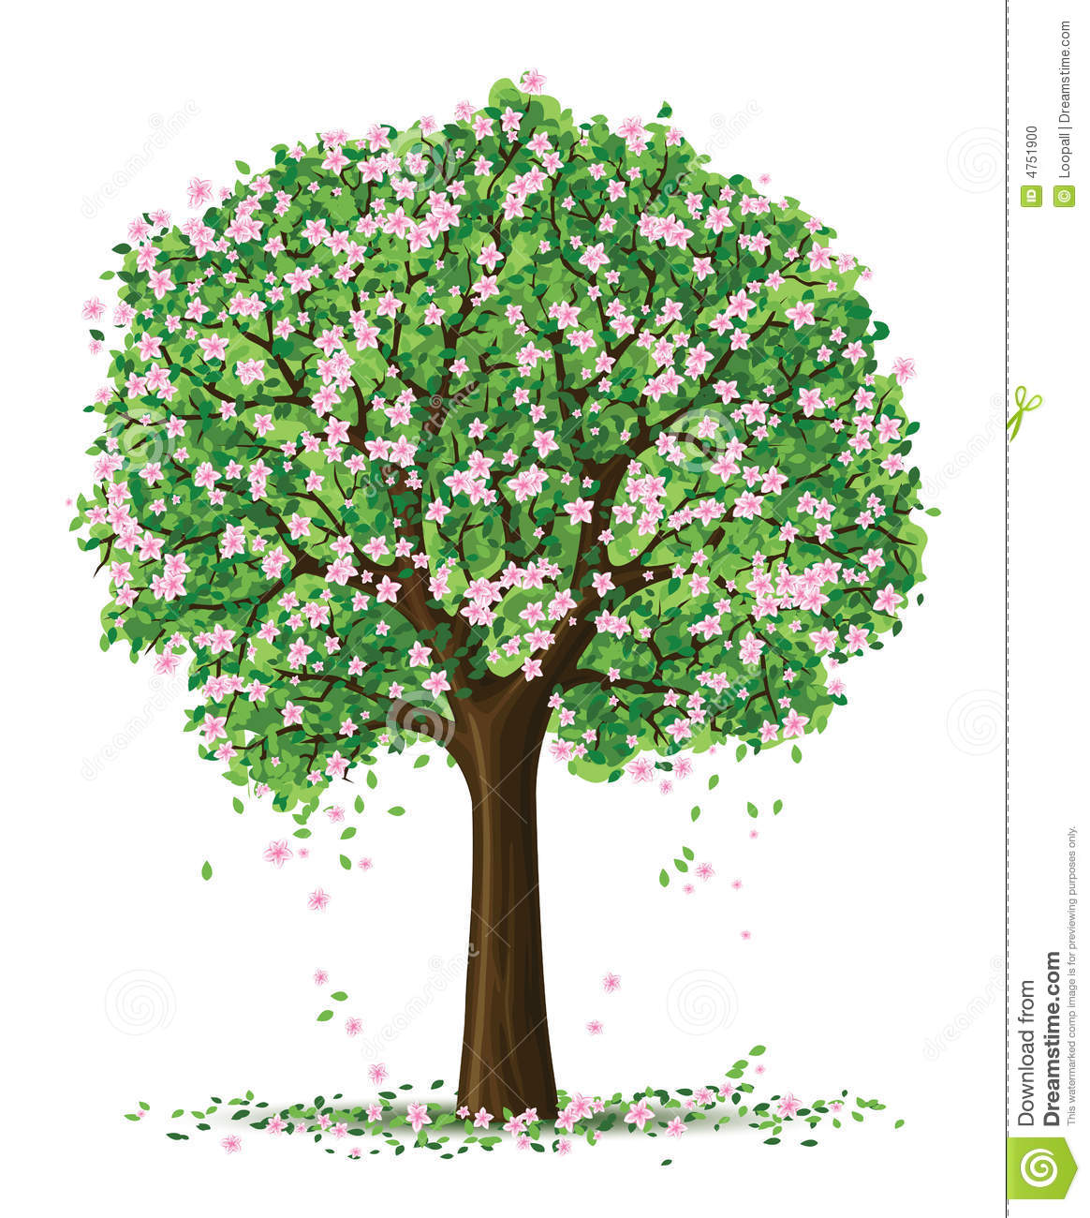
All:’I will extend peace to [you] like a river,
and the wealth of nations like a flooding stream…’”
Isaiah 66:12 NIV
Psalm 96 (Alternate verses, please.)
- The Creator of the earth reigns!
Yes, the world has been created, a gift to all generations.
Let truth and justice give birth to peace and harmony!

- Let the heavens be glad and let the earth rejoice!
Let the seas roar and all that fills them.
Let the fields exult and everything in them.
EASTER, SPRING (con’t) 2
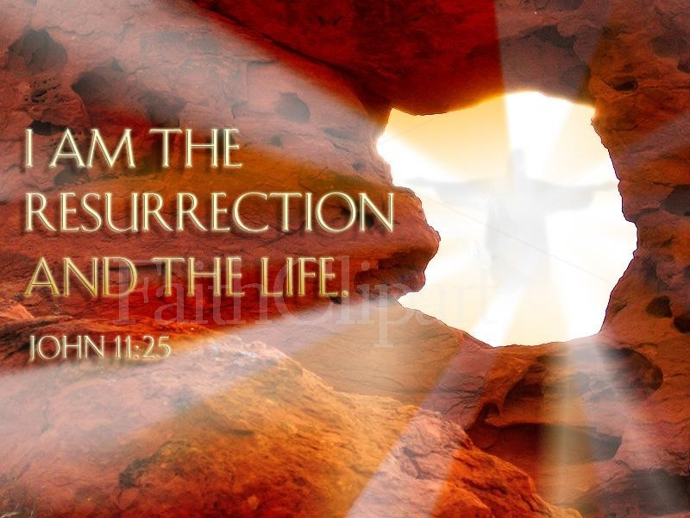
- Then shall the trees of the wood sing for joy
before the coming of our God who reigns in glory.

- For through love will come truth and justice,
offering all people gifts of new life!
adapted from Nan C. Merrill Psalms for Praying, pages 199-200
All: Glory be to the Father and to the Son and
to the Holy Spirit, now and forever. Amen.
Scripture Along both banks of the river, fruit trees of every kind shall grow; their leaves shall not fade nor their fruit fail. Every month they shall bear fresh fruit for they shall be watered by the flow from the sanctuary. Their fruit shall serve for food and their leaves for medicine. Ezekiel 47: 12 NAB
Reflection Jesus tells us he is the living water. When we thirst for God, Jesus gives us the water we need to grow and be joyful, We are fruitful because we stay by the stream, close to Jesus. While God’s grace is given to us through Jesus, it is not for us alone. True holiness and wholeness give to God and reach out in service to others. Joan Mueller “Journey to Joy” page 29
Reflection and Sharing
What gives me Easter life as a person, a Child of God, a Lady of Charity?
How have my efforts brought forth benefits/fruit for God’s reign on earth?
Response All: If seeds in the black earth can turn into beautiful roses, what might the human heart become in its long journey to the stars. adapted G. K. Chesterton
Our Father
Prayer All: God of all life and growth, through the Resurrection of your Son, Jesus. you accomplish in our receptive hearts what every springtime brings about in nature, We give you glory and praise as we ask that you uproot the seeds of worry, fear and regret and grace us with fruits of joy and peace through Jesus, in Your Spirit. Amen, Alleluia!
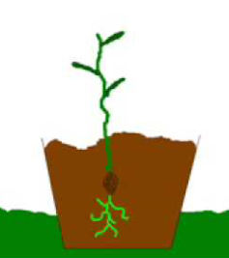
* * * * * * * * * * * * * * * * * * * * * * * * * * * * * * * * * *
Prayer Texts
John 12:24 “… if it dies, it produces much fruit.”
Philippians 1: 21-22 “…’life means Christ … fruitful labor…”

prepared for the Ladies of Charity by Sr. Carol Schumer, D.C.

