“… if it dies …” Lent March
Call to Prayer “… unless a grain of wheat falls into the earth and dies, it remains alone; but if it dies, it bears much fruit.” John 12:24 (NAB)

Hymn: “Unless a Grain of Wheat” refrain
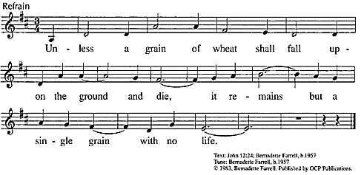
Used with permission
Antiphon: (all) “If seeds in the black earth can turn into such beautiful roses, what might the heart of [a person] become in its long journey to the stars.” Gilbert K Chesterton
Mark Link, Vision 2000, p. 99
Psalm 71: 1-6 (Alternate sides, please)
+In you, O God, I take refuge; let me never be put to shame.
- In your righteousness, rescue me, free me; incline your ear to me and save me.
+Be my rock, my constant refuge, a mighty stronghold to save me. You are my rock.
- My God, free me from the hands of those who are wicked, from those who oppress.
+It is you, O God, who are my hope, my trust, O God, from my youth.
- On you I have leaned from my birth. At all times, I give you praise.
+Glory be to the Father and to the Son and to the Holy Spirit,
- As it was in the beginning, is now and ever shall be, world without end, amen.
Reading: And the Stalk Said How does a grain of wheat feel as it is planted in the soil? To answer that, I imagine interviewing a stalk of wheat for every stalk was once a grain. Here is what the stalk might say. “I liked being a grain of wheat. I was proud of who I was. Golden. Smooth. Perfectly intact. But then some farmer dug a hole and tossed me into it. ‘What’s going on?’ I asked. But my question was met with silence. Then the dirt came pouring down upon me. I protested, ‘Hey! You’re burying me alive! Stop!’ But no one heard me. I sat in total darkness. Afraid. Then I felt something. Moisture. At first, I thought, ‘Good. I won’t die of thirst.’ But soon I began to get soggy. I sensed my golden color was fading. My smooth exterior becomes wrinkly. My intact-ness was breached as I was split asunder. I whimpered, ‘I’m dying… This is the end of me.’ Then something happened. Out of my shriveled, broken, dying self, two shoots emerged. One began pushing upward, the other downward, both powered by a force within and beyond me. As my root went down, my shoot went up until it broke through the soil and into the brightness of the sun. I was no longer a grain of wheat, but some-thing better, a stalk of wheat. From me would come forth many, many grains of wheat said, ‘Trust the Farmer. Befriend silence and darkness. Embrace transformation. Will-ingly relinquish your intactness. Believe. For the Ending is really the Beginning.’”
Melannie Svoboda, SND, Give Us This Day, March 2018, 5th Sunday of Lent page 202-03
“… if it dies …” Lent March, 2019 (con’t) 2
Reflection: Pause and reflect, then share as time allows.
+As a Lady of Charity, when have I seen newness of life after a death experience?
+When has following Jesus brought me through pain to growth and life?
Response: “I Want to Walk as a Child of the Light” verse 1
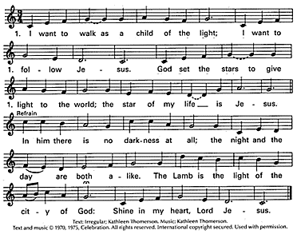
Reading: Jesus Transforms … “Like the ultimate cleansing-filter, [Jesus] purifies life itself. He takes in hatred, holds it, transforms it and gives back love; he takes in bitterness, holds it, transforms it and gives back graciousness; … he takes in chaos, holds it, transforms it and gives back order; he takes in fear, holds it, transforms it and gives back freedom; he takes in jealousy, holds it, transforms it and gives back affirma-tion; he takes in Satan and [betrayal], holds them, transforms them and gives back God and forgiveness. Jesus takes away the sins of the world in the same way a water-filter takes impurities out of water, by absorbing and holding all that isn’t clean and giving back only what is.” Ron Rolheiser, April 4, 2004 The Agony in the Garden, The Place of Transformation
Response: (all) “Jesus Christ … is our father, our mother and our all.” (SV, Vol. V, p.537)
Blessing: [May God] “be your light and strength in all the events of life.” (SV, Vol. V, p.451)
(All) Amen.
++++++++++++++++++++++++++++++++++++++++

Prayer Texts
John 5: 24 “… passed from death to life.”
Ephesians 2: 5 “… brought us to life … when we were dead …”

prepared for the Ladies of Charity by Sr. Carol Schumer, D.C. March

