God is LOVE


Call to Prayer ALL: In the name of the Father and of the Son and of the Holy Spirit. Amen.

Reading Love is always patient and kind; it is never jealous; love is never boastful or conceited; it is never rude or selfish; it does not take offence and is not resentful. Love takes no pleasure in other people’s sins but delights in the truth; it is always ready to excuse, to trust, to hope and to endure whatever comes. … In short, there are three things that last: faith, hope and love; and the greatest of these is love. 1 Corinthians 13: 4-7, 13

Reflection I have a friend who says he’ll argue the idea that Love is blind. Love, he says, is anything but blind. Love is vision. Love sees! I have to agree with this. Love can see for miles and miles. Love could transform our entire lives if we would let it make its home in us. This insight, of course, isn’t new. Jesus, the man from Galilee, preached a gospel of love. And not only did He preach it, He lived it. He loved much. We are slow to catch on. Jesus also told us that God is love. And God, like love, can see for miles and miles into the innermost places of our hearts where everything that is us has its home.
God, like love, waits for us. If the name of God makes us nervous, we aren’t told immediately that all of the love in our hearts, that part of us that hungers for goodness, is actually God living in us. But then, quietly, on some day when we find ourselves wondering where all this love that we feel came from, we are told gently: “It’s Me – God! I’ve set up my tent in your heart. I’m the One who is all of the vision that you are. I’m the reason you see so well. I am vision. I am love. I am part of the flow of life that you are.”

Let us remember than, that love is vision. And as our vision increases, so also will world-healing increase. Don’t ever forget that love sees. And it’s all because God has built a home in us.

Hymn “Where Charity and Love Prevail” verses 1, 2, 5
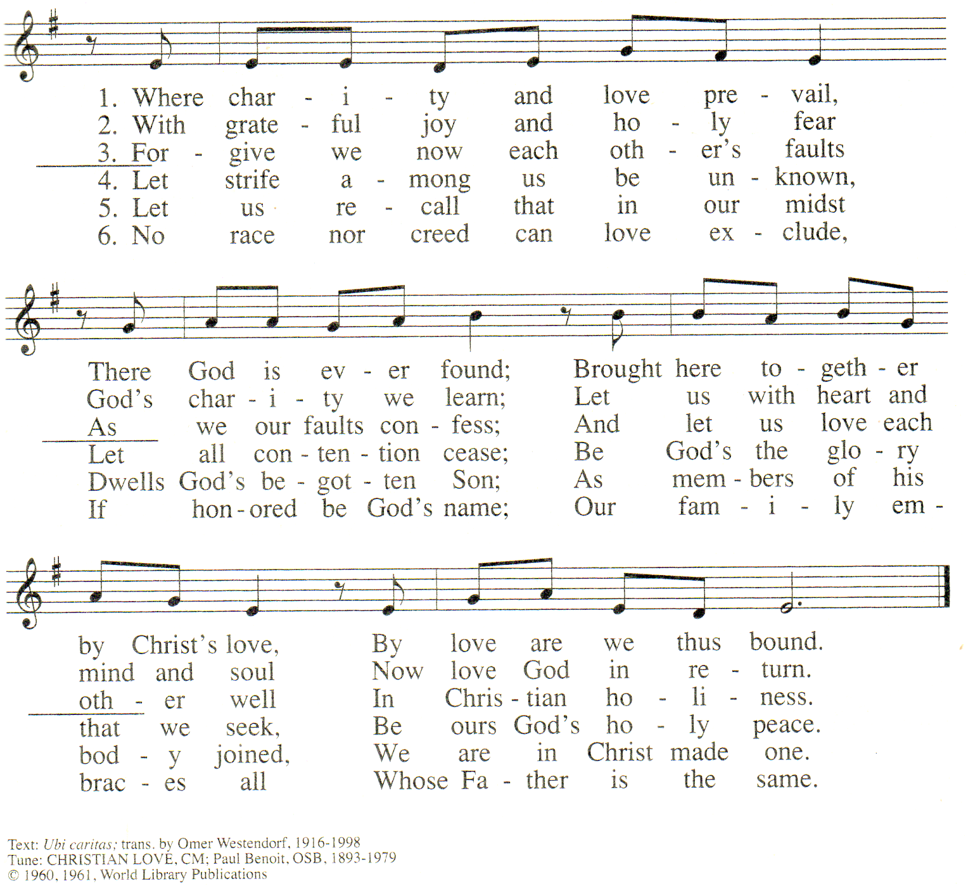



used with permission
CP LicenSing Online #612305

God is LOVE (con’t)
Instructions First, everyone together is invited to read, aloud, the following poem, as it is written.
Then, each person is invited to pray the poem a second time, silently, changing the word love to God and changing the pronouns accordingly.
Finally, each prays it silently, a third time. (This may be the hardest, though the most Incarnational.) Change love to your own name and change the pronouns to fit you.

Poem Love is not blind, love is vision.
It can see what microscopes have never seen.
Love does not need a magnifying glass.
It has clear eyes that see forever.
You do not have to be afraid of love’s presence.
You will not be used or taken lightly or ignored or laughed at.
Your significance will be seen with the pure eye of truth.
Love needs no glasses -- though some people
who are made of love, wear them.

Those glasses are to see earththings --
things that will not last.
Love sees spirit things –
the deep things of God that last forever.
You don’t have to be afraid of loneliness
in love’s presence.
For love has a way of filling you up
yet never smothering you.
Love does not greedily snatch you to itself.
It breathes on you and gives you wings
then lets you free.
Love does not tell you how to use your wings
but it watches while you fly.
And because love sees,
it can tell you every little movement of your flying,
that needs to be improved, and it can tell you how.

Love watches and it knows because it sees.
Love’s glance is sometimes gentle, sometimes stern.
To fit your need, it falls on you like morning dew
or a lightning bolt, but it is vision to the very end.
Love sees the things we dare not see
because we are afraid of sight.
Love sees the things we try to hide
because we are afraid of light.
Love is vision and love is not afraid.

Intercessions
Response: Thank you for your love, O God.
+ for the call to be Ladies of Charity, that is Ladies of God,
Ladies of Love, we pray …
+for the gift of life that is an expression of God’s love
for each of us, we pray …
+for Jesus, God’s compelling, undeniable sign of love for us,
we pray …
+for our families, friends, collaborators and poor persons
who give us an example of God’s love, we pray …
(Please, add your own prayers of thanksgiving.)

Our Father
(Please, pray together.)

Prayer ALL: God is love and those who abide
in love, abide in God and God in them. Amen.
(adapted 1 John 4: 16)
(adapted from Seasons of Your Heart, Macrina Wiederkehr, O.S.B.,
pages 74-76)
prepared for the Ladies of Charity by Sr. Carol Schumer, D.C., February

