A New Beginning -- January

Call to Prayer: What is so magical about a date on a calendar? We could say nothing. January 1 is just another day. But beginnings count for something. Actually, they matter a lot. In the course of our routines and relationships, we can get very comfortable, into a groove, a rut. What beginnings offer us is a chance to reflect on what was and consider what could be. What might the coming year become if we opened up to it being a genuinely new episode of our lives? adapted from “Revisioning Our Ministry in the New Year,” famvin

Hymn: “As With Gladness Men of Old” (all verses)

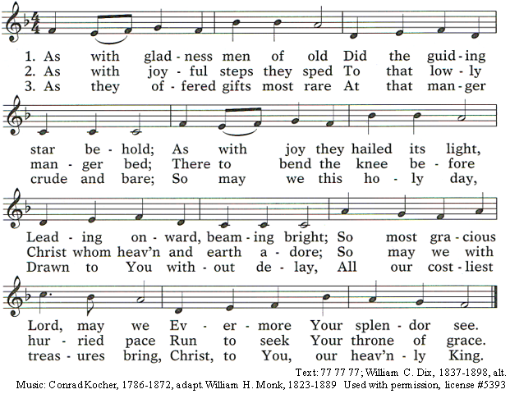
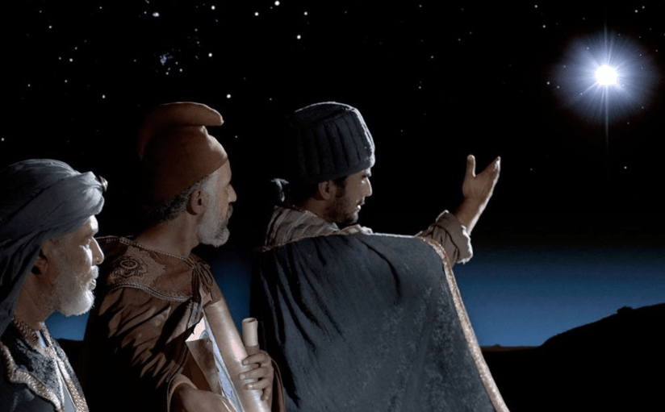
Reading: After Jesus was born in Bethlehem in Judea, during the time of King Herod, Magi from the east came to Jerusalem and asked, “Where is the one who has been born king of the Jews? We saw his star when it rose and have come to worship him.” When King Herod heard this, he was disturbed. When he had called together the chief priests and teachers of the law, he asked them where the Messiah was to be born. “In Bethlehem in Judea,” they replied. Then Herod called the Magi secretly and found out from them the exact time the star had appeared. He sent them to Bethlehem and said, “Go and search carefully for the child. As soon as you find him, report to me, so that I too may go and worship him.” After they had heard the
king, they went on their way and the star they had seen when it rose went ahead of them until it stopped over the place where the child was. When they saw the star, they were overjoyed. On coming to the house, they saw the child with his mother, Mary, and they bowed down and worshiped him. Then they opened their treasures and presented him with gifts of gold, frankincense and myrrh. And having been warned in a dream not to go back to Herod, they returned to their country by another route. Matthew 2: 1-12 (adapted from NIV)

A New Beginning (con’t) 2
Reflection: This story tells us of choices between staying with a comfortable status quo like Herod or looking at life with beginners’ minds like the three magi. This latter is how St. Vincent and St. Louise looked at the needs of their day. They were the wise ones of the 17th century as they sought not only to address immediate needs, but also to seek long-term solutions. Together, their beginners’ minds, their openness and creativity realized the vast untapped potential of engaging the laity, especially women, in addressing the needs they face. Think of the rapid spread of the Confraternities of Charity. What would happen if we approached the needs of today with beginners’ minds, renewed vision and open hearts?
adapted from “Revisioning Our Ministry in the New Year” by John Freund, CM, January 2, 2019, famvin
Questions for Thought and Sharing:
Who will we be in 2022, Herod or the Magi?
Might we adopt open minds and flexibility in this new year
and turn a fresh page in our service of those who are marginalized?

Response: “As With Gladness Men of Old” (verse 1)

Intercessions:

Leader – Led by the star and with child-like wonder, the magi came to see Jesus and

they found him. In our longing for new vision, we pray:

ALL: Guide us who seek you, O God.
Leader – Word of God made-flesh, the magi searched and adored you in the Christ Child;
ALL -- help us to recognize you in each other and in those who need our help.
Leader – Source of all wisdom, you dwell within us, the light of our minds;
ALL -- help us to listen attentively and follow the inspiration of your Spirit.
Leader – Loving God, you know the multiple needs we face and all the possible solutions;
ALL -- help us to see situations and remedies as you see them.
Leader – Creator of the world, complete the work which you have begun;
ALL -- help us to move out of our comfort zones in order to see, understand and act.
adapted from Companion to the Breviary, Carmelite Monastery, feast of the Epiphany, page 183
(Please, add your own prayers.)
Prayer: ALL -- O God, the magi sought Jesus in wonder and simplicity. By eagerly following the brilliancy of a star, they found him. Help us open our hearts, our minds and our eyes to behold Jesus present in your people and give us the insight and energy to address their needs in fresh, creative, new ways this year. We ask this in the name of Jesus, your Son, who lives and reigns with you in the Spirit, one God, forever and ever. Amen.
Blessing:
Leader – May God, who led the Magi to his Son by a star, fill our hearts with grace and our minds with light.
ALL – Amen.
Leader – May God, creator of all, help us approach the needs of today with beginners’ minds and clear vision.
ALL – Amen.
Leader – May God, the source of all blessing, grant us abundant resources to share during this new year.
ALL – Amen.
Leader – May Almighty God, bless us, protect us and lead us to everlasting life. ALL – Amen.
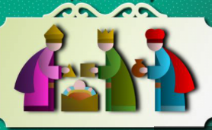

+++++++++++++++++++++++++++++++++++++++

Prayer Texts
Isaiah 60:1-6 “… you shall be radiant at what you see…”
1 Peter 5, 9-10 ”… now you are God’s people …”
prepared for the Ladies of Charity by Sr. Carol Schumer, D.C. January

