Thank You, God, for Little Moments
Call to Prayer: “Be very grateful to God, thank Him often ....”
(Coste, Vincent de Paul, Correspondence #3147, volume 8, page375)
Prayer ALL: Glory be to the Father and to the Son and to the Holy Spirit,
as it was in the beginning, is now and ever shall be, world without end. Amen.

Hymn: We Plough the Fields and Scatter (alternate recitation of verses, sing refrain)
- We plough the fields and scatter the good seed on the land,
but it is fed and watered by God’s almighty hand.
- God sends the snow in winter, the warmth to swell the grain,
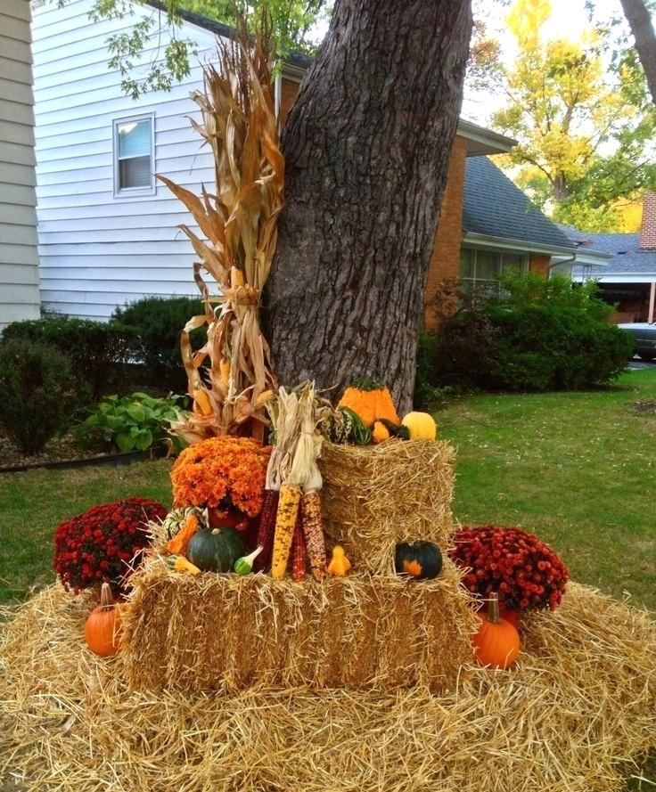
the breezes and the sunshine and soft refreshing rain.
ALL (sing): All good gifts around us are sent from heav’n above,
then thank the Lord, O thank the Lord for all his love.
- God only is the Maker of all things near and far.
God paints the wayside flower and lights the evening star.
- The winds and waves obey him; by God, the birds are fed.
Much more to us, his children, God gives our daily bread.
ALL (sing): All good gifts around us are sent from heav’n above,
then thank the Lord, O thank the Lord for all his love.
- We thank you, then, O Father, for all things bright and good,
the seed time and the harvest, our life, our health, our food.
- No gifts have we to offer for all your love imparts,
but that which you desirest, our humble, thankful hearts.
ALL (sing): All good gifts around us are sent from heav’n above,
then thank the Lord, O thank the Lord for all his love.

Antiphon ALL: “Exhaust the little moment. Soon it dies. And be it gash or gold, it will not come again in this identical disguise.” Gwendolyn Brooks
Voice 1: Gratitude, yes, for all the big thinks that stand tall,
thick with abundance, joy, fruitfulness.
I cannot help but applaud their presence.
Voice 2: But deep thankfulness for the bite-sized pieces of my life?
I had not thought of them,
those little snippets of time so easily consumed
in the hurry and blur of pretentious days.
Voice 3: The little moments, assumed and presumed,
slip quickly through the fingers of my busy life.
Voice 4: Winter gestures with a wrinkled brown hand,
beckons me wisely to consider those fleeting moments of grace
in things quickly passing …
Voice 5: I turn to gather finely-layered remnants … in the come and go of my days,
and discover, with surprise, how quickly my inner room is a harvest of gold.
adapted Joyce Rupp, Out of the Ordinary
Thank You, God, for Little Moments (con’t) 2
Reading (1 Thessalonians 5: 16-18)
“Rejoice always, never cease praying, render constant thanks
such is God’s will for you in Christ Jesus.”
Reflection and Sharing:
Recall a time in your daily life when you were captured by the moment.
As a Lady of Charity, when did your interaction with a poor person
touch your heart and urge you to offer gratitude to God?
Response ALL: Let us bless and thank God for entrusting to us
the care of these poor people,
for in serving them we see and touch the extent and diversity of human misery.
(adapted from Coste, Vincent de Paul, Conference #13, volume 11, page 19)
Litany of Thanks Response ALL: With hearts full of gratitude, we praise you.
+ For waking us up this morning and providing us with the energy needed for this day...
+ For calling us to gather together as Ladies of Charity, to praise and glorify your name…
+ For the wisdom passed down to us through our parents, past Ladies and our ancestors…
+ For the uniqueness of our gifts and your presence in these talents…
+ For Jesus, our brother, who is alive today in persons who live in poverty…
+ For the ever-abiding Spirit, who continually renews and guides us from within…
+ (Please, add your own prayers of thanksgiving.)
Our Father Leader: As sisters, Beloved of God, let us join our voices
as one family as we prayer,
ALL: Our Father …
Prayer Leader: Blessed be the name of God who made heaven and earth!
Blessed be our God who has given us every good gift.
Blessed be God who has called us to accompany poor people.
Great and wonderful is our God, now and always.
ALL: Amen.
+++++++++++++++++++++++++++++++++++++++++
Prayer Texts
1 Chronicles 16:34 "Give thanks to the Lord, for he is good…
Psalm 34:1-3 ‘I thank you, Lord, with all my heart; I sing praise to you.”
Colossians 3:15 “Dedicate yourselves to thankfulness.”
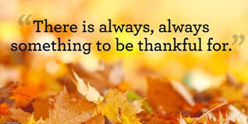

prepared for the Ladies of Charity
by Sister Carol Schumer, D.C.

