The Incarnation with Mary, Joseph and Jesus

Call to Prayer: On May 30, 1659, Vincent reflected and questioned aloud, “Let’s look at the Son of God; what a heart of charity He had; what a fire of love! Please, tell us, Jesus, who pulled You away from heaven to come to endure … [the] torments You suffered? O Savior! Source of love, humbled to our level …, who showed … greater love for the neighbor than You yourself did? You came to lay yourself open to all our misfortunes; … is there any love like that? But who else could love in such an outstanding way? Only Our Lord, who was so enamored with the love of creatures as to leave the throne of His Father to come to take a body subject to weaknesses. And why? To establish among us, by His word and example, love of the neighbor. This is the love that … brought about that admirable work of our redemption. O [Ladies], if we had only a little of that love … Charity can’t remain idle; it impels us to work for the salvation and consolation of others.” Coste, vol.12, #207, “Charity” p. 216
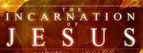
Angelus expanded
Introduction: ALL: Mary, Theotokos, pray for us, that we may birth Jesus into our world and remain faithful as you did to the end, in humility, simplicity, charity, trust, obedience and freedom.
Reader 1: The angel Gabriel announced to you, Mary,
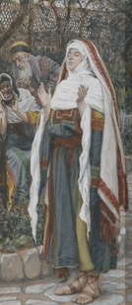
ALL: “Hail Mary, full of grace, God is with you.”
Reader 1: You were troubled; you pondered, questioned, prayed than replied, as do we,
ALL: “Behold the handmaid of our God; be it done to me according to your word.”
Reader 1: And, Mary, you conceived of the Holy Spirit. In joy and haste, you traveled
to the hill country to visit Elizabeth. On hearing Mary’s greeting,
Elizabeth, the babe in your womb danced for joy and you exclaimed,
ALL: “Blessed are you among women, Mary, and blessed is the fruit of your womb.”
Reader 1: Mary, you responded:
ALL: “My soul magnifies our God and my spirit rejoices in God, my Savior,
for God has done marvelous things for me and holy is God’s name!”
Reader 1: Mary, you remained with Elizabeth three months, helping, encouraging, supporting,
working, praying, playing, enjoying, loving, being with one another until Elizabeth
gave birth to her son and Zechariah named him John and life settled in Ain Karim.
Reader 2: Then, Mary, you returned to Nazareth to speak with Joseph.
Joseph, you were shocked, angry; you questioned.
You pondered, prayed, then decided, when Gabriel visited and told you,
ALL: “Don’t be afraid to wed Mary, Joseph. She has conceived of the Holy Spirit
and you are to name your son, Jesus.”
Reader 2: On awakening, Joseph, you asked Mary to be your wife. The two of you married and
moved into the home you had built, settling as a couple, preparing for the arrival of your
son and a quiet life in Nazareth as a family.
However, when the time of Mary’s delivery came very near, a degree was promulgated
requiring that you return to Judea to enroll. You urged Mary to stay in Nazareth.
ALL: Mary, you insisted on accompanying Joseph so he would be the first to meet your son.
Reader 2: So, the two of you traveled to the city of David, to Bethlehem. On your arrival, there was
no room anywhere. Joseph, you searched, pleaded and begged. And no one would help.
Finally, a servant showed compassion and took you to an out-of-way place on the hillside
where you could stay. Here, under the stars, in the dark of night, amid the animals,
in this alone, quiet, safe, secluded, peaceful, solitary, filthy hovel, graced haven,
ALL: Mary, you gave birth to your son and, Joseph, you named him, Jesus.
Incarnation with Mary, Joseph and Jesus (con’t) 2

Reader 2: The animals watched; the angels rejoiced; the shepherds marveled; the magi adored and,
Mary and Joseph, you pondered, for indeed the Word of God had become flesh in Jesus
and continues to dwell among us through the Spirit.
Response: Away in a Manger Traditional American Carol verses 1, 3
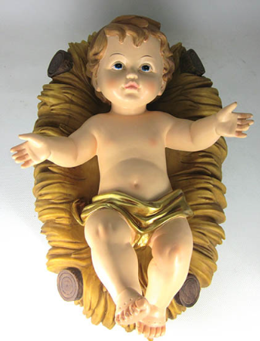
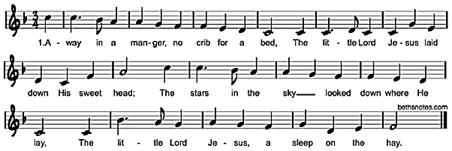
3. Be near me, Lord Jesus, I ask You to stay
Close by me forever and love me, I pray.
Bless all the dear children in your tender care
And fit us for Heaven to live with you there.

Reflection and Sharing: How am I being called to birth Jesus in love?

Prayer: ALL: Holy Mary, Mother of God, Blessed Joseph, foster Father of Jesus,
pray for us who have sinned, now and at the hours of our deaths. Amen.
Leader: Pray for us, holy Mother of God, earthly Father of Jesus,
ALL: That we may be made worthy of the promises of your Son, God’s Son, Jesus.
Leader: Let us pray,
ALL: Pour forth, we beseech you, O God, your grace into our hearts,
that we to whom the Incarnation of your Son, Mary and Joseph’s Son,
was made known by the message of the angel Gabriel to Mary and Joseph,
may by His Incarnation, birth, hidden life, public life -- preaching, teaching,
feeding, forgiving, healing, miracles; passion, death, Resurrection and Ascension,
may be brought through our current pain and suffering into fullness of life
and complete joy now and eternal life, joy, happiness, glory, peace, freedom,
love and unity with you and one another forever through this same Jesus,
your Son, Mary and Joseph’s Son, our brother, our friend, our Savior,
the Messiah, the Christ in your Spirit. Amen.
O Mary, conceived without sin, pray for us who have recourse to you
and those who don’t have recourse to you.
St. Joseph, pray for us. Amen.

prepared for the Ladies of Charity by Sister Carol Schumer, D.C.

