Mary, our Mother May 2021
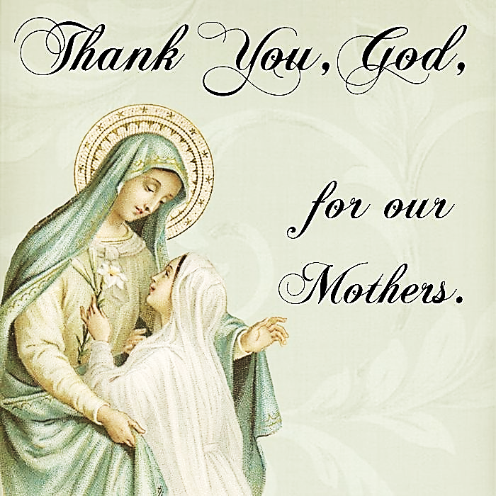
Call to Prayer Leader: “Each of our days is marked with the protection of Mary,
who is exceedingly anxious to be our mother when we desire to be her children.”
Reflections Daily Thoughts of St. Vincent, calendar April 12
Leader: O God, open our lips
ALL: and our mouths will proclaim your praise.
Glory be to the Father and to the Son and to the Holy Spirit,
as it was in the beginning so now and ever shall be, world without end.
Amen. Alleluia!
Hymn “Sing of Mary” verses 1, 3 (Crown Mary, if choose.)
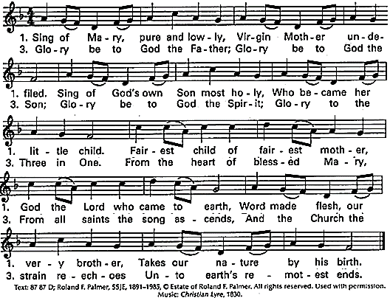
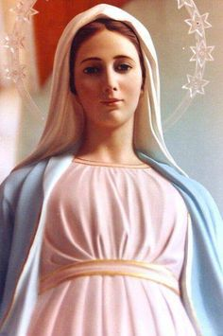
Messages St. Vincent to us about Mary, the Blessed Virgin
+“… take the example of the Blessed Virgin…” Coste, volume 9, #13, January 25, 1643 page 72
+“… love… was the motive of all the actions of the Blessed Virgin [and] of the good women who ministered to poor persons under the guidance of our holy [Mother] …, of whom you’re so fortunate as to be the successors.” Coste, volume 9, #3, July 19, 1640, page 18
+“I ask [God] to give you the grace to imitate the Blessed Virgin in the care, attention and love she had for her Son…” Coste, volume 9, #16, December 7, 1643, page 115
+”… contemplate the Blessed Virgin, …. [let her] serve … as a subject for mental prayer.”
Coste, volume 9, #4, August 2, 1640, page 27
+“…the Blessed Virgin … kept the words of her Son in her heart; she drank them in and afterward meditated on them so that she lost nothing of what He said.” Coste, volume 9, #36, May 1, 1648, page 318
and from St. Louise
+“Mary is a woman chosen by God to give to the world the Word of Life. A [Lady] of Charity is a woman called by God to bring to the poor the love of God.”
Reflections Lent through Pentecost Calendar, Wednesday of the Second Week of Easter
Mary, our Mother (con’) 2
Reading “… we should likewise have special devotion to the Most Blessed Virgin Mary. …
Both individually and collectively, [we] should, with God’s help, try to carry this out perfectly:
(1) by specially honoring every day [of] this preeminent Mother of Christ, who is also our Mother;
(2) by putting into practice, as far as possible, the same virtues as she did ….
(3) by enthusiastically encouraging others, whenever opportunity and means permit, to show [Mary] the greatest reverence and always to serve her loyally.”
Coste, volume 13a, #117a, May 17, 1658. page 456
Pause in Silent Prayer
Response ALL: My soul rejoices in you, O God. You know me, love me and work wonders in my life. Through the intercession of Mary, the Blessed Mother, may I always follow her example and say “yes” to your will in everything you ask of me. Amen.
Intercessions Leader: “Mary, you are such a powerful intercessor with your son. [We] commend to you today, all the most urgent needs and desires of [our] hearts, knowing you will obtain for [us] what [we] need most.” Reflections Daily Thoughts of St. Vincent, calendar April 12
ALL: Mary, intercede for us.
+Mary, you are blessed among women and an example of one who listens to the Word of God,
ALL: Bless all women with hearts and ears open to the Word.
+Mary, you freely agreed to become the mother of the Son of God and our mother,
ALL: Help all people choose and follow their vocations in life.
+Mary, you changed your life plans and welcomed God’s shocking intervention.
ALL: Open us to accept when our circumstances demand a change of plans.
+Mary, you loved and ministered to Joseph, Jesus, the apostles, the women and all who needed you.
ALL: Give your care and guidance to us who minister to family, friends and persons in need.
(Your intercessions are welcome.)
Hail Mary … (Pray together.)
Prayer ALL: “O my God, we give ourselves to You for the accomplishment of your plan for us.
We acknowledge that we are unworthy of this grace, but we ask it of You through the love of Your Son; we ask it of You through the Blessed Virgin and we ask it of You through our sisters whom, in Your goodness, You have already taken to Yourself into Your holy paradise. Grant it to us for Your glory, God, and bless us in the name of the Father and of the Son and of the Holy Spirit. Amen.”
Coste, volume 9, #15, June 14, 1643, page 103
Blessing Leader: Let us “implore Mary to offer to God the way by which He is calling” us. O God, through the intercession of Mary, our Mother and Queen, bless us and keep us close to you now and always. ALL: Amen, alleluia! Louise de Marillac, Spiritual Writings, A.30, page 697
* * * * * * * * * * * * * * * * * * * * * * * * * * * * * * * * * *
Prayer Texts
Luke 2: 19 “Mary treasured all … in her heart.”
John 19: 27 “Behold, your Mother!”

prepared for the Ladies of Charity by Sister Carol Schumer, D.C., May, 2021

