Easter JOY April 2021
Call to Prayer: Want more joy? Cultivate it! Joy springs from viewing events from a spiritual perspective. With this intentional focus, we see today differently, with more joy and conviction that God is alive and at work in our lives.
Leader: Joy to the world!
ALL: Jesus, our Savior, is risen!
Glory be to the Father and to the Son and to the Holy Spirit,
as it was in the beginning, is now and ever shall be, world without end. Amen.
Hymn: Joy to the World, vs. 2, 4 Handel, Isacc Watts
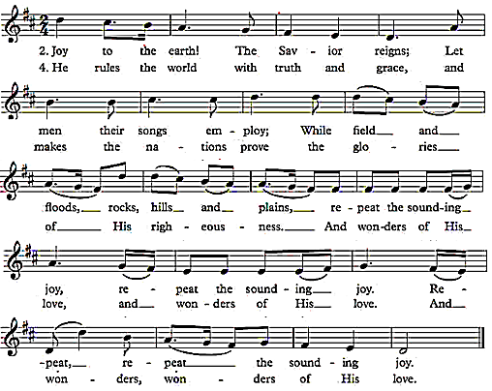
all
Easter JOY 2
Reading: Joy can emerge out of the darkness or the light. It can be prompted by reviewing our day’s happiness or sadness. Vincent saw this as uniting ourselves with the Paschal Mystery. “I beg Our Lord, that we may be able to die to ourselves in order to rise with Him, that He may be the joy of your heart, the end and soul of your actions and your glory in heaven. This will come to pass if, from now on, we humble ourselves as He humbled Himself; if we renounce our own satisfaction to follow Him by carrying our little crosses and if we give our lives willingly, as He gave His, for our neighbor whom He loves so much and whom He wants us to love as ourselves.” (Coste III #1202, March 27, 1650, page 616)
Frederick Buechner wrote, “The place God calls you to [be] is the place where your deep gladness and the world’s deep hunger meet.” (www.goodreads.com/140448) Vincent’s gladness is joy. Let’s be joyful! In doing God’s will, we are on the road to deep gladness. Let us be grateful that we have been called to this Vincentian path of service to people who are poor.
(adapted https://famvin.org/en/2015/12/13/joy-cometh)
Easter Resolutions:
- Rejoice, Jesus lives, alleluia!
- Unite yourself with the Paschal Mystery.
- Be grateful for your call.
Intercessions:
Leader: Loving God, you fill the world with rejoicing in the resurrection of Jesus. With exultant hearts, we pray,
Response ALL: Spread your joy across the earth, O God.
+that the whole of our lives might radiate joy, we pray …
+that we may joyfully carry out God’s law of love in our daily lives, we pray …
+that we may celebrate so all our days are expressions of God’s joy, we pray…
+that all who grieve, are sorrowful or oppressed may know God’s love, peace and joy, we pray…
(Please, add your own petitions.)
Our Father
Closing Prayer to Mary: Be Joyful, Mary
Blessing: Leader: O God, may Easter joy resound in every heart and through every land, in Jesus, crucified and risen, through the Spirit.
ALL. Amen, alleluia!
prepared for the Ladies of Charity by Sr. Carol Schumer, D.C., April 2021

