Prayer – March 2021
Call to Prayer: Life's essential daily habit is prayer, spending time in prayer. For many years, I've challenged people to start with 10 minutes a day. This habit will change your life. Sometimes people ask, "Why do you pray?" I pray because I don't know how people can live in this crazy, noisy, busy world without a little bit of silence and solitude each day to focus their lives, to center their lives, to re-establish what matters most, what matters least so that we can go out into the world with clarity about who we are and what we're here for.
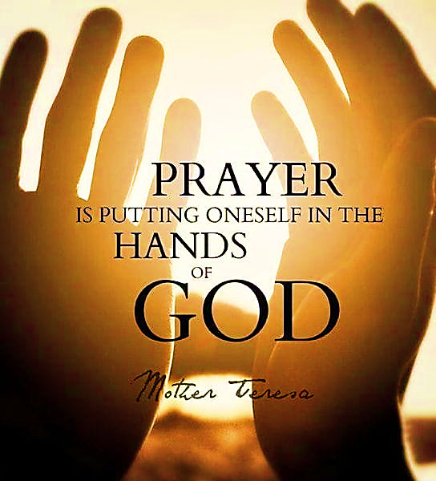
adapted from Dynamic Catholic Best Lent Ever 2021, Matthew Kelly, 2/22/2021
Leader: O God, come to our assistance
ALL: O Lord, make haste to help us.
Leader: Glory be to the Father and to the Son and to the Holy Spirit,
ALL: As it was in the beginning, is now and
ever shall be world without end. Amen.
Hymn: “Open My Eyes” verses 1, 3, 4
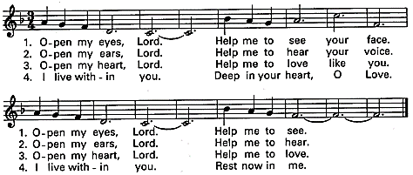
Used with permission.
Antiphon ALL: “We pray well when we remain in the presence of God, with no exertion of the understanding or will.” Coste, Vincent de Paul, volume 4, page 385, May 21, 1652
Psalm 86:1-12 (Pray in alternating sides, please.)
1 Hear me, O God, and answer me, for I am poor and needy.
- Guard my life, for I am faithful to you; save your servant who trusts in you.
- You are my God; have mercy on me, O God, for I call to you all day long.
- Bring joy to your servant, God, for I put my trust in you.
- You are forgiving and good, abounding in love to all who call to you.
- Hear my prayer, O God; listen to my cry for mercy.
- When I am in distress, I call to you because you answer me.
- Among the gods there is none like you, O God; no deeds can compare with yours.
1 All the nations you have made come and worship before you; they will glorify your name.
2 For you are great and do marvelous deeds; you alone are God.
Prayer (con’t) 2
1 Teach me your way that I may rely on your faithfulness; give me an undivided heart.
2 I praise you, my God, with all my heart; I glorify your name forever.
ALL: Glory be to the Father … As it was in the beginning …
Antiphon ALL: “We pray well when we remain in the presence of God, with no exertion of the understanding or will.” Coste, Vincent de Paul, volume 4, page 385, May 21, 1652
Reading: Your strength is not in numbers, nor does your might depend upon those who are powerful. You are the God of the lowly ones, the helper of those of little account, the supporter of those who are weak, the protector of those in despair, the savior of those without hope. Please, please, God, Master of heaven and earth, Ruler of all, hear my prayer! Make everyone know clearly that you are God, the God of all power and might and that there is no other who shelters the people, but you alone.
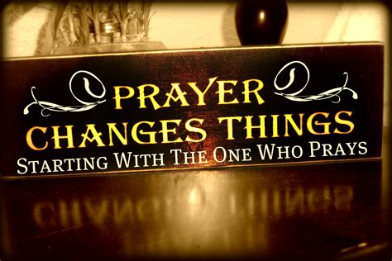
adapted Judith 9:11-12, 14 New American Bible, revised edition 2010
Reflection and Sharing:
When I pray, do I listen and hear God speaking in me?
When was my prayer unexpectantly answered?
Intercessions:
Leader: During this Lenten season, we raise our voices to God.
Response ALL: O God, hear our prayer.
+for perseverance in prayer and confidence in God’s answer, we pray …
+for courage to tell God what’s true and most important, we pray …
+for patience as we wait for God’s Spirit to lead the way forward, we pray …
(Add your own intercessions, please.)
Our Father Leader: Let us pray the perfect prayer, taught to us by Jesus,
ALL: Our Father …
A Prayer for Prayer ALL: O My God, my soul’s companion, my heart’s precious friend, I turn to You. I need to close out the noise, to rise above the noise, that interrupts, that separates, that isolates. I need to hear You again. In the silence of my innermost being, in the fragments of my yearned-for wholeness, I hear whispers of Your presence, echoes of the past when You were with me, when I felt Your nearness, when together we walked, when You held me close, embracing me in Your love, laughing with me in my joy. I yearn to hear You again. In You, I find healing. In the promise of Your love, I, too, can become whole. Listen to my call. Help me find the words and the strength within. Help me shape my mouth, my voice, my heart. using words only my heart can speak, songs only my soul can sing. Let me lift my eyes and heart to You. Open my lips, dear God, so that I can speak with You again. Amen.
adapted Rabbi Sheldon Zimmerman, President of Hebrew Union College

*********************************************

Prayer Texts
Jeremiah 29: 12 "… pray to me and I will listen.”
I Thessalonians 5: 16-18 “… pray without ceasing …”

prepared for the Ladies of Charity by Sr. Carol Schumer, D.C. March 2021

