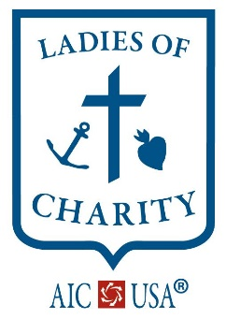
LADIES OF CHARITY
OF THE UNITED STATES OF AMERICA ®
Providing Vincentian Leadership to Women Acting Together Against All Forms of Poverty
LCUSA NATIONAL SERVICE CENTER Phone: 816-260-3853
2816 E. 23rd Street Email: office@ladiesofcharity.us
Kansas City, MO 64127 Website: aic.ladiesofcharity.us
INDIVIDUAL MEMBER ANNUAL DUES NOTICE AFFILIATED WITH LADIES OF CHARITY OF THE UNITED STATES OF AMERICA® (LCUSA) AND INTERNATIONAL ASSOCIATION OF CHARITIES (AIC)
LCUSA annual dues are $35.00. Please complete form and send with dues payment to LCUSA National Service Center to be received by no later than MARCH 22st. Dues received after MARCH 22nd^{t} are considered delinquent (see Dues Worksheet).
Please print clearly, or fill in online as an Adobe form.
THE INFORMATION BELOW WILL BE USED TO ANNUALLY UPDATE THE LCUSA DATABASE. THROUGHOUT THE REMAINING YEAR, PLEASE CONTACT LCUSA NATIONAL SERIVCE CENTER WHEN A CHANGE OCCURS.
LCUSA Region______________________________________________________________________
Name_____________________________________________________________________________
Address ___________________________________________________________________________
City/ST/Zip _______________________________________________________________________
Phone number ______________________________________________________________________
Email______________________________________________________________________________ MATERIALS FROM LCUSA WILL BE SENT TO THE EMAIL ABOVE. PLEASE PROVIDE AN EMAIL THAT IS CHECKED REGULARLY. THANK YOU.
Dues Worksheet Membership dues must be paid in full to be an Individual Member (IM) of the “Ladies of Charity” within the National Association in the USA (LCUSA) and the International Associations of Charity (AIC).
Individual Membership $ 35.00
Optional donation to LCUSA $ ______________________
Optional donation to AIC $ ______________________
Total Dues remitted $_______________________

