TRUST in GOD January 2021

Call to Prayer: A God who could take the worst thing in the world (the killing Jesus, the Son) and turn it into the best thing (the redemption of all people) is surely a God we can trust to “work all things together for good.” (Romans 8:28)
adapted Richard Rohr, Daily Meditations, 10-27-14

Hymn: “Only in God” John Foley, SJ Sing both verses.
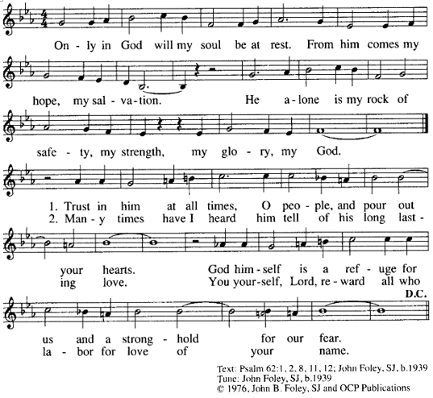

Reading: Meister Eckhart writes, “... the Father laughs and gives birth to the Son. The Son laughs back at the Father and gives birth to the Spirit. The whole Trinity laughs and gives birth to us.”^{[1]} Matthew Fox adds, “laughter may well be the ultimate act of letting go and letting be, the music of the divine cosmos. For in the core of the Trinity, laughing and birthing go on all day long.”^{[2]} Let us put our trust in this God of laughter.

^{[1]} Meister Eckhart, Meditations with Meister Eckhart, trans. and ed. Matthew Fox (Bear and Company: 1983), 129;

^{[2]} Matthew Fox, Passion for Creation: The Earth-Honoring Spirituality of Meister Eckhart (Inner Traditions: 1980, 2000), 48

TRUST in GOD (con’t) 2

Quotes from St. Vincent (Rotate readers, pausing briefly for thought between quotes.)
“Put your trust in God’s great goodness and offer yourself frequently to God that He may accomplish His good pleasure in and through you.” (Coste, Volume 7, page 218)
“Trust in God’s infinite goodness and you can be sure that He will strengthen you …”
(Coste, Volume 8, page 233)
“You must act in such a way that you are also prompted to trust even more in God for His grace is sufficient to help you…” (Coste, Volume 5, page 473)
“Put your trust in the Lord and following His example, always act humbly, graciously and in good faith. You will see that all will go well.” (Coste, Volume 4, page 122)
“All our trust must be in God and we must rest assured that nothing will happen to us that God does not allow. (Coste, Volume 4, page 393)
“Have courage, trust in Our Lord, who will be our help in the work we have begun and in the undertaking to which He has called us.” (Coste, Volume 12, page 388)

Reflection and Sharing (Pause, reflect on these questions, then share if possible.)
During the COVID pandemic, what situations have challenged my trust in God?
How have I witnessed God bring good out of these months?

Response: ALL: “Let us be steadfast in this precious trust in God…” (Coste, Volume 3, page 159)

Intercessions: Leader: Let us pray to God who works all things together for good.
Response – ALL: We trust you, O God.
+that we may be courageous enough to place our lives in your hands, O God … (response)
+that we may wait with patience for your action and care for us … (response)
+that all who have been affected by this pandemic, those who are ill, their caregivers; those who grieve and those who have died, may know your presence with them … (response)
+that we may live today knowing you will complete what you have begun in us… (response)
(Additional prayers are welcome.)

Prayer: ALL: O God, we thank You for You do all things well. We trust Your ability, not our own. Teach us to see the difficulties in our lives from Your perspective. Help us to focus on You and Your power. We bring to You our struggle with COVID. Help us not to fear, but to trust You as we do our part to stem the spread of this virus. We believe in Your promise to bring good out of these challenging circumstances. You are with us. We trust your control. Give us solid faith and stronger hope in

your goodness through Jesus, your Son, and in the Holy Spirit. Amen.
*******************************************
Prayer Texts
Proverbs 3: 5 “Trust … with all your heart …”
Psalm112: 7 “… heart is firm, trusting in the Lord.”
prepared for the Ladies of Charity by Sr. Carol Schumer, D.C., January 2021

