St. Elizabeth Ann Seton Prayer Service
Call to Prayer: Come, let us worship the Lord and proclaim the glorious heritage of St. Elizabeth Ann Seton’s strong faith and pure love for God and for others.
(Canonization Address of Paul VI)
Hymn: “Spirit Seeking Light and Beauty”
Spirit seeking light and beauty, heart that longest for thy rest,
Soul that asketh understanding, only thus can ye be blest.
Through the vastness of creation, though your restless heart may roam,
God is all that you can long for; God is all creation’s home.
Litany of Saint Elizabeth Ann Seton (Leader invoke [caps]; all respond with second line.)
ELIZABETH, LOVING DAUGHTER,
encourage in all children obedience and love.
ELIZABETH, TROUBLED TEENAGER,
speak in today’s confused, sometimes abused young people.
ELIZABETH, FAITHFUL WIFE,
grant gifts of love and generosity to spouses.
ELIZABETH, CARING MOTHER,
share your mother’s heart with all parents.
ELIZABETH, GRIEVING WIDOW,
look with compassion on all bereaved spouses.
ELIZABETH, LOYAL FRIEND,
teach us to share friendship generously.
ELIZABETH, HEROIC SEARCHER OF TRUTH,
guide all who, with fear and doubt, seek the way.
ELIZABETH, COURAGEOUS CONVERT,
strengthen the newly baptized as they embrace the faith.
ELIZABETH, SORROWING MOTHER,
console those suffering the loss of a child.
ELIZABETH, STEADFAST RELIGIOUS,
inspire young women to follow in your path.
ELIZABETH, INSPIRED EDUCATOR,
share your gifts with all teachers.
ELIZABETH, WOMAN FOR ALL WOMEN,
bestow your charism of love and service on all women today.
Reading Elizabeth Ann Seton was a woman intent on loving. Her affection for her family, her unusual capacity for friendship were fully integrated with her love of God. On September 20, 1809, in a letter to Julia Scott, she wrote, “the nearer a soul is truly united to God the more its sensibilities are increased to every being of his creation much more to those whom it is bound to love by the tenderest and most endearing ties.” (EAS Collected Writings 6.7, vol. 2, p. 82) In the margin of her Imitation, she wrote, “ Our Jesus has abridged 613 precepts of the old testament under the laws of LOVE.”
(Imitation, p. iii, EAS Collected Writings, vol.3b, p. 79)

St. Elizabeth Ann Seton Evening Prayer Service (con’t) 2
Response: We have dedicated our lives to those laws of love. To us, Elizabeth says,
(ALL) “May Christ find a dwelling place, through faith, in your hearts. May your lives be rooted in love, founded on love. May you and all the saints be enabled to measure, in all its breadth and length and height and depth, the love of Christ, to know what passes knowledge. May you be filled with all the completion God has to give. God whose power is at work in us is powerful enough and more than powerful enough to carry out his purpose beyond all our hopes and dreams. May God be glorified in the Church and in Christ Jesus, to the last generation of eternity. Amen.
(paraphrase of Ephesians 3: 27-21)

The Magnificat of Mary and of Elizabeth Ann Seton (Alternate sides, please.)
My soul magnifies the Lord and my spirit rejoices in God, my Savior.
At last, God is mine and I am His as I receive him for the first time. It seemed to me my King had come to take His throne and, instead of the humble, tender welcome I expected to give Him, it was a triumph of joy and gladness.
God has regarded the humility of His handmaid. Behold from henceforth all generations will call me blessed.
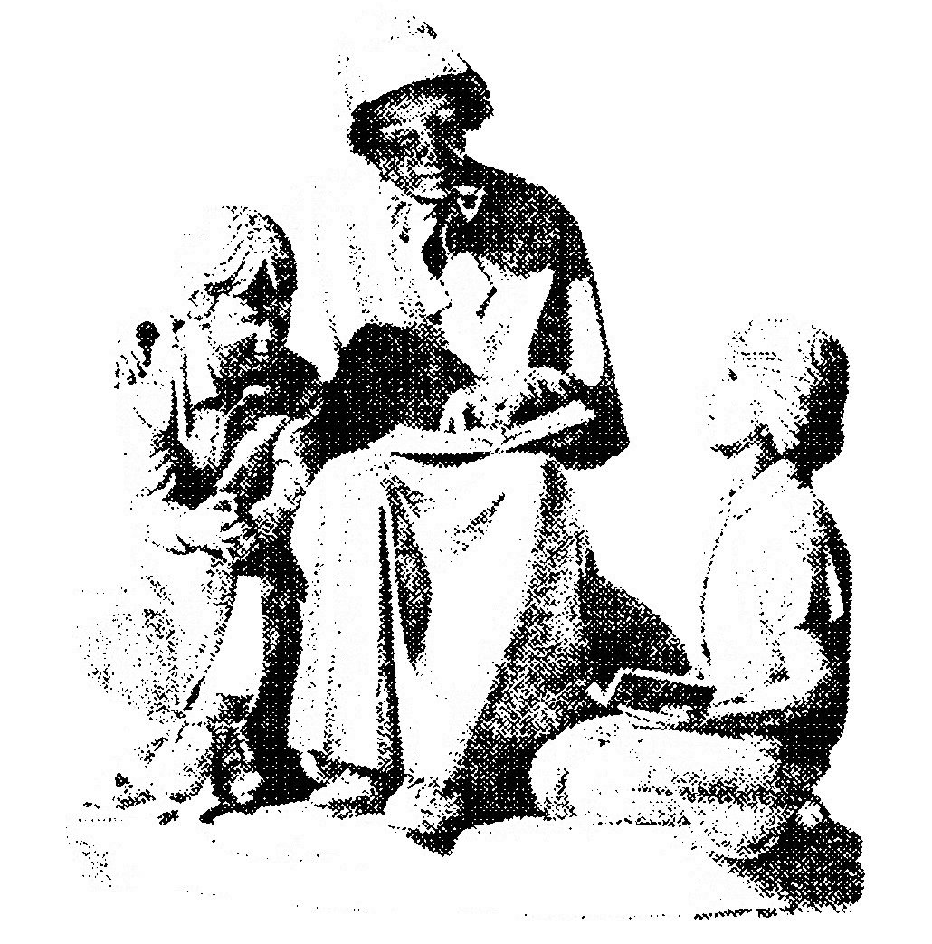
The tender name of Mother salutes me everywhere. The greater
my unworthiness, the more abundant is His mercy.
God who is mighty has done great things for me; holy is His name.
Admire how the Lord has chosen such a one as I to preside over
the community. His blessed name be adored forever.
God’s mercy is from generation to generation on those who fear Him.
Let me have but one wish, that of pleasing my Lord; but one fear,
the fear of offending Him.
God has shown might with His arm. He has scattered the proud in the conceit of their heart. He has put down the mighty and has exalted the humble.
The highest in heaven were the lowest here and coveted most the poverty and humility which accompanied their and our Master every step of the way.
God has filled the hungry with good things; the rich He has sent away empty.
Never can you find a surer way of obtaining all your desires then that of leaving all to God, who delights to grant the wishes, even for this life, if you are full of confidence.
God has received Israel, His servant, being mindful of His mercy. As He spoke to our ancestors, to Abraham and to his descendants forever.
How sweet is every moment employed in the service of our most generous God who repays with tender, compassionate love the good will of His child.
(ALL) Glory be to the Father, who created Mother Seton, destined her for great work in His Church and, that she might accomplish it, led her by hard paths into its fold. Amen.

Prayer: (ALL) We stand together this day as we celebrate this 200th anniversary since Elizabeth Ann’s death, one in our desire to be more than we are; one in our gratitude for all that has gifted our lives and one in our unity through Mary and Elizabeth Ann Seton, in Jesus through the Spirit. Amen.
prepared for the Ladies of Charity by Sr. Carol Schumer, D.C., January 2021

