Unconditional Gratitude
Call to Prayer: We say, “I am thankful for my family. I am thankful for my friends. I am thankful for this meal. I am thankful for …” She responds, “Big deal! So, you like some of your family members and you are thankful for that. You have selected a group of people you call friends and you are thankful for that. You chose the food and the recipes you like and you are thankful for that. …thanksgiving or gratitude? These are acknowledgements of what pleases you, conditional gratitude, conditional thankfulness. Are you thankful for whatever unfolds in front of you? Are you thankful for the challenges in front of you? Are you thankful for the miracle we call life no matter what it brings?” This is unconditional gratitude! adapted from Mehrad Nazari and Michele Hebert … 11-20-2019

Hymn: “How Great Thou Art” Stuart K. Hine verses 1-3
Unconditional Gratitude (con’t) 2
Antiphon ALL: “In ordinary life we hardly realize that we receive a great deal more than we give and that it is only with gratitude that life becomes rich.” Dietrich Bonhoeffer One Spirit 10-16-2020
I. Give praise to the Lord, proclaim his name; make known among the nations what he has done.
Sing to him, sing praise to him; tell of all his wonderful acts.
Glory in his holy name; let the hearts of those who seek the Lord rejoice. Psalm 105:1-3
II. I will extol the Lord at all times; His praise will always be on my lips.
I will glory in the Lord; let the afflicted hear and rejoice.
Glorify the Lord with me; let us exalt his name together. Psalm 34:1-3
I. It is good to give thanks to the Lord, to make music to your name, O Most High,
to proclaim your faithful love in the morning and your truth in the watches of the night,
on the ten-stringed lute and the harp, with the sound of song on the lyre. Psalm 92: 1-3
II. Let us give thanks to the Lord for his unfailing love and his wonderful deeds for humankind,
for he satisfies the thirsty and fills the hungry with good things. Psalm 107:8-9
I. Glory be … II. As it was …

Scripture Reading: “For everything created by God is good, and nothing is to be rejected when received with thanksgiving.” 1 Timothy 4:4

Reflection: Paul challenges Timothy, and us, to renegotiate our categories and to simply receive all that God creates with thanksgiving. We believe that God created us and loved us into being. God continues to provide for all our needs, in sometimes surprising ways.
https://www.loyolapress.com/3-minute-retreats-daily-online-prayer 11-18-19
Ponder and Share: For what can I give unconditional gratitude today?

Reflective Response: The famed novelist Morris West suggests that, when we turn seventy-five years of age, there should only be three phrases left in our vocabulary, “Thank you! Thank you! Thank you!” At a certain point in our lives, nothing else matters. Gratitude is the ultimate virtue and the only real route to happiness. It is more important even than love because anything, which does not take its root in gratitude, will be self-serving in some way. Only, when we give ourselves to others because we are grateful for how we have been blessed, will our love pour out in selflessness. The entire spiritual task of growing into truly mature and loving persons consists in rooting ourselves more and more in gratitude, where love can flow out from our hearts and demand nothing in return because it already has its return. adopted from Fr. Ronald Rolheiser, OMI Give Us This Day, November 2019, 11-28-19, pages 298-99
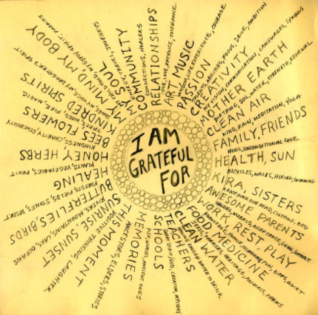
Activity: Some people make grocery lists, some make “to do” lists or even bucket lists. Maybe it’s time to make an I-am-thankful-for-all-God’s-gifts list. Start by looking at how blessed America is with beautiful shore-lines, rich farmland and spectacular mountain vistas. Varied climate zones allow abundant production of corn, rice, soybeans, wheat, cotton, peanuts, pecans, fruits and vegetables. The land abounds with natural resources, i.e., fish, coal, oil, forests, gold, copper and the people. What other country can give God praise for the many gifts we have been given!
Presidential Prayer Team Vantage Point 11-3-19

Happy Unconditional Thanksgiving!

prepared for the Ladies of Charity by Sister Carol Schumer, D.C., November, 2020

