God’s Providence – Jesus’ Birth December 2020

Call to Prayer: “Almost everything will work again if [we] unplug it for a few minutes, including [us].” (Writers Inspiring Writers, Anne Lamott (Dynamic Catholic,11/11/2020) Let’s quiet ourselves and focus on God’s gift of Jesus as we await his coming among us!

Hymn: O Come, O Come Emmanuel
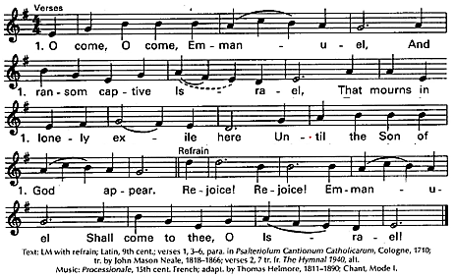

Reflection: When God becomes man, when we have Christmas, [Jesus] leaves the circumstances
very much the way they are, the same problems, pain, suffering and hunger, but He begins reforming hearts; the God-Man works in the heart. Suppose a great scientist found a remedy for the plague [pandemic] and he made the remedy available to the whole human race. There would be some who would come to be relieved; others might not. That’s just what happened when God came to this earth. We’d all be willing to have our circumstances changed. We’d like to have more money. Maybe live in a different house, but do we want our thinking changed? Do we want our loves changed? The God-Man who came to this earth, came for the remedy of moral and spiritual plagues. He came to make us happy on the inside. adapted from https://churchpop.com/2019/12/24/abp-fulton-sheen-how-christs-littleness-
at-christmas-is-more-powerful-than-superman/?
Reading: The Nativity Scene of Bethlehem is an Ode to Providence that Saint Vincent de Paul sang … Saint Vincent cultivated a deep devotion to the mystery of the Incarnation because there, in that humble manger …, Divine Providence showed the world the perfect face of love. … The mystery of the Incarnation and [of] Divine Providence … make us pilgrims of the Gospel and invite us to take a leading place in a world so full of needs. We Vincentians have been called there. … Let us together continue, facilitating Jesus’s birth in people’s hearts! Fr. Tomaž Mavrič, C.M. 12/24/2019
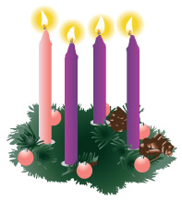
God’s Providence (read slowly, pausing briefly between each line.)
Saint Vincent speaks “All things come to those who wait.” (Coste volume 1, page 234)
“Let us abandon ourselves to the Providence of God and be on our guard against
anticipating it.” (Coste volume 2, page 499)
“Let us keep ourselves always dependent on God’s Providence since it pleases Him
and He sees what is best for us.” (Coste volume 2, page 517)
‘Let us abandon ourselves to the direction of God’s loving Providence and we shall be safe from all
sorts of inconveniences that our haste may draw down on us.” (Coste volume 2, page 517)
‘Wisdom consists in following Providence step by step.” (Coste volume 2, page 521)
Prayer: (all) O God, may each of us welcome you into our heart, knowing you provide for all that we need, leading us in your providence to love and service. We ask this in the name of Jesus. Amen.
prepared for the Ladies of Charity by Sr. Carol Schumer, D.C. December 2020

