Luminous Mysteries – October 2020
Call to Prayer: The "Mysteries of Light" or Luminous Mysteries of the rosary are so called because they shed light on who Jesus is. He understands his public ministry, his whole person and life are a mission of light. "While I am in the world, I am the light," (John 9:5) he proclaims. Each one of the mysteries, situated between the Joyful (Incarnation) and the Sorrowful (Passion, Crucifixion) ones, represents a facet or a beam of light. Each reveals a different aspect of Jesus' mission in the world.
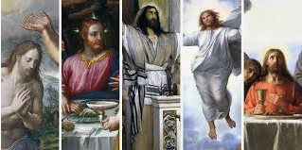
Leader: O God, come to our assistance
ALL: O Lord, make haste to help us.
Leader: Glory be to the Father and to the Son
and to the Holy Spirit,
ALL: As it was in the beginning, is now and
ever shall be world without end. Amen.

Hymn: “Christ, Be Our Light” Bernadette Farrell
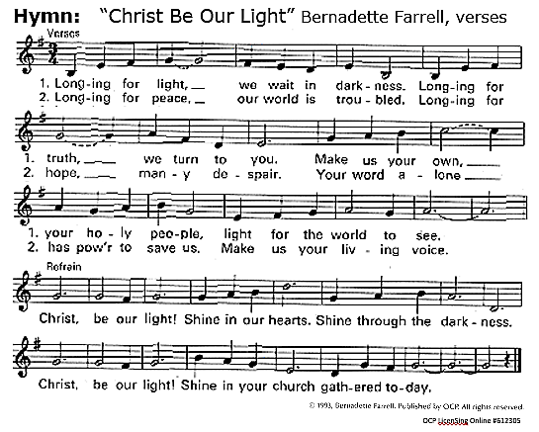
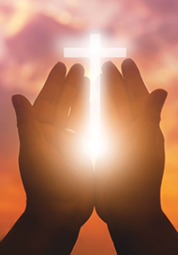
All: Our Father
Leader: The five Luminous Mysteries reveal that Jesus is one of us and also the Son of the Father. Jesus demonstrates God's love broken and shared with the whole of humankind. (pause)
The first Luminous Mystery -- the Baptism of the Lord in the Jordan. This event reveals Jesus as "Son of the Father." God the Father sheds light on the true origin of Jesus. He is the one who sent him; in turn Jesus chooses to receive this conversion ritual, Baptism. The Spirit descends. The Trinity is present. The Son is one of us, God incarnate.
All: Jesus, let the sun, its light and heat remind us of the Trinity, one God in three persons, inseparable. Hail Mary… (adapted from Coste, volume 13a, page 176)
Luminous Mysteries (con’t) 2
Leader: The second Luminous Mystery -- the wedding Feast of Cana This event marks Jesus' first miracle and clearly reveals his divine origin. He acts as the Son of God, changing water into wine. Through Jesus, God deals with human needs. He is a God of ordinary circumstances.
All: Let us praise and bless God and joyfully thank Him for the opportunity to do great good, coming down from the Father of Lights. Hail Mary… (Coste, 13a, page 437)

Leader: The third Luminous Mystery -- the Proclamation of the Kingdom of God This declaration reveals the ultimate goal of God's plan, the changing of the earth and all people into a new creation, the Kingdom of God. The light of Jesus in this mystery is justice, peace, especially love.
All: May we be continually devoted to working at our spiritual advancement, keeping the lamp within us lighted. Hail Mary… (adapted Coste, 13b, page 434)

Leader: The fourth Luminous Mystery -- the Transfiguration of Our Lord This manifestation is the mystery of light par excellence. It illumines Jesus’ ultimate victory over darkness, of life over death. We see the glory of God shining forth from the face of Jesus as his promise of eternal life.
All: O God, grant us light, discernment, strength of will and counsel which are gifts of the Holy Spirit. Hail Mary… (adapted Coste, 13b, page 251)

Leader: The fifth Luminous Mystery -- the Institution of the Eucharist In this supreme gift, Jesus reveals the permanence and fidelity of God's love. He offers his body and blood under the form of bread and wine. In this, he testifies "to the end" that he loves us and all humanity. (John 13:1)
All: Jesus, illuminate us with your light and unite our hearts in love. Hail Mary…
(adapted Coste, 4, page 60)
All: Glory Be

Reading: The Rosary is called a synthesis of the Gospel; the mysteries of light make the Rosary even more complete. They also show that the Rosary is at heart a Christian's prayer. John Paul II in his Apostolic Letter on the Rosary summarizes the meaning of the Rosary with these words, "With the Rosary, the Christian people sit at the School of Mary and are led to contemplate the beauty of the face of Christ and to experience the depths of his love."
adapted from https://udayton.edu/imri/mary/r/rosary-luminous-mysteries-as-enlightenment.php
Closing Prayer: “We are the Light of the World”
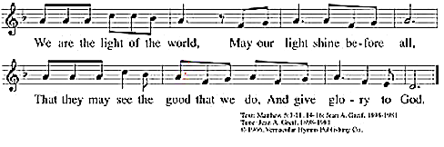

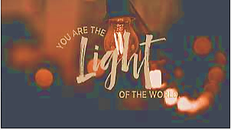

Used with permission OCP LicenSing Online #612305

Blessing Leader: May God illumine us with His light and accomplish through us the good we are called to do, through Mary, in Jesus, God’s Son, and the Spirit of love. (adapted Coste, 3, page 532)
All: Amen.
prepared for the Ladies of Charity by Sr. Carol Schumer, D.C., October 2020

