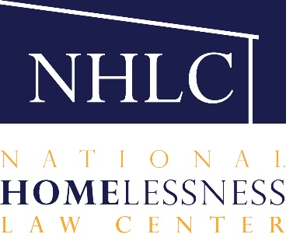

Voting Rights for People Experiencing Homelessness During the COVID-19 Crisis

As citizens of this country, participation in the electoral process is our primary method for voicing our concerns about the issues we hold dear, the conditions that impact us, and it is the way we challenge America to conform to its higher ideals expressed in the Constitution. Voting encompasses all of this. The vote gives us a voice.

People experiencing homelessness deserve the right to use their voice—unimpeded. People experiencing homelessness should not be barred from weighing in on the issues that matter most to them. Especially with COVID-19 threatening millions with evictions, misinformation and structural barriers may prevent this if we do not actively work to share people’s rights and ensure they can be enforced.

Join Law Center staff on Sept. 23rd at 2:00 EDT as we discuss the importance of helping people experiencing homelessness exercise their right to vote and provide tools and resources to address those rights.

Click to Register

To view previous webinars and see planned ones, please visit nlchp.org/resources/webinars/. Even if you cannot attend at the broadcast time, if you register you will automatically receive a link to the recorded version.

This biweekly webinar series will share the actions and legal strategies needed to ensure a right to housing both during the COVID-19 and moving forward. Keep an eye out for future themes and speakers!

