Eucharist and Service of Poor Persons September 2020

Introduction: During these months of the sheltering-in due to the pandemic, receiving Jesus in the Eucharist and serving poor persons have been rare opportunities for many of us. Let us always remember that Jesus identifies with us and everyone whom we touch, wherever we are.

Call to Prayer: “The identity between Christ and the poor is profound. We are speaking of a ‘real presence.’ It parallels the central mystery of our faith. We see Christ in a mixture of flour and water; we see Christ in a destitute person. We have the insight, the eyes to see Christ in the Eucharist and also in the poor; we meet Christ in the poor as much as we meet him in the Eucharist. Each mode of presence is real and complementary. It is an experience
of faith and is an expression of love. It is part of the Christian vision, not just Vincentian, but we have learned of this gift because of our companionship with Vincent because he has been our particular mentor and because, in God’s mercy, we share in his particular charism which is an essential way of living out the gospel, nothing more-yet nothing less.”
Eucharist – poor persons – Christ’s presence

Hymn: “Whatsoever You Do” (verses 1, 3)
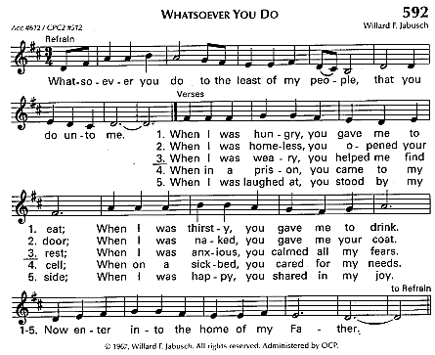
Used with permission, OCP LicenSing Online #612305

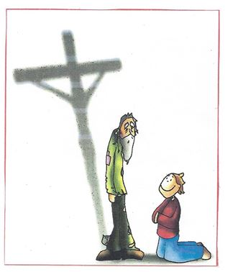
St. Vincent says to us:
+I ask Our Lord … to animate you …, so that everything you do and say may be to render Him the service He expects of you. (Coste, Vol XIIIb, #295).
+Go and do what you can for your part and God will do the rest. (Coste, Vol XII, #139)
+The Little Company strives to serve persons who are poor, the well-beloved of God, (Coste, Vol XI, #349)
+How beautiful it is to see poor people if we consider them in God and with the esteem in which Jesus Christ held them. (Coste, Vol XI, #19)
Eucharist and Service of Poor Persons September 2020 (con’t) 2

+You serve Jesus Christ in the person of the poor. Ten times a day, you will go out to visit the sick and ten times a day you will find God there; … take care of little children and you will find God there. You go into households of the poor there you find God. How wonderful! God kindly accepts the service you render to them and considers it done to himself.” (Coste, Vol. IX, #24)
+There will be two of you for the work, Our Lord and you, and with Him you can do all things. (Coste, Vol I, #369).
+O my God, how well you know how to direct your work, and how clearly you make it seen that it is Yours! (Coste, Vol XIIIa, #202).

Readings: “Only through relationships can I discern what kind of service is really needed, if I’m the one to offer it and whose needs I am meeting. It’s not about ‘I’m helping you,’ but ‘We’re walking and learning together.’ We must avoid the temptation to play “savior” because we think we know best.” Richard Rohr Daily Meditation, Working Together, 9/20/2019
Pause for Reflection
“… the secret to Vincent’s reverent interactions with the poor [is] he saw them as an invitation, not a threat; a manifestation of God’s presence. Sometimes surly and ungrateful, not pleasing in appearances, the poor were a difficult group with which to cast one’s lot. But Vincent and Louise served the poor with tenderness, respect and love; believing that no matter how they appeared, they manifested God’s abiding presence among us. In St. Vincent’s writings, one cannot help but be impressed with images he invokes to humanize and to even exalt them as those who ‘took the place of the Son of God, who chose to be poor.’.
“Vincent realized that for charity to be effective, it had to be organized and done with a community effort. He was among the first community organizers. Both Vincent and Louise were forward thinking people in their era, founding … lay movements with innovative rules to insure mobility.” …
“Vincent took great pains to instruct the Ladies and Confraternities of Charity specifically on how to serve the poor. … Vincent wrote to the Confraternities of Charity, directing those serving the poor, to help them learn to pray and to nurture their faith. Still, [his] emphasis was on invitation, not coercion. No poor person was refused help. [Vincent’s] “… vision was one of true foresight, helping the poor to move beyond crisis assistance toward self-reliance.
Bearing Beams of Love in a World of Contrary Lights,Gregory Gay, C.M., October 17, 2011
http://famvin.org/en/2014/08/17/a-vincentian-view-of-rioting-and-protests/
Pause for Reflection
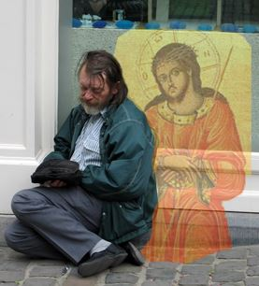
Closing; “Celtic Alleluia” (sing refrain, recite verse, repeat refrain)
Used with permission, OCP LicenSing Online #612305

Fed with the Bread of new life, filled with the wine of compassion,
Send us out to serve all the world in your name.

prepared for the Ladies of Charity by Sr. Carol Schumer, D.C. September 2020

