The Message of the Cross -- Lent
Call to Prayer Our age of prosperity strives to avoid discomfort and pain. Let us ponder the meaning of the Cross for our age of prosperity.
Reading 1: I do not think that the fundamental message of the cross is suffering. Jesus does not suffer because suffering is in itself a value, but because love without restraint requires suffering.
Reading 2: If the fundamental message of the cross is not suffering, but an absolute and communicative love, then the cross speaks compellingly to an age of prosperity.
Reading 3: It reminds us that Christianity is not a choice of suffering or of deprivation, but the choice of a new type of love. Anthony Padovano, Who is Christ?
Hymn “The Faithful One” refrain Dan Schutte, S.J. (formerly “Yahweh, the Faithful One”) 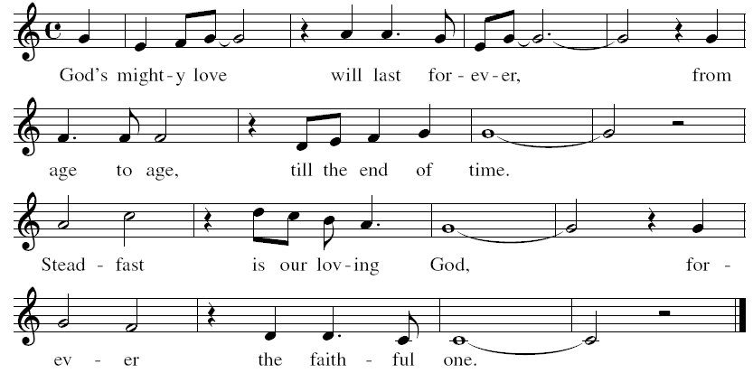
Used with Permission

http://content.ocp.org/shared/pdf/general/The-Faithful-One2008.pdf
Reading All: “I have come to rate all as loss in the light of the surpassing knowledge of my Lord Jesus Christ. For His sake, I have forfeited everything. I have accounted all else rubbish so that Christ may be my wealth and I may be in Him, not having any justice of my own based on observance of the Law. … I wish to know Christ and the power flowing from His resurrection; likewise, to know how to share in his sufferings by being formed into the pattern of his death.” Philippians 3: 8-9, 10
Hymn “The Faithful One” refrain (above)
Reflection and Sharing
What is the message of the cross for me, in my life?
How can I support others, especially those living in poverty, carry their crosses?
The Message of the Cross -- Lent (con’t) 2
Intercessions Leader: Vincent invites Louise and us to “… the foot of the Cross … the best place in this world [we] could be.” (Coste #103, page 155)
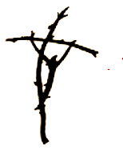
So let us pray to our God who, for us, accepted this cross as a clear sign of absolute and communicative love.
response: Help us love without restraint, O God.
+that we may be given the love and strength to take up our crosses and, in losing life, find it again, we pray …
+that we may not make the cross of Jesus an empty symbol by looking for success in grandiose deeds and accomplishments, we pray …
+that the values of the world and the prosperity of our age may be put to shame by the foolishness and gift of the cross, we pray …
+that we may boast only in the cross of Jesus through whom peace, mercy and love come to us, we pray …
+that with Jesus, we may accept the cross when we find ourselves threatened by hatred and violence because we advocate for the rights of those living in poverty, we pray …
(Please, add spontaneous prayers as desired.)
Our Father (All pray in unison.)
Prayer
Voice 1 Holy One, shock and save us with terrible goodness, with the incredible love of the cross of Jesus and drive us deep into the longing for your blessed reign,
until we seek it first, yet not for first for ourselves, but for your children who are hungry, sick and poor; for those imprisoned by conscience around the world;
for those we have rejected by our racism and sexism, by our ageism, nationalism, classism and religionism;
for those living on mother earth and in this city, who,
this Lent, know far more of the cross than of goodness,
Voice 2 that, in our seeking first your reign, for them as well as for ourselves,
all these things may be ours, things like a coat and courage and
something like comfort, a few lilies in the field, the sight of birds
soaring in the wind, a song in the night and gladness of heart;
Voice 3 and the sense of your presence, the realization of your promise that
nothing in life or death will be able to separate us or those we love,
from your unconditional love in the crucified one who is Jesus,
and in whose name and in whose Spirit we pray.
All Amen. adapted from Ted Loder, Guerillas of Grace
Hymn “The Faithful One” refrain (page 1)
+++++++++++++++++++++++++++++++++++++++

Prayer Texts
1 Corinthians 1: 18 “the cross … is the power of God.”
Philippians 2: 5-8 ”… obediently accepting … a cross.”
prepared for the Ladies of Charity by Sr. Carol Schumer, D.C.

