“Little Easters”
Call to Prayer: "… be quite cheerful in the disposition of willing everything that God wills. And because it is [God's] good pleasure that we remain always in holy joy of His love, let us remain in it …" Coste, Volume 1, #23 Vincent to Louise, p. 36
ALL: In the name of the Father and of the Son and of the Holy Spirit. Amen.
Reading: A “Little Easter”
Introduction Each church year, as we celebrate that jubilant event of Jesus’ Resurrection, we are urged to sing “alleluias” and songs of joy. I have often wondered just how many people do feel that joy deep inside themselves. I wonder because I sometimes have a difficult time entering into the “alleluia” and know others who also have expressed this same experience. We know intellectually and by faith, that it is a wonderful time to rejoice in Jesus being raised by the Father. But in spite of that truth, we sometimes just cannot muster an “alleluia” within us to no matter how hard we try to find the smile in our spirit. Illness or tragedy, anxieties or worries may prevent us from feeling the enthusiasm proclaimed in the songs and prayers of Easter (especially due to the current circumstances of the pandemic!)
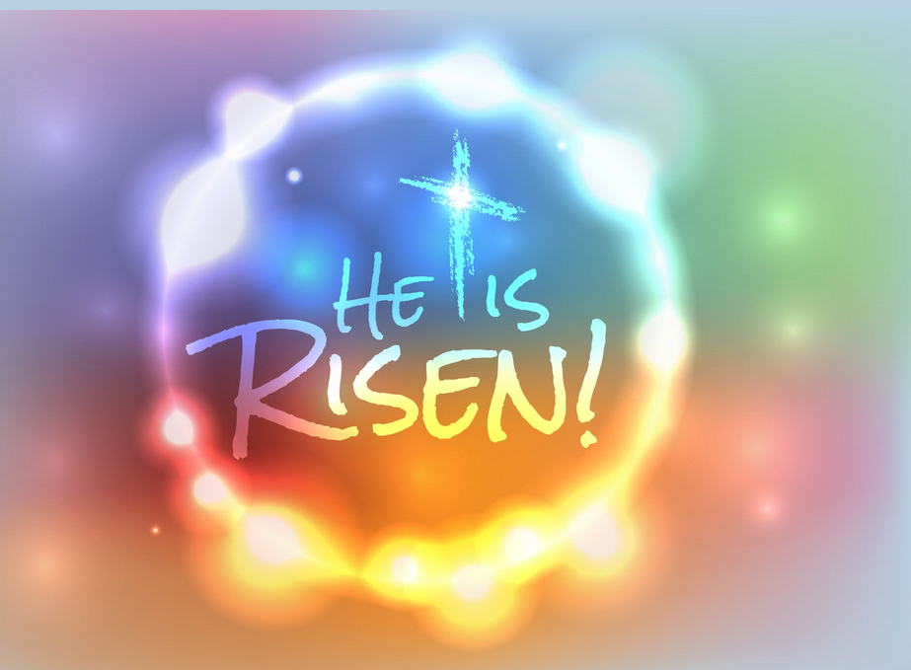
Let us discover yet another way of rejoicing when our feelings do not match the season’s message. It is the gift of recogniz-ing and remembering all the “little Easters” of our lives.
Our “little Easters” are those moments when we feel hope press against our spirit and can say, “Hooray! God is alive and
loves me so much!” Our “little Easters” are those moments when something that has died in us is raised to life again:
+watching and caring for new leaves on a plant thought to be dead
+seeing a project completed and being appreciated by those who benefitted from it
+receiving an e-mail from a friend who writes, “Hello, I’ve missed you!”
+seeing another empowered to act on his/her own behalf
+experiencing the inspiration of the Spirit when everything seems like a blank
+being motivated by a friend who has accomplished what he/she thought was impossible
+hearing a prayer come from someone who is shy about sharing God with others
+receiving a hug and a big smile from a child
+seeing a family member turn his/her life around and learn what true happiness is
+being blessed by an elderly person who shares his/her wisdom
(Please, share your own “little Easter” moments.)
adapted from Joyce Rupp, Fresh Bread, pages 56-57
“Little Easters” (con’t) 2
Prayer (Alternate sides, please.)
Praise to you, our risen Jesus, who keeps meeting me in the garden of my life, who continues to call my name, allowing me to feel loved, blessed and cherished.
Praise to you, our risen Jesus, who walks with me on my Emmaus journeys coaxing the ache out of me, comforting and strengthening me with the intimate presence of yourself.
Praise to you, our risen Savior, who keeps challenging the doubts in me, who perceives the Thomas in me and allows me those grace-filled times when I, too, can put my fingers into the wounds of my everyday life and there come in contact with you.
Praise to you, our risen Savior, who surprises me on the sandy beaches of my so-often-planned-and-programmed life, inviting me to come and taste what you have prepared. Time after time, you nourish me with all that I need to carry your risen presence with me, wherever I go and to whomever I meet.
adapted from Joyce Rupp, Fresh Bread, page 63
ALL: Amen, Alleluia!
Closing Hymn: “The Strife is O’er” all verses
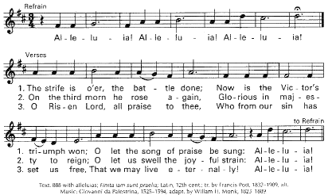
Used with permission.

Prayer Texts
1 Corinthian 15: 20-28 “In Christ Jesus, all will come to life.”
John 20: 19-31 “Happy are those who have not seen, … yet believe.”
prepared for the Ladies of Charity by Sr. Carol Schumer, D.C. May 2020

