Easter JOY and PEACE,
to each of you and your dear ones!
May this season overflow with blessings,
laughter, good health and well-being!
Soon may we "run" from our "shelter in place"
like Jesus does from the tomb!

I've attached a reading for you to enjoy!
Best to stay positive!
Love, prayers, "Sonshine,"
Sr. Carol
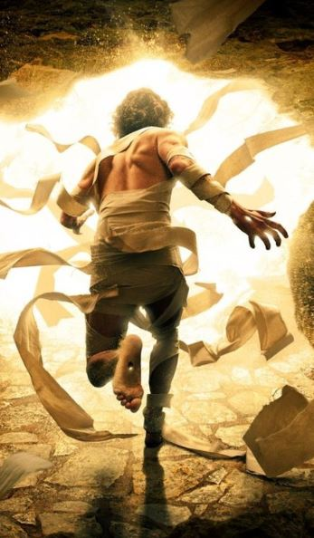

How the Virus Stole Easter
by Kristi Bothur
With a nod to Dr. Seuss 😊
T’was late in ‘19 when the virus began
Bringing chaos and fear to all people, each land.

People were sick, hospitals full,
Doctors overwhelmed, no one in school.

As winter gave way to the promise of spring,
The virus raged on, touching peasant and king.

People hid in their homes from the enemy unseen.
They YouTubed and Zoomed, social-distanced,
and cleaned.

April approached and churches were closed.
“There won’t be an Easter,” the world supposed.

“There won’t be church services, and egg hunts are out.
No reason for new dresses when we can’t go about.”

Holy Week started, as bleak as the rest.
The world was focused on masks and on tests.

“Easter can’t happen this year,” it proclaimed.
“Online and at home, it just won’t be the same.”

Maundy Thursday, Good Friday, the days came and went.
The virus pressed on; it just would not relent.

The world woke Sunday and nothing had changed.
The virus still menaced, the people, estranged.

“Pooh pooh to the saints,” the world was grumbling.
“They’re finding out now that no Easter is coming.

“They’re just waking up! We know just what they’ll do!
Their mouths will hang open a minute or two,
And then all the saints will all cry boo-hoo.

“That noise,” said the world, “will be something to hear.”
So it paused and the world put a hand to its ear.

And it did hear a sound coming through all the skies.
It started down low, then it started to rise.

But the sound wasn’t depressed.
Why, this sound was triumphant!
It couldn’t be so! But it grew with abundance!

The world stared around, popping its eyes.
Then it shook! What it saw was a shocking surprise!

Every saint in every nation, the tall and the small,
Was celebrating Jesus in spite of it all!

It hadn’t stopped Easter from coming! It came!
Somehow or other, it came just the same!

And the world with its life quite stuck in quarantine
Stood puzzling and puzzling. “Just how can it be?”

“It came without bonnets, it came without bunnies,
It came without egg hunts, cantatas or money.”

Then the world thought of something it hadn’t before.
“Maybe Easter,” it thought, “doesn’t come from a store.
Maybe Easter, perhaps, means a little bit more.”

And what happened then? Well....the story’s not done.
What will YOU do? Will you share with that one,

Or two or more people needing hope in this night?
Will you share the source of your life in this fight?

The churches are empty, but so is the tomb,
And Jesus is victor over death, doom and gloom.

So this year at Easter, let this be our prayer,
As the virus still rages all around, everywhere.

May the world see hope when it looks at God’s people.
May the world see the church is not a building or steeple.

May the world find Faith in Jesus’ death and resurrection,
May the world find Joy in a time of dejection.

May 2020 be known as the year of survival,
But not only that, let it start a revival.

