Prayer for a Pandemic
Ursuline Sisters of Louisville
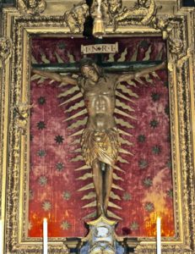
Plague Crucifix of 1522
We who are merely inconvenienced
Remember those whose lives are at stake.
May we who have no risk factors
Remember those most vulnerable.
May we who have the luxury of working from home
Remember those who must choose between
preserving their health or making their rent.
May we who have to cancel our trips
Remember those who have no safe place to go.
May we who are losing our margin money
in the tumult of the economic market
Remember those who have no margin at all.
As fear grips our country,
Let us choose love.
During this time when we cannot physically
wrap our arms around each other,
Let us yet find ways to be the loving embrace
of God to our neighbors.
Amen

