**The Slow Work of God in Me–Lent**

**Call to Prayer: Dialogue with God**



**God – Are you ready?**

**Me – Ready for what?**

**God – For growth during Lent!**

**Me – Oh, I’ve got a few ideas and some plans.**

**God – Plans are good! Just like you make plans for vacation.**

**Me – Lent is *no vacation*!**

**God – True, it’s more like spring break! “*Lent*’ means “*spring.*” It’s a “break” for Christians to get their lives back in shape, to grow in holiness.**

**Me – Like spring training?**

**God – Exactly! Time to exercise prayer, practice self-discipline and flex your outreach to those in need, all to make *Lent* a *break* for *spring training*.**

**Me – That’s a perspective, God. Thanks for sharing your viewpoint.**

**God – Great! Now use these days to get your faith in better shape!**

**Me – Help me with this, please!**

**God – You got my help. I’ll provide all the grace you need.**

**Me – Okay! Together we can work this growth in me.**

**God – Amen. We’re on! (adapted from Concord Pastor, 2-29-2020)**



**Hymn**: “Now the Green Blade Rises” verses 1, 4

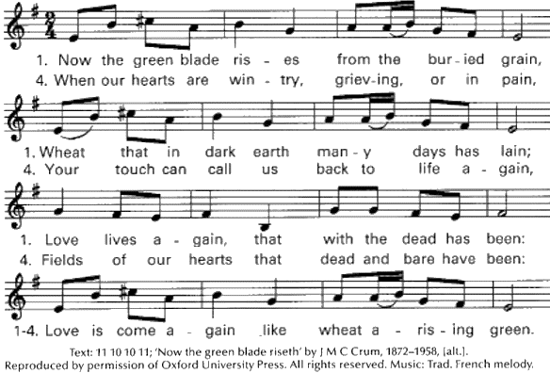

**Used with permission OCP LicenSing Online #612305**

**Scripture**  **Mark 4: 26-29**

**Jesus said, "The kingdom of God is as if someone would scatter seed on the ground and would sleep and rise, night and day; the sower does not know how. The earth produces of itself, first the stalk, then the head, then the full grain in the head. When the grain is ripe, at once the farmer goes out with the sickle because the harvest has come."**

**The Slow Work of God in Me–Lent** (con’t)

2



**Reading** **adapted from Teilhard de Chardin**

**Above all, let us trust in the slow work of God. We are, quite naturally, impatient in everything to reach the end without delay. We should like to skip the intermediate stages. We are impatient of being on the way to some-thing unknown, something new.**

**And yet it is the law of all progress. Growth happens by passing through stages of instability and this may take a long time. And so it is with us. Our beings mature gradually. We need to let them grow. Let them take shape, without undue haste.**

**We can’t force this, as though we could be today what time will make us tomorrow. Only God can say what this new spirit gradually forming within us will be. Let us give God the benefit of our believing that his hand is leading us and of our accepting the anxiety of feeling ourselves in suspense and incomplete.**

**Reflection and Sharing**

In what area of my life will God help me grow this Lent?

How can my Lenten growth aid my ministry as a Lady of Charity?



**Concluding Prayer** **ALL**: **We thank you, O God, for our determination to get things done and to achieve results. We thank you for the energy of our lives and our commitments. We ask you, God, to imbue our dedicated hearts with a spirit of patient endurance that corresponds to the gradual way in which your work and your reign is realized among us. May this patient spirit save us from restlessness, agitation and frustration in our growth and yield in us instead the peace of heart that frees us to see the fruits of your Spirit in our midst. We ask this though Jesus, your Son, who, in the power of the Spirit, graces us with all that we need, to your honor and glory. Amen.**

**Blessing Leader**: **“May you be forever a beautiful tree of life bringing forth fruits of love…”**

(Coste, volume 1, page 46, Vincent to Louise)

**ALL**: **Amen.**

++ +++++++++++++++++++++++

**Prayer Texts**

**Psalm 92:13-14 “… planted in the house of God, …They … bear fruit in old age,**

**they stay fresh and green.”**

**2 Peter 3: 18 “… grow in the grace … of … Jesus …”**

prepared for the Ladies of Charity by Sr. Carol Schumer, D.C., March, 2020