Called to Love and Unity

Call to Prayer Leader: “What a blessing to be a member of a Community because each individual shares in the good that is done by all! By this means you’ll have more abundant grace. Our Lord promised, ’Where two or three are gathered in my name, there am I in their midst.’” (Mt. 18:20)
Conferences Vincent de Paul Coste, Vol. 9, C1, page 2, Explanation of the Regulations, July 31, 1634

ALL: In the name of the Father and of the Son and of the Holy Spirit. Amen.

Hymn “Where Charity and Love Prevail” verses 1, 4, 5
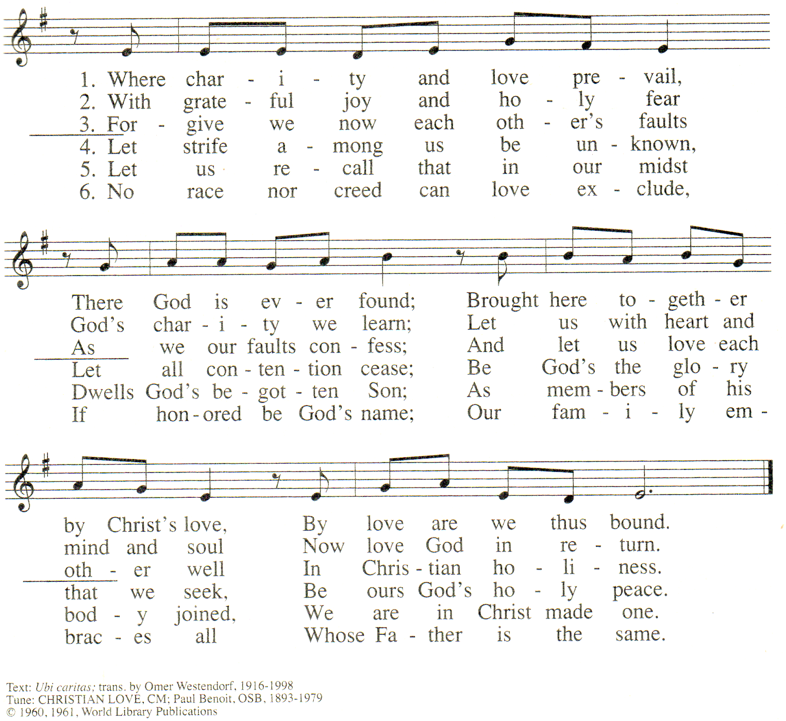

used with permission OCP LicenSing Online #612305

Antiphon ALL: How good it is to live and work together in harmony!
Psalm 133
Leader: Behold, how good and pleasant it is where women dwell in unity!
Side 1: It is like vistas seen from atop a mountain one has climbed
or like the stillness of a sunset after a long day’s work.
Side 2: It is like a shimmering rainbow, breaking through a summer rain.
ALL: When women dwell in harmony, the star of LOVE appears.
adapted from Psalms for Praying, Nan C. Merrill, pages 281-82
Called to Love and Unity (con’t) 2
Leader: Community necessitates unity which leads to opportunity. St. Louise de
Marillac reminds us:
Reading 1 “The person who does not love does not know God, for God is Charity. The cause of love is esteem for the good in the thing loved. … The love of creatures enters into the nature of this love. … The practice of charity is so powerful that it gives us knowledge of God, …we penetrate so deeply into the mystery of God and His greatness that we may say that the greater our charity the greater our participation in this divine light which will inflame us with the fire of Holy Love for all eternity.” Spiritual Writings of Louise de Marillac, A.29 page 710-11, On Charity, ~1631
Pause Silently re-read St. Louise’s words and ask:
How do I personally show charity within my group of Ladies of Charity?
Leader: From St. Vincent de Paul, in a conference to the Daughters, we hear:
Reading 2 “… considering the importance of cordial respect, I felt that it was the chief means of maintaining good order in a Community; that the early Christians were exact in practicing this virtue, which kept them in a state of great perfection and contentment, and that, when enthusiasm for this virtue lessened, there was unrest among them. The same would happen to us if we were to fail in respect, whereas, on the contrary, if we practice it reciprocally, as the Son of God recommended to His Apostles, teaching them to love one another as the eternal Father loved them, there will be good order and union.” Conferences Vincent de Paul Coste, Vol. 9, C17, page 117, Cordial Respect, January 1, 1644
Pause Silently re-read St. Vincent’s words and ask:
How do I show cordial respect to my companions in the Ladies of Charity?
What kind of respect do I want from each of them?
Personal Reflection
Human beings differ in our values, experiences and viewpoints so conflict is inevitable.
What disagreements and divisions hinder my love, our unity and service?
How am I/are we called to unity/community; to appreciate differences?
Prayer ALL: Loving God, we ask you to pour forth on our
association the spirit of love and union, by which we will honor the
unity within the Trinity and the respect present in the holy family of
Joseph, Mary and Jesus. Then we will enjoy the peace given by
your Son after His resurrection and we will have great union
among ourselves. Our work in serving our neighbor, especially
poor persons, will benefit from our community spirit, to your glory,
O God. Please, bless us in Your name, Father, Son and Holy
Spirit. Amen. adapted from Conferences Vincent de Paul Coste, Vol. 9, C17, page 128
Cordial Respect, January 1, 1644
+++++++++++++++++++++++++++++++++++++++++++++++++++++++++++++++++++++++
Prayer Texts
Matthew 22: 34-40 Which commandment is the greatest? Love …
John 17: 11-12, 22-23 … that they may be one as we are one, … brought to complete unity.
Acts 4: 32 … of one heart and one mind.
prepared for the Ladies of Charity by Sr. Carol Schumer, D.C., February

