September 14, 2018

Dear Ladies of Charity,

The Catholic Church has been in the news again, and not in a good way! I am saddened by the news of yet more sexual abuse and cover-ups perpetrated by some of the clergy and bishops of the Church, and I am moved with compassion for those victims whose lives have been damaged by this abuse. But this is not to say I am discouraged or disheartened.

Throughout its history, the Church has been plagued by scandals, which have in turn forced the Church to reform. I believe the Holy Spirit is always with us and will guide us through this new scandal.

But let us not forget, even as we are shocked and dismayed by the actions of a few, that one truth in the Church remains constant – that Jesus Christ suffered and died for our sins and rose from the dead to bring us new life. We welcome this same Jesus into our hearts every time we attend Mass and receive the Eucharist!

As we journey through these difficult times, let us always remember our mission of serving God’s poor with simplicity, humility, and love. We continue that mission as witnesses to God’s love. Let us pray for healing for the victims and forgiveness for the predators.

In the words of St. Vincent de Paul, “We must never be surprised when those upon whom we relied fail us; it is then that God steps in to do His work.”

God bless you and the work you do.

Sincerely,
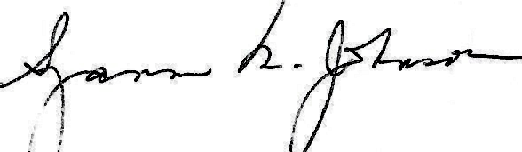
President

