January: Peace, Peace, Peace


Call to Prayer Leader: As we commence this new year, let’s ponder,
with Elizabeth Ann Seton, God’s gift of peace through the birth and life of Jesus
and God’s promise of a peaceable kingdom. (pause) “… may Peace be with you.”
Collected Writings of EAS vol. 1, p. 67, 1.42 To Julia Scott March 27, 1799

ALL: In the name of the Father and of the Son and of the Holy Spirit. Amen.

Reading “Peace and tranquillity of heart is the only good which our Lord has promised his
followers in this life" (Cf. John 14:27) … - but in how many ways must this peace and tranquillity be
interrupted …” Collected Writings of EAS vol. 3a, p. 569, Sickness by our own fault

Hymn “Peace is Flowing like a River" (sing twice)
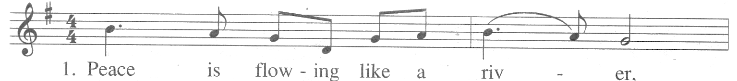
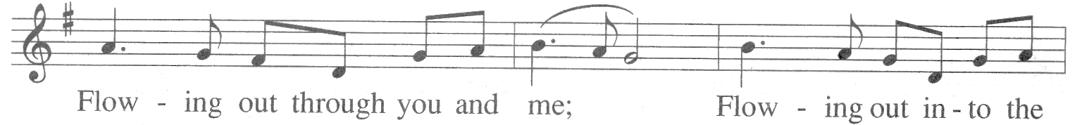
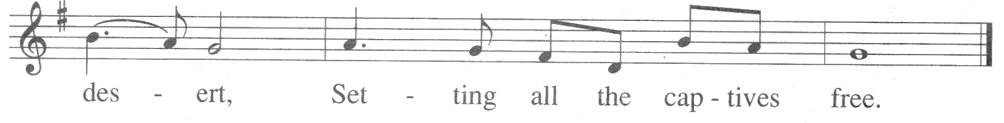
Text: Unknown Tune: Unknown 1993, GIA Publications, Inc. Used with permission, license #5393

Antiphon ALL: “… what I most desire and wish for you now is Peace that first and
most perfect of all earthly attainments.” Collected Writings of EAS vol. 1, p. 25, 1.16 To Julia Scott April 23, 1798
Psalm 145 Psalm of Praise, of David

- I will extol You, O my God and King; I will bless Your name forever and ever.
Every day I will bless You and I will praise Your name forever and ever.
- God, You are good to all and compassionate toward all Your works.
Let Your works give You thanks, O God; let Your faithful people bless You.
- Let them discourse of the glory of Your Kingdom and speak of Your might.
Let them make known to all people the splendor of Your Kingdom.
- Your Kingdom is a Kingdom for all ages and Your dominion endures throughout all generations.
- You raise up all who are bowed down.
The eyes of all look to You; You give them food in due time.
- O God, You are near to all who call upon You, to all who call upon You in truth.
You keep all who love You and all will bless Your holy name forever and ever.
ALL: “How much pain you will spare yourself if you will abandon yourself to God -- never be
hurried by anything whatever -- nothing can be more pressing than the necessity for your peace
before God -- commit every thing to him that passes thro' your hands and you will help others more
by the peace and tranquillity of your heart than by any eagerness or care you can bestow on them.”
[left side, back flyleaf (of her Bible)] Collected Writings of EAS vol. 3b, p. 84
Peace, Peace, Peace (con’t) 2

Reading Peace is something we all strive for in our lives. Many times we ask God to bring peace to our minds, our hearts and our relationships with others. When Jesus appeared to his disciples after his Resurrection, he knew their interior distress and so he offers peace.
Peace is not simply the absence of conflict. Peace is the reality that exists when heaven and earth connect. The peace that Jesus offers the disciples and us is the knowledge that God is present, that God cares and that God will be with us always. adapted from Loyola Press 3-minute retreat, Peace of Mind and Heart 11/3/14

Prayer Response ALL: Jesus, through your Spirit, share your peace with us so
that we may offer peace to others thus building your kingdom of peace.

Personal Reflection
When has someone made the peaceable kingdom a reality for me?
How do I share God’s gift of peace with the persons I serve?

Prayer ALL: Awaken, my heart, God’s reign is here;
the Peaceable Kingdom is in my hands.

The wolf can be the guest of the lamb and
the bear and cow be friends,
then no injury or hate can be a guest
within the kingdom of my heart.
Eden’s peace and harmony will only return
when first, in my heart,
there hides no harm or ruin,
for the Peaceable Kingdom is in my hands.
Isaiah’s dream became Jesus’ vision: “Come, follow me,” Emmanuel’s echo rings.
“Reform your life, recover Eden’s peace,” for only then will salvation appear.
For Advent’s dream is the healing of earth, when the eagle and bear become friends,
the child and the serpent playmates.
Arise, awaken my heart, the Peaceable Kingdom is in your hands.
adapted from Prayers for a Planetary Pilgrim, Edward Hays, “Pslams for Sacred Seasons” page 127

Leader: Loving God, may the peace that Jesus gave by his Incarnation fill our hearts and lives.
ALL: Amen.
++++++++++++++++++++++++++++++++++++


Prayer Texts
Isaiah 9: 5 “A child is born to us …, Prince of Peace.”
Luke 2: 14 “Glory to God … and on earth, peace …”
John 20: 21-22 “Peace be with you …”

prepared for the Ladies of Charity by Sr. Carol Schumer, D.C., January, 2015

